# Supplementary Information (SI) to:

**Occurrence and *in vitro* toxicity of organic compounds in urban background PM2.5**

Jonas P. Wallraffa*, Florian Ungeheuera*, Andrea Dombrowskib, Jörg Oehlmannb, Alexander L. Vogela

aInstitute for Atmospheric and Environmental Sciences, Goethe-University Frankfurt, Altenhöferallee 1, 60438 Frankfurt am Main, Germany

bInstitute of Ecology, Evolution and Diversity, Goethe-University Frankfurt, Max-von-Laue-Str. 9, 60438 Frankfurt am Main, Germany

*These authors contributed equally

*Correspondence to:* Alexander L. Vogel (vogel@iau.uni-frankfurt.de)

Table S1. AChE phosphate buffer.

|  |  |  |  |
| --- | --- | --- | --- |
|  | Solution | M (mol l-1) | Mass concentration (g l-1) |
| K2HPO4 | A | 1.5 | 342.34 |
| KH2PO4 | B | 1.5 | 204.14 |
| 100 ml solution A and 48.5 ml solution B were mixed. If necessary, the pH was adjusted to 7.2 | | | |

Table S2. EC20 and EC25 valueswith 95 % confidence interval (CI) for the Microtox- and AChE inhibition assay.

|  |  |  |  |
| --- | --- | --- | --- |
|  | **Sample** | **Microtox, EC20 with CI**  **(m3 air ml-1)** | **AChE, EC25 with CI**  **(m3 air ml-1)** |
| Airport, normal  operation | AN27 | 54.5  (7.48 to 427) | 3.32  (2.21 to 4.98) |
| AN19 |  |  |
| AN24 | 57.1  (8.25 to 395) | 5.34  (4.45 to 6.41) |
| AN26 | 41.4  (33.7 to 51.0) | 4.553  (4.01 to 5.17) |
| Airport strike | AS31 |  | 3.81  (2.90 to 5.00) |
| AS28 | 49.9  (38.3 to 65.0) | 5.09  (4.41 to 5.88) |
| AS29 |  | 11.2  (10.0 to 12.6) |
| AS30 | 56.6  (7.48 to 427) | 8.353  (7.51 to 9.30) |
| City | C5 | 27.7  (22.2 to 34.6) | 3.24  (2.94 to 3.57) |
| C3 | 49.3  (38.7 to 62.7) | 1.74  (1.36 to 2.22) |
| C4 | 24.7  (20.2 to 30.3) | 1.39  (1.05 to 1.83) |
| C7 | 32.7  (26.8 to 40.0) | 3.11  (2.30 to 4.21) |



**Fig. S1**. AChE inhibition of the three highest tested concentrations in m3 air ml‑1. The field blank showed high activity in the two highest concentrations of 52.9 and 26.5 m3 air ml‑1. Therefore, these concentrations were excluded from the EC25 calculation. In the remaining six dilutions from 13.2 m3 air ml‑1 downwards, the field blank shows no inhibition to AChE.

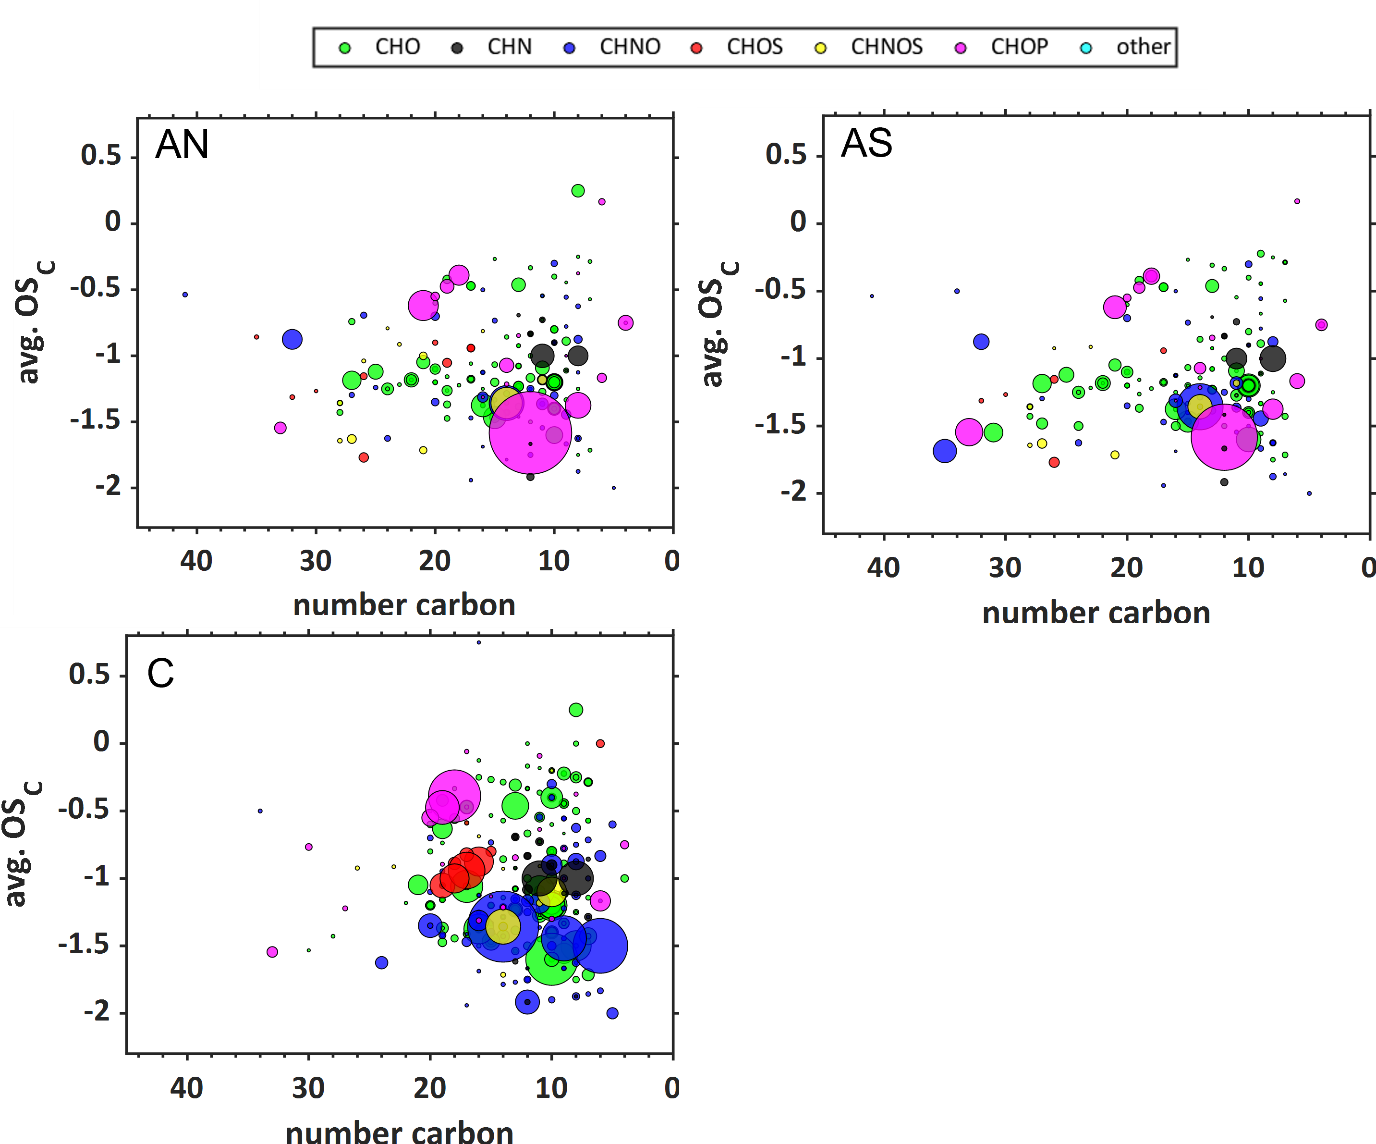

Fig. S2. Kroll plot of the filter averages for each sampling condition. The plot shows the average carbon oxidation state (avg. OSC) against the number of carbon atoms. It is a way of characterizing complex organic fractions based on their oxidation state and was calculated according to Kroll et al. (2011). Notably, CHO compounds from AN and AS have higher carbon numbers than samples from C. AN – normal airport operation, AS – airport strike, C – city.

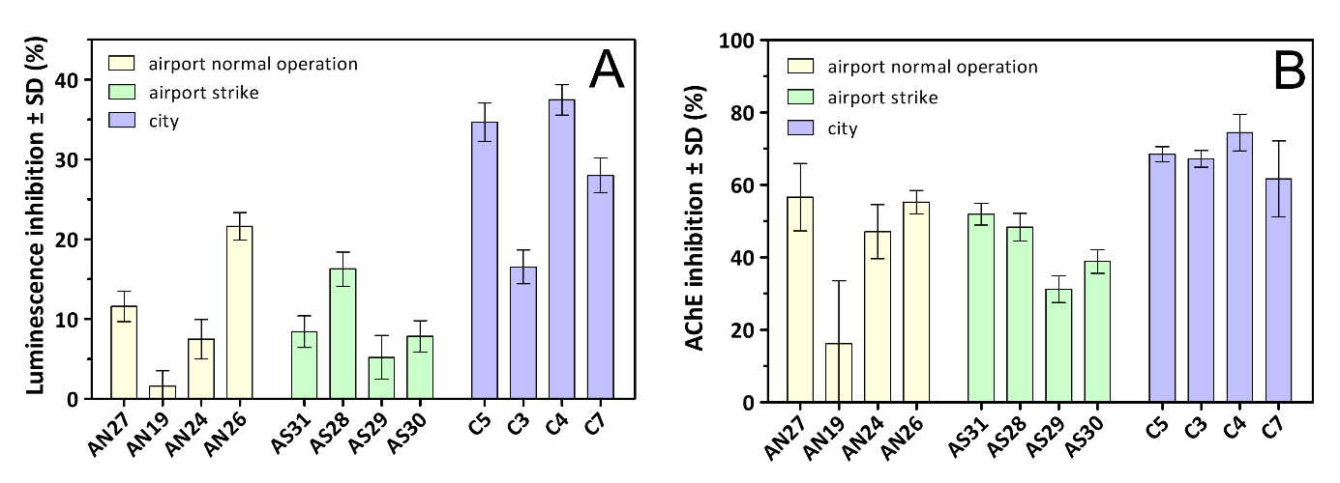

Fig. S3. Luminescence inhibition and AChE inhibition of the highest used test concentrations. A represents the luminescence inhibition (%) in the Microtox assay caused by extracts with a concentration of 47.1 m3 air ml-1,B represents the AChE inhibition caused by extracts with a concentration of 13.2 m3 air ml-1.

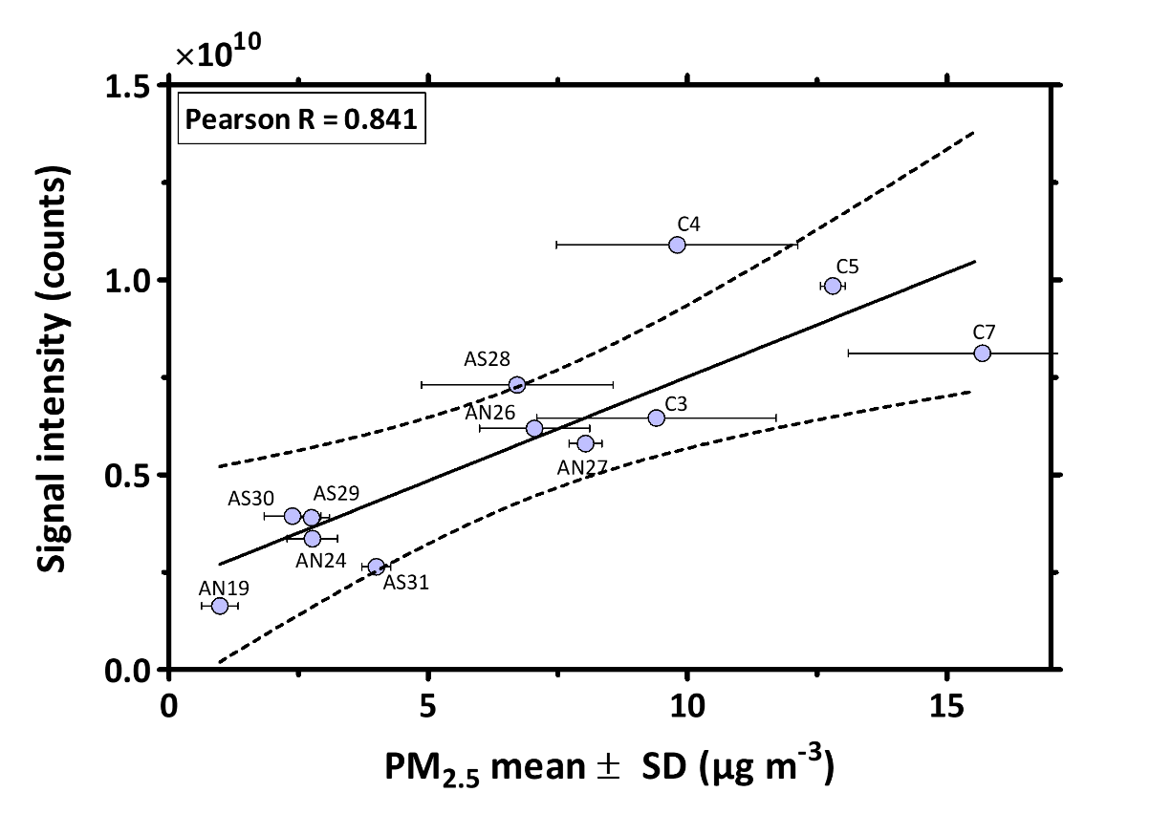

Fig. S4. Pearson correlation between the summed signal intensity of all detected compounds with a s/b ≥ 5 and the ambient PM2.5 concentrations. P=0.0006, Pearson r=0.841 (0.352 to 0.970), confidence interval 99 %.

Table S3. Coefficients of determination (r2) for the linear regression analyses (Pearson) at a p-level of 0.01 for single compounds. ns = not significant.

|  |  |  |
| --- | --- | --- |
|  | AChE (r2) | Microtox (r2) |
| TPhP | 0.616 | 0.616 |
| CDP | 0.674 | 0.659 |
| DPP | 0.704 | 0.703 |
| TCP | ns | ns |
| TBP | ns | ns |
| TEP | 0.341 | 0.523 |
| Norharman | 0.396 | 0.364 |
| NBBS | ns | 0.558 |
| Caryophyllene oxide | ns | ns |
| OP1EO | 0.575 | 0.693 |
| Prosulfocarb | 0.360 | 0.542 |

**Table S4.** Detailed settings of the CD-workflow.

Processing node 0: Input Files

------------------------------------------------------------------

------------------------------------------------------------------

Processing node 1: Select Spectra

------------------------------------------------------------------

1. Spectrum Properties Filter:

- Lower RT Limit: 0

- Upper RT Limit: 0

- First Scan: 0

- Last Scan: 0

- Ignore Specified Scans: (not specified)

- Lowest Charge State: 0

- Highest Charge State: 0

- Min. Precursor Mass: 0 Da

- Max. Precursor Mass: 5000 Da

- Total Intensity Threshold: 1000000

- Minimum Peak Count: 1

2. Scan Event Filters:

- Mass Analyzer: Is FTMS

- MS Order: Is MS2; MS1

- Activation Type: (not specified)

- Min. Collision Energy: 0

- Max. Collision Energy: 1000

- Scan Type: Any

- Polarity Mode: Is +

3. Peak Filters:

- S/N Threshold (FT-only): 1.5

4. Replacements for Unrecognized Properties:

- Unrecognized Charge Replacements: 1

- Unrecognized Mass Analyzer Replacements: ITMS

- Unrecognized MS Order Replacements: MS2

- Unrecognized Activation Type Replacements: CID

- Unrecognized Polarity Replacements: +

- Unrecognized MS Resolution@200 Replacements: 60000

- Unrecognized MSn Resolution@200 Replacements: 30000

5. General Settings:

- Precursor Selection: Use MS1 Precursor

- Use Isotope Pattern in Precursor Reevaluation: True

- Provide Profile Spectra: Automatic

- Store Chromatograms: False

------------------------------------------------------------------

Processing node 2: Align Retention Times

------------------------------------------------------------------

1. General Settings:

- Alignment Model: Adaptive curve

- Alignment Fallback: Use Linear Model

- Maximum Shift [min]: 0.3

- Shift Reference File: True

- Mass Tolerance: 5 ppm

- Remove Outlier: True

------------------------------------------------------------------

Processing node 3: Detect Compounds

------------------------------------------------------------------

1. General Settings:

- Mass Tolerance [ppm]: 5 ppm

- Intensity Tolerance [%]: 10

- S/N Threshold: 3

- Min. Peak Intensity: 500000

- Ions:

[2M+H]+1

[2M+K]+1

[2M+Na]+1

[2M+NH4]+1

[M+H]+1

[M+H+MeOH]+1

[M+K]+1

[M+Na]+1

[M+NH4]+1

- Base Ions: [M+H]+1; [M+Na]+1

- Min. Element Counts: C H

- Max. Element Counts: C90 H190 Br3 Cl4 N4 O20 P S3

2. Peak Detection:

- Filter Peaks: True

- Max. Peak Width [min]: 0.5

- Remove Singlets: True

- Min. # Scans per Peak: 5

- Min. # Isotopes: 2

------------------------------------------------------------------

Processing node 5: Group Compounds

------------------------------------------------------------------

1. Compound Consolidation:

- Mass Tolerance: 2 ppm

- RT Tolerance [min]: 0.3

2. Fragment Data Selection:

- Preferred Ions: [M+H]+1

------------------------------------------------------------------

Processing node 6: Fill Gaps

------------------------------------------------------------------

1. General Settings:

- Mass Tolerance: 2 ppm

- S/N Threshold: 1.5

- Use Real Peak Detection: True

------------------------------------------------------------------

Processing node 7: Mark Background Compounds

------------------------------------------------------------------

1. General Settings:

- Max. Sample/Blank: 3

- Max. Blank/Sample: 0

- Hide Background: False

------------------------------------------------------------------

Processing node 9: Assign Compound Annotations

------------------------------------------------------------------

1. General Settings:

- Mass Tolerance: 2 ppm

2. Data Sources:

- Data Source #1: mzCloud Search

- Data Source #2: Predicted Compositions

- Data Source #3: (not specified)

- Data Source #4: ChemSpider Search

- Data Source #5: (not specified)

- Data Source #6: (not specified)

- Data Source #7: (not specified)

3. Scoring Rules:

- Use mzLogic: True

- Use Spectral Distance: True

- SFit Threshold: 20

- SFit Range: 20

------------------------------------------------------------------

Processing node 10: Search mzCloud

------------------------------------------------------------------

1. General Settings:

- Compound Classes: All

- Precursor Mass Tolerance: 5 ppm

- FT Fragment Mass Tolerance: 5 ppm

- IT Fragment Mass Tolerance: 0.4 Da

- Library: Autoprocessed; Reference

- Post Processing: Recalibrated

- Max. # Results: 10

- Annotate Matching Fragments: False

2. DDA Search:

- Identity Search: HighChem HighRes

- Match Activation Type: True

- Match Activation Energy: Match with Tolerance

- Activation Energy Tolerance: 20

- Apply Intensity Threshold: True

- Similarity Search: Similarity Forward

- Match Factor Threshold: 60

3. DIA Search:

- Use DIA Scans for Search: False

- Max. Isolation Width [Da]: 500

- Match Activation Type: False

- Match Activation Energy: Any

- Activation Energy Tolerance: 100

- Apply Intensity Threshold: False

- Match Factor Threshold: 20

------------------------------------------------------------------

Processing node 8: Predict Compositions

------------------------------------------------------------------

1. Prediction Settings:

- Mass Tolerance: 2 ppm

- Min. Element Counts: C H

- Max. Element Counts: C90 H190 Br3 Cl4 N4 O20 P S3

- Min. RDBE: 0

- Max. RDBE: 40

- Min. H/C: 0.1

- Max. H/C: 3.5

- Max. # Candidates: 10

- Max. # Internal Candidates: 200

2. Pattern Matching:

- Intensity Tolerance [%]: 10

- Intensity Threshold [%]: 0.1

- S/N Threshold: 3

- Min. Spectral Fit [%]: 30

- Min. Pattern Cov. [%]: 90

- Use Dynamic Recalibration: True

3. Fragments Matching:

- Use Fragments Matching: True

- Mass Tolerance: 5 ppm

- S/N Threshold: 3

------------------------------------------------------------------

Processing node 11: Search ChemSpider

------------------------------------------------------------------

1. Search Settings:

- Database(s):

EAWAG Biocatalysis/Biodegradation Database

Nature Chemistry

Sigma-Aldrich

- Search Mode: By Formula Only

- Mass Tolerance: 5 ppm

- Max. # of results per compound: 100

- Max. # of Predicted Compositions to be searched per Compound: 3

- Result Order (for Max. # of results per compound): Order By Reference Count (DESC)

2. Predicted Composition Annotation:

- Check All Predicted Compositions: False

------------------------------------------------------------------

Processing node 12: Apply mzLogic

------------------------------------------------------------------

1. Search Settings:

- FT Fragment Mass Tolerance: 10 ppm

- IT Fragment Mass Tolerance: 0.4 Da

- Max. # Compounds: 0

- Max. # mzCloud Similarity Results to consider per Compound: 10

- Match Factor Threshold: 30

------------------------------------------------------------------

Processing node 13: Apply Spectral Distance

------------------------------------------------------------------

1. Pattern Matching:

- Mass Tolerance: 5 ppm

- Intensity Tolerance [%]: 30

- Intensity Threshold [%]: 0.1

- S/N Threshold: 3

- Use Dynamic Recalibration: True

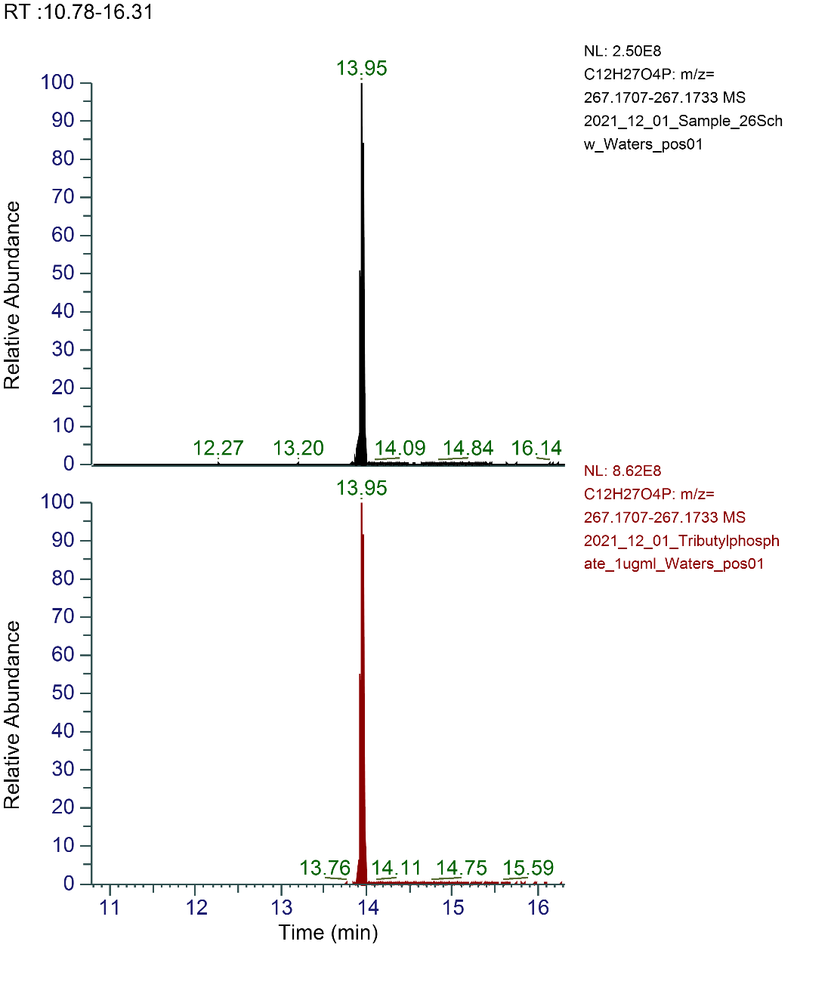

Fig. S5. Chromatograms of tributyl phosphate (TBP) signals in the sample AN26 (top) and the authentic standard (≥99 %, Sigma Aldrich) (bottom).

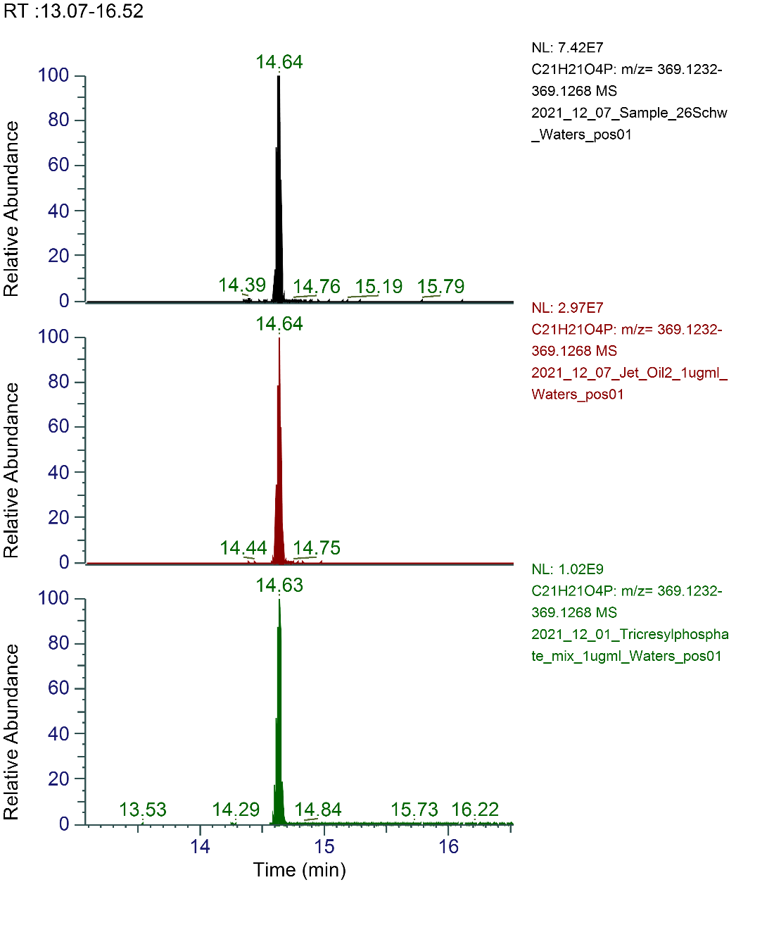

Fig. S6. Chromatograms of tricresyl phosphate (TCP) signals in the sample AN26 (top), in Mobil Jet Oil II (middle) and in the authentic standard (mixture of TCP isomers 63-85 %, residue of other tolyl phosphate isomers, Acros Organics) (bottom).

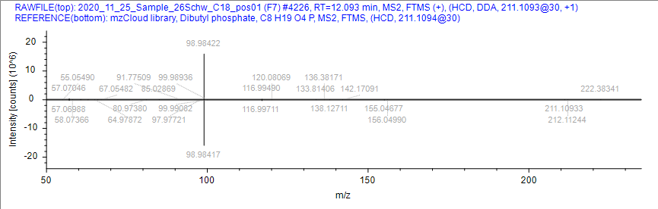

Fig. S7. MS/MS mirror plot of the compound dibutyl phosphate in sample AN26 (top) and the mzcloud library spectrum (bottom).

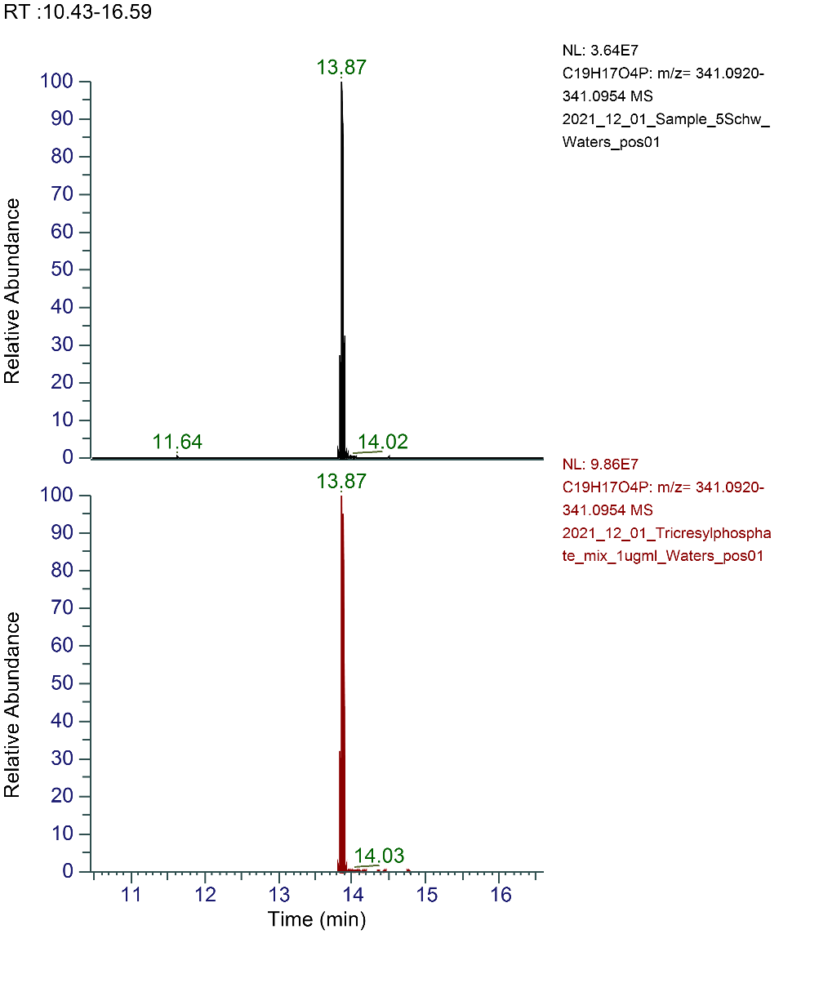

Fig. S8. Chromatograms of cresyldiphenyl phosphate (CDP) signals in the sample C5 (top) and the authentic standard (mixture of TCP isomers 63-85 %, residue of other tolyl phosphate isomers, Acros Organics) (bottom).

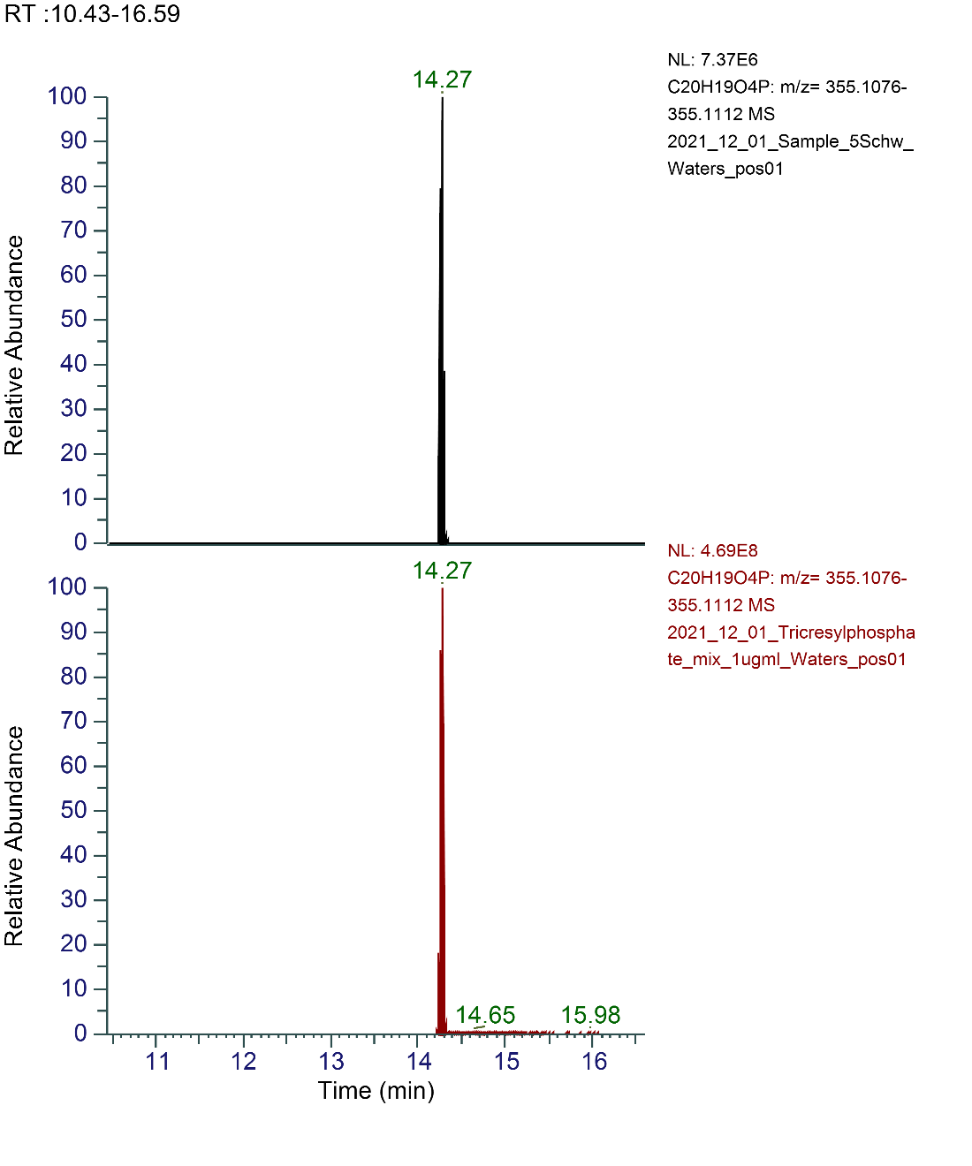

Fig. S9. Chromatograms of dicresylphenyl phosphate (DPP) signals in the sample C5 (top) and the authentic standard (mixture of TCP isomers 63-85 %, residue of other tolyl phosphate isomers, Acros Organics) (bottom).

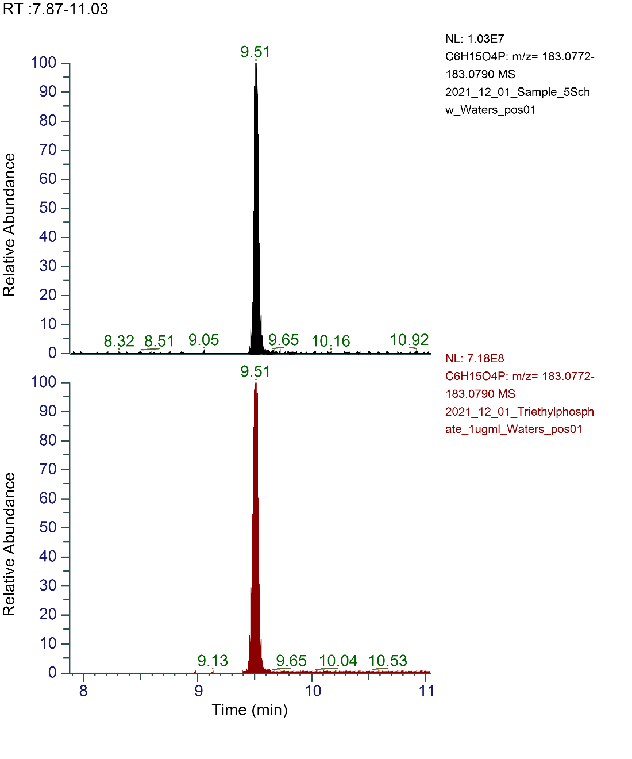

Fig. S10. Chromatograms of triethyl phosphate (TEP) signals in the sample C5 (top) and the authentic standard (≥99.8 %, Sigma Aldrich) (bottom).

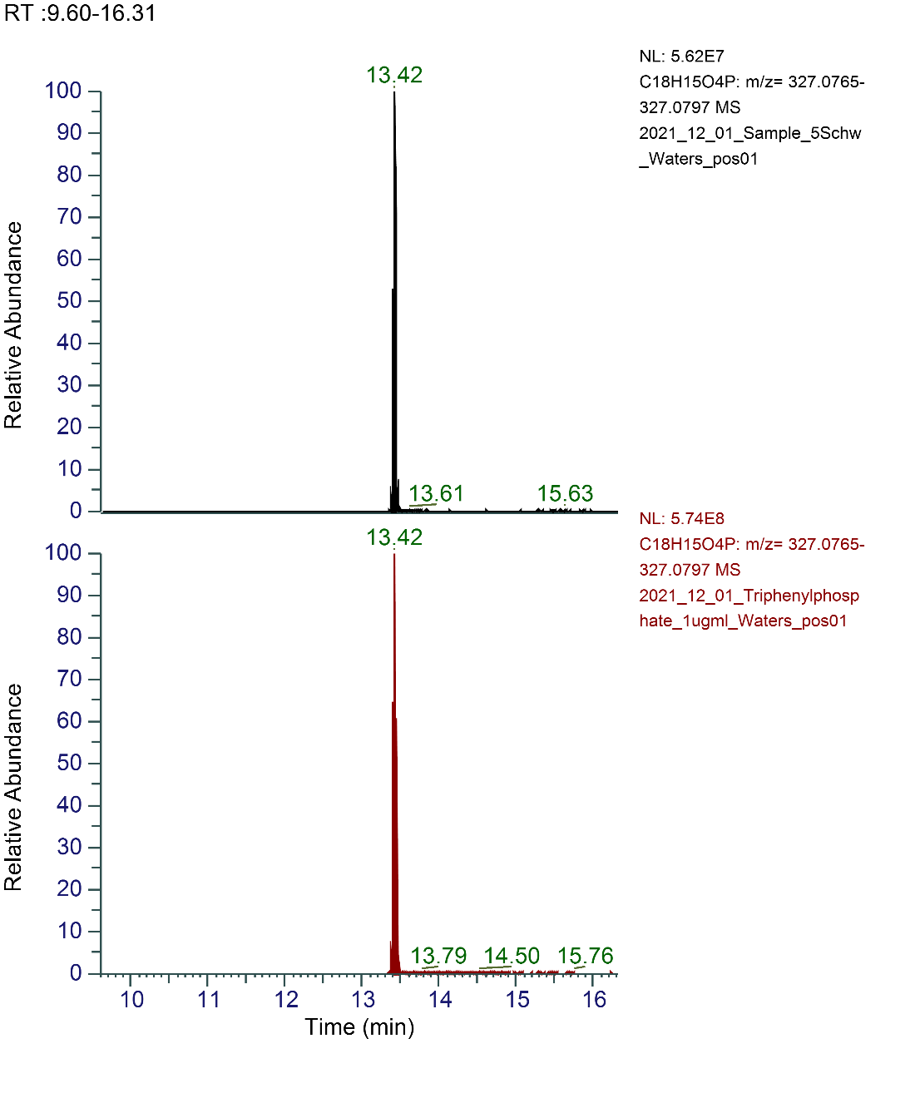

Fig. S11. Chromatograms of triphenyl phosphate (TPhP) signals in the sample C5 (top) and the authentic standard (≥99 %, Sigma Aldrich) (bottom).

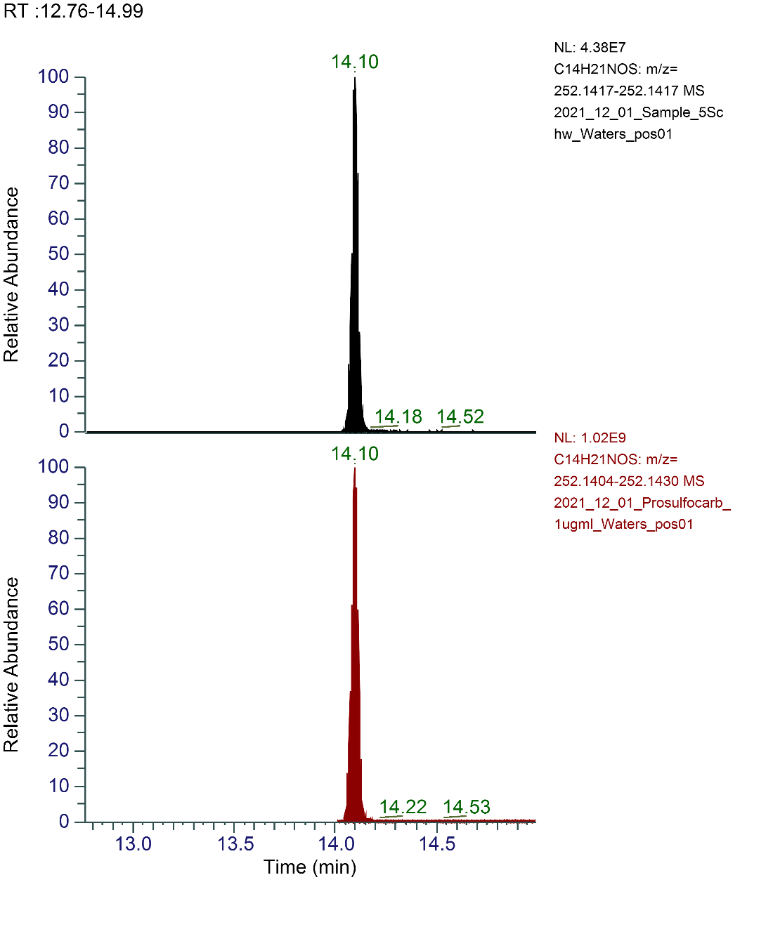

Fig. S12. Chromatograms of prosulfocarb (PSC) signals in the sample C5 (top) and the authentic standard (≥98 %, Sigma Aldrich) (bottom).

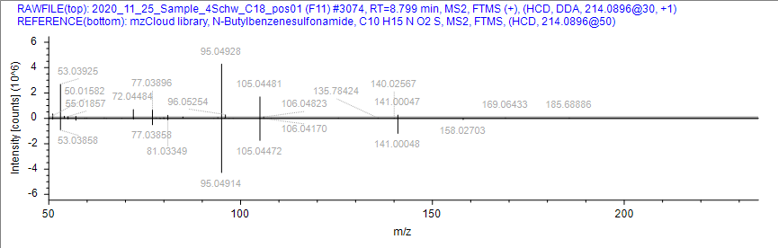

Fig. S13. MS/MS mirror plot for N-butylbenzenesulfonamide (NBBS) in sample C4 (top) and the mzcloud library spectrum (bottom).

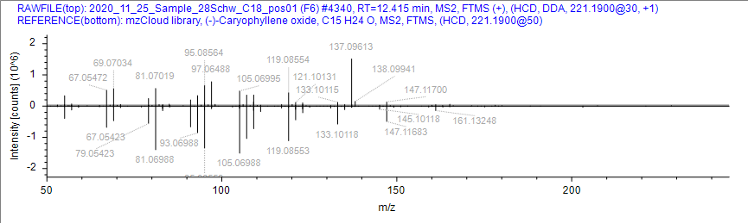

Fig. S14. MS/MS mirror plot for caryophyllene oxide in sample AS28 (top) and the mzcloud library spectrum (bottom).

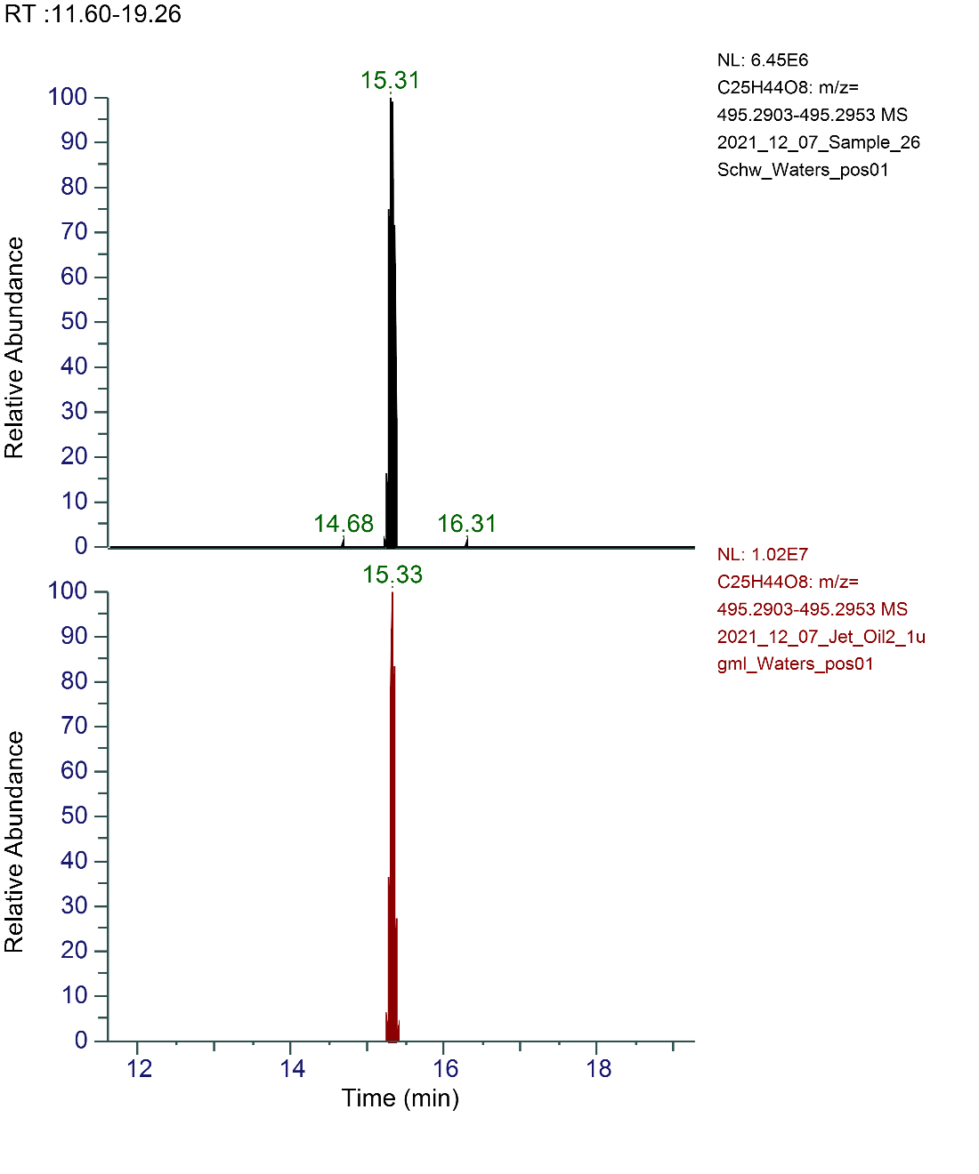

Fig. S15. Chromatograms for the signals of the synthetic ester C25H44O8 in the sample AN26 (top) and in Mobil Jet Oil II (bottom).

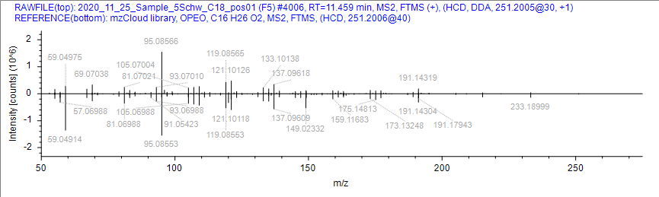

Fig. S17. MS/MS mirror plot for OP1EO in sample C5 (top) and the mzcloud library spectrum (bottom).

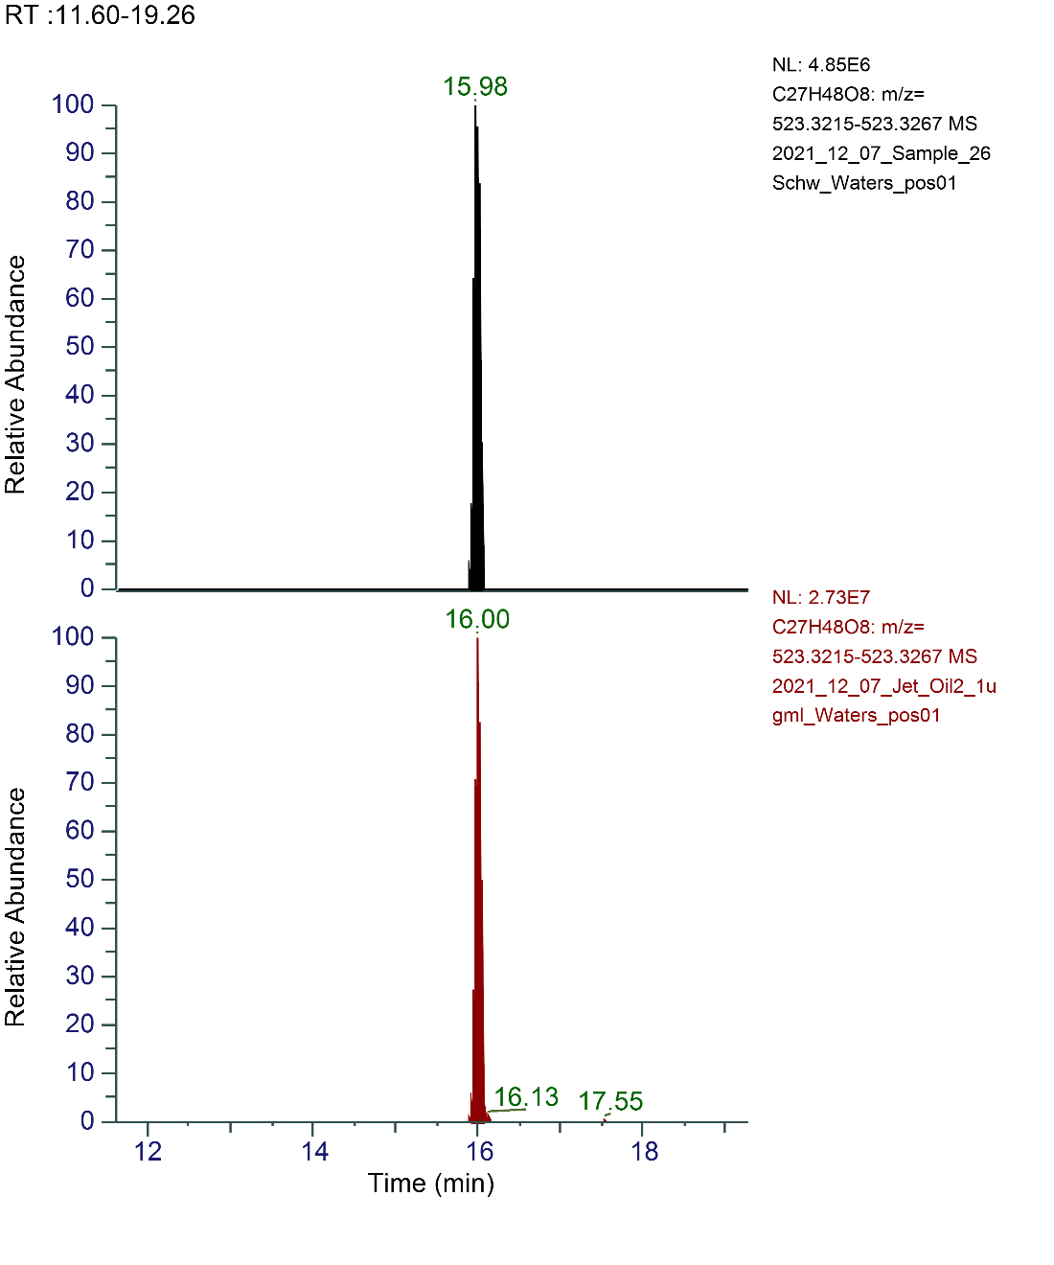

Fig. S16. Chromatograms for the signals of the synthetic ester C27H48O8 in the sample AN26 (top) and in Mobil Jet Oil II (bottom).

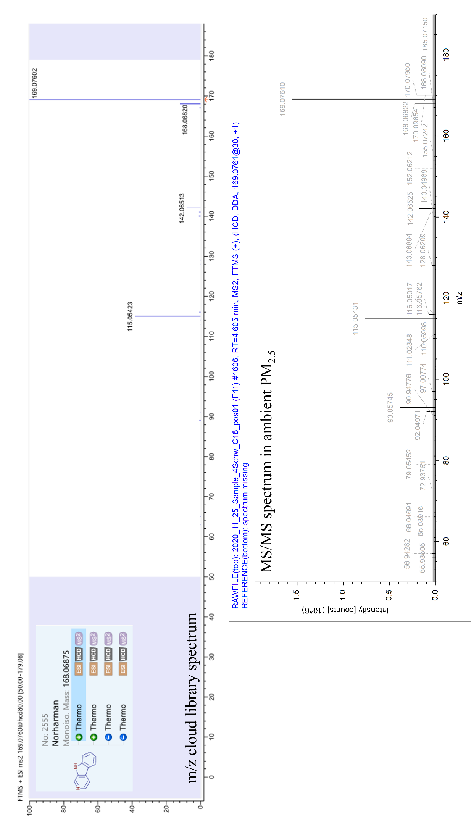

Fig. S18. Mzcloud library spectrum for norharmane with the characteristic fragments of *m/z* 115.05423; 142.06513; 168.06820; and 169.07602 (top) and the MS/MS spectrum for sample C4 at *m/z* 169.0761, where we observe the according fragments and therefore identify the compound as norharmane (level 2).

**References**

Kroll, J.H., Donahue, N.M., Jimenez, J.L., Kessler, S.H., Canagaratna, M.R., Wilson, K.R., Altieri, K.E., Mazzoleni, L.R., Wozniak, A.S., Bluhm, H., Mysak, E.R., Smith, J.D., Kolb, C.E., Worsnop, D.R., 2011. Carbon oxidation state as a metric for describing the chemistry of atmospheric organic aerosol. Nat. Chem. 3, 133–139. https://doi.org/10.1038/nchem.948