Supplement 1
Supplement 1a. Risk‐of‐bias summary of included randomized trial according to the RoB2 risk of bias tool for randomized studies
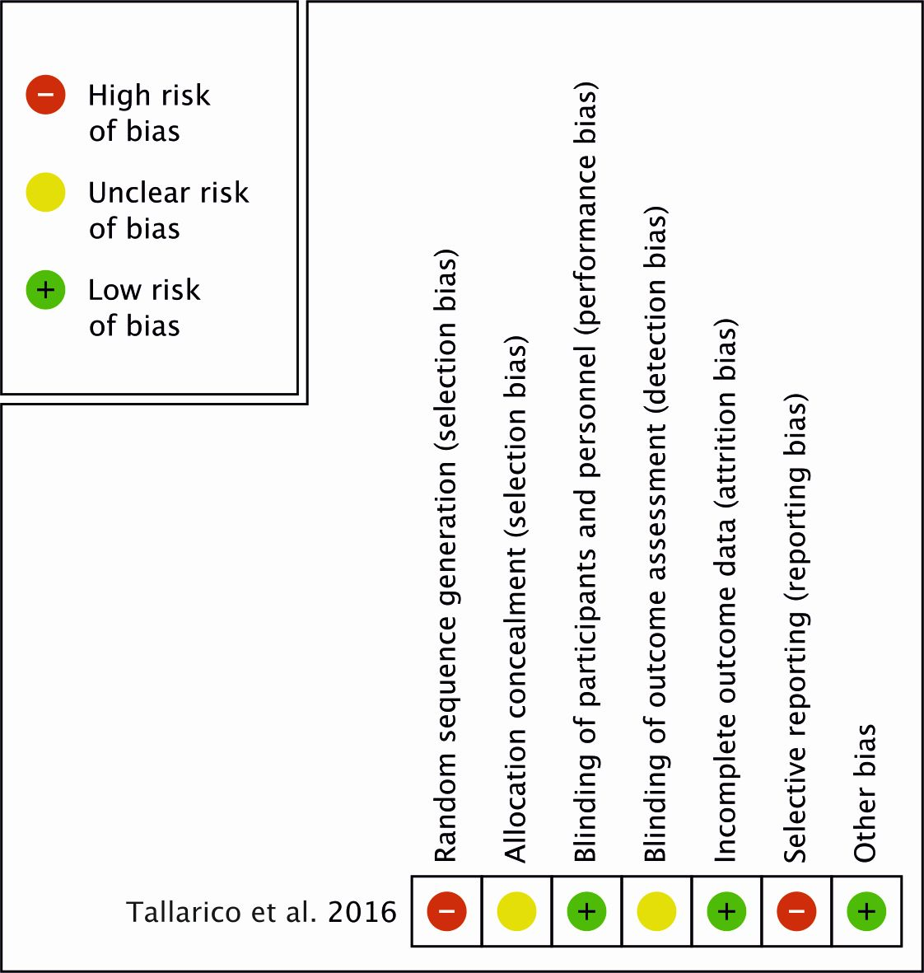

Supplement 3.b. Risk‐of‐bias summary according to the RoB1 risk of bias tool for non-randomized studies.
