Supplementary Material to

Miocene high elevation in the Central Alps
Emilija Krsnik^{1,2}, Katharina Methner^{1,5}, Marion Campani¹, Svetlana Botsyun³, Sebastian G. Mutz³, Todd A. Ehlers³, Oliver Kempf⁴, Jens Fiebig², Fritz Schlunegger⁶, Andreas Mulch^{1,2}
¹Senckenberg Biodiversity and Climate Research Centre (SBiK-F), Senckenberganlage 25, Frankfurt (Main), 60325, Germany
²Institute of Geosciences, Goethe University Frankfurt, Altenhöferallee 1, Frankfurt (Main), 60438, Germany
³Department of Geosciences, University of Tübingen, Schnarrenbergstr. 94-96, 72076 Tübingen, Germany
⁴Federal Office of Topography swisstopo, Geologische Landesaufnahme, Seftigenstr. 264, Wabern, 3084, Switzerland
⁵Department of Geological Sciences, Stanford University, CA 94305, USA
⁶Institute of Geological Sciences, University of Bern, Baltzerstrasse 3, Bern, 3012, Switzerland

Correspondence to:
Emilija Krsnik
Senckenberg Biodiversity and Climate Research Centre (BiK-F), Senckenberganlage 25,
60325 Frankfurt/Main
0049 69 7542 1815
emilija.krsnik@senckenberg.de

Content
- Text S1 (Age constraints)
- Text SI2 (Analytical procedures)
- Text S3 (Paleoelevation reconstruction)
- Text S4 (Diagenetic implications)
- S5 Figures (Fig. S1–S3)
- S6 Table1
- S7 Data tables (Table T1–T5, tables can be found in a separate EXCEL file)

This supplementary information provides details on calculation of sample ages (S1), analytical procedures (S2), paleoelevation reconstruction (S3), listed stable (δ¹³C, and δ¹⁸O; Table T1) and clumped isotope data (Δ₄₇; Tables T2–T4), and paleoelevation calculation for alternative scenarios with different oxygen isotope lapse rates and near sea level reference baselines (Table T5). It further comprises Table1 (S5) listing data used in this study and three additional figures showing pedogenic carbonate δ¹³C values for each section (Fig. S1), pedogenic carbonate δ¹⁸O and δ¹³C values as function of time for each section (Fig. S2) and the δ¹⁸O/ δ¹³C relationship for the Aabach section (Fig. S3). Data tables contain sample and age information, analytical results of oxygen and carbon stable isotope analysis for carbonate nodules, and calculated oxygen isotope data for meteoric water (Table T1).

S1 Age constraints for Fontannen, Jona, and Aabach sections
Pedogenic carbonate nodules from all three Swiss Molasse Basin sections were collected along magnetostratigraphically-dated sections and each sample was assigned an exact position within the local paleomagnetic stratigraphy. Age constraints for the Fontannen section follow the age model published in (Methner et al., 2020) and details on the calculation can be found therein.
Chronostratigraphic framework for both, the Jona and Aabach sections has been established based on combined magnetostratigraphy (Kälin and Kempf, 2009; Kempf et al., 1997; Kempf and Matter, 1999), biostratigraphy (Bolliger, 1992; Kälin, 1997), and radiometric dating of volcanic ashes (Gubler et al., 1992; Schmieder et al., 2018).
The Jona section spans an age interval of ca. 16.5 to 13.5 Ma (Kempf et al., 1997) and is dated by the projected Küsnacht bentonite (14.91 ± 0.09 Ma) and seven mammal sites comprising faunal zones MN 4b, MN 5, and MN 6. Furthermore, the Hüllistein conglomerate serves as an important stratigraphic marker bed (at 16 Ma; Kempf et al., 1997) and allows a lateral correlation with the Meilen limestone in the Aabach section 20 km further to the west (Kempf & Matter, 1999). We used the paleomagnetic section of (Kempf et al., 1997) to construct the age model of the sampled section. We sampled ca. 650 m of the section covering the uppermost part of Chron C5Cr to the lowermost part of Chron C5ABr, spanning a time interval of 16.773 Ma to 13.711 Ma (chron ages from the Astronomically Tuned Neogene Time Scale (ATNTS2012; Hilgen et al., 2012).
Paleomagnetostratigraphy and age assignments for the Aabach section are presented in Kempf & Matter (1999). Absolute age constraints are given by two projected volcanic ash layers (the Küsnacht and the Urdorf bentonites) which are dated to 14.91 ± 0.09 Ma and 15.27 ± 0.12 Ma, respectively (Gubler et al., 1992). Biostratigraphic constraints include five mammal sites (all in mammal faunal zone MN 5; Kälin & Kempf, 2009). We sampled 352 m of the section covering the base of Chron C5Cr to the top of Chron C5Bn.1r, which transfers into a time interval of 17.222 Ma to 14.870 Ma (according to ATNTS2012; Hilgen et al., 2012). Uncertainties are introduced by two confirmed hiatuses at ~172 m and ~280 m of section with unknown durations. We defined the time of ending of the hiatuses to be at the beginning of the subsequent confirmed chron. We therefore indicate that the section sequence was interrupted from 16.472–15.974 Ma, and 15.160–15.0321 Ma by hiatus 1 and hiatus 2, respectively. A third, yet unconfirmed hiatus is assumed at ~180 m of section and was therefore not considered in our age model.
Sample age error results from uncertainties of sample placement within the stratigraphic section. We assumed a maximum uncertainty of ± 15 m. Based on the interval with the lowest sedimentation rate (Fontannen = 0.20 mm/ a; Jona = 0.10 mm/ a, and Aabach = 0.12 mm/ a) and assuming a constant sedimentation rate this transfers into a maximum error for the Fontannen section of ± 80 kyr, for the Jona section of ± 150 kyr, and for the Aabach section of ± 120 kyr.

S2 Analytical procedures

2.1 Stable (δ¹³C, δ¹⁸O) isotope analyses
High time resolution oxygen and carbon stable isotope (δ¹³C, δ¹⁸O_{c}) analysis on carbonates from the Fontannen section (MC--) was carried out at Leibniz University Hannover, Germany, and data was presented in (Campani et al., 2012). Details on analytical setup and error calculation can be found therein. We complemented the stable isotope record from (Campani et al., 2012) with additional 16 samples which were collected and analysed in 2017 (Table S1; 17 EK--). δ¹³C and δ¹⁸O_{c} analysis of pedogenic carbonates from the Jona and Aabach sections was performed at the Joint Goethe University–Senckenberg BiK-F Stable Isotope Facility Frankfurt, Germany. Carbonate nodules were drilled with a low-speed micro drill. 0.1 mg to 2.5 mg of sample powder was digested with orthophosphoric acid at 72°C. After a reaction time of 90 min the evolved CO₂ gas was extracted by the Thermo Scientific GasBench II inlet system and isotope ratios were measured with a Thermo Scientific MAT 253 mass spectrometer. International and in-house standard materials (Carrara, NBS-18, and Merck) were measured along with the samples. The isotopic results were reported in standard delta notation relative to VSMOW (δ¹⁸O) and VPDB (δ¹³C). Two standard errors (2σ_{n}) were calculated for each section based on the Carrara standard (n_{Fontannen} = 22; n_{Jona} = 84; n_{Aabach} = 56) and vary between 0.01 and 0.03‰ for δ¹⁸O and between 0.01 and 0.02‰ for δ¹³C (Table S1).

2.2 Carbonate clumped isotope (Δ47) analyses
Carbonate clumped isotope analysis measures the extent to which the rare isotopes ¹³C and ¹⁸O are bound to one another within the carbonate mineral lattice forming the ¹³C¹⁸O¹⁶O₂⁻² ion group. Proportions of the ¹³C–¹⁸O bonds (clumping) are sensitive to the carbonate formation temperature and are independent of the isotopic composition of the meteoric fluid from which the carbonate grew (Eiler, 2011; and ref. therein). Clumped isotope values are reported as the variable “Δ₄₇” which is the difference, in per mil, between the measured abundance of the CO₂ isotopologue and the theoretical abundance of that isotopologue expected for a stochastic distribution of C and O isotopes for that sample. The Δ₄₇ value can be expressed as:
Δ₄₇ = [(R⁴⁷/ R^{47*} -1) − (R⁴⁶/ R^{46*} -1) − (R⁴⁵/ R^{45*} -1)] *1000 (‰) (1)
where R^{i} is mass i/mass 44.
Carbonate clumped isotope analyses for 2013–2018 were performed on a Thermo Scientific MAT 253, and data for 2019 on a ThermoFisher 253 plus gas source isotope ratio mass spectrometer at the Joint Goethe University–Senckenberg BiK-F Stable Isotope Facility Frankfurt, Germany.
Sample powder was reacted with >106 % H₃PO₄ at 90°C for 30 min. Acid digestion, purification of extracted CO₂ gases, and measurements followed outlines provided by (Wacker et al., 2013, 2014), and (Bajnai et al., 2018).
The data has been acquired in five measurement periods (14.02.2013–28.03.2013; 03.05.2016–04.07.2016; 06.01.2017–10.07.2017; 10.07.2018–19.10.2018; 15.03.2019–05.08.2019).

Fontannen section
Δ₄₇ values for the Fontannen section were measured in 2013 and 2016/2017 and were published in Methner et al. (2020). The details for the background correction can be found therein. Further data processing follows the same steps as for data obtained after 2017 (see paragraph “Jona and Aabach sections”).

Jona and Aabach sections
Δ₄₇ values for the Jona and Aabach section were measured in 2018/2019. For samples measured in 2018 a background correction was accomplished by correcting directly for the contribution of secondary electrons to the m/z 47 raw signals by scaling the negative background of m/z 47 to the intensity of m/z 49 ion beam (Fiebig et al., 2016). Whenever the merged equilibrated gas data set displayed a non-zero slope in δ⁴⁷ vs Δ₄₇ space, the residual slope of the merged set of equilibrated gases was used to perform a final correction, according to the principle outlined by Dennis et al. (2013). Since January 2019 background correction was performed by monitoring the intensities measured on the m/z 47.5 cup according to the protocol outlined by Fiebig et al. (2019). The m/z 47.5 cup intensities was multiplied by a unique scaling factor of –1 and finally added to the intensities measured on the m/z 47cup. After this background correction, equilibrated gases displayed a slope of zero in δ⁴⁷–Δ₄₇ space, demonstrating that the non-linearity had been effectively removed.
The scale compression was monitored by measuring reference gases equilibrated at 1000°C and 25°C along with the carbonate samples and carbonate reference materials (ETH1, ETH2, ETH3, ETH4, Carrara marble, and the aragonitic bivalve A. islandica). Empirical transfer function were determined by the comparison of nominal CDES-values of 0.9196 ‰ and 0.0266 ‰ for CO₂ equilibrated at 25 °C and 1000 °C, respectively, (Petersen et al., 2019) with the intercepts displayed by these gases in δ⁴⁷–Δ₄₇ space. Finally, we applied an acid fractionation factor of +0.088‰ (Petersen et al., 2019) such that all Δ₄₇ data is reported on the CDES 25 (Carbon Dioxide Equilibrium Scale at a reaction temperature of 25 °C).
Raw data were obtained on the basis of 10 acquisitions before 2019, and on 13 acquisitions since January 2019. Each acquisition consisted of 10 cycles with integration times of 20 seconds each. All data, including that of the Fontannen section, was processed with the IUPAC/ [BRAND] set of isotopic parameters (¹³R_{VPDB} = 0.011180, ¹⁷R_{VSMOW} = 0.038475, ¹⁸R_{VSMOW} = 0.0020052, λ = 0.528; Daëron et al., 2016). Reference gases equilibrated at 1000°C and 25°C and associated empirical transfer functions (ETF) can be found in Table S3.

Apparent carbonate formation temperatures were calculated using the following temperature calibration of (Petersen et al., 2019):
Δ_{47 (CDES 25)} = (0.0383 ± 1.7E⁻⁶) * (10⁶ / T²) + (0.258 ± 1.7E⁻⁵) (2)
Each day we measured 1-3 carbonate reference materials along with the pedogenic carbonate samples. The mean Δ_{47 (CDES)} values (±1 SD), averaged for the five measurement periods, are: Carrara (marble, calcite, n = 264) 0.406 (±0.026) ‰, MuStd (Arctica islandica, aragonite, n = 104) 0.748 (±0.021) ‰, Strauss (n = 7) 0.682 (±0.024) ‰, ETH 1 (calcite, n = 98) 0.299 (±0.012) ‰, ETH 2 (calcite, n = 90) 0.300 (±0.015) ‰, ETH 3 (calcite, n = 101) 0.705 (±0.015) ‰, ETH 4 (calcite, n = 34) 0.538 (±0.014) ‰, and are listed separately for each measurement period in table S4.
The external standard errors (1 SE) for 4–5 replicate measurements vary between 0.004 ‰ and 0.009 ‰.

2.3 Soil water oxygen isotopic composition
We calculated the oxygen (δ¹⁸O_{w}) isotopic composition of the soil (meteoric) water from which the pedogenic carbonate formed for each Swiss Molasse Basin carbonate sample and list the results in Table S1 in the Supplementary Material. δ¹⁸O_{w} values were calculated from δ¹⁸O_{c} values by applying the measured Δ₄₇-based carbonate formation temperatures and the calcite-water fractionation equation of (Kim and O’Neil, 1997). Based on the revised acid fractionation factor (Kim et al., 2007), the updated calcite-water fractionation can be expressed as:
1000 ln α = 18.03 (1000/T) − 32.23 (3)
where α is the fractionation factor and T is the fractionation temperature in kelvin. Note, that the original expression after Kim & O’Neil (1997) had a slightly different intercept of -32.42.

Additionally, we provide δ¹⁸O_{w} values calculated after (Coplen, 2007) with the following equation:
1000 ln α = 17.4 (1000/T) − 28.6 (4)
where α and T are the fractionation factor, respectively the fractionation temperature in kelvin.

S3 Paleoelevation reconstruction
Paleoelevation estimates were derived from the relative difference in precipitation δ¹⁸O_{w} values between the near sea level sites (Swiss Molasse Basin; SMB) and the high-elevation Simplon Fault Zone (SFZ) (Table S5). For comparison we also show paleoelevation estimates for the Fontannen δ¹⁸O_{w} record published in Campani et al. (2012) based on 1) a mean annual temperature of 21°C as derived from paleobotanical data (“Fontannen 2012”), and 2) the Δ₄₇-based carbonate formation temperature (“Fontannen”) as measured in this study. For near sea level precipitation δ¹⁸O_{w} estimates we calculated the 1st quartile (lowest 25%) mean of the SMB δ¹⁸O_{w} values averaged per horizons for the time interval 15.5–14.0 Ma (number of individual measurements n_{Fontannen} = 47; n_{Jona} = 100; n_{Aabach} = 57). Relative differences in precipitation δ¹⁸O_{w} values (Δ(δ¹⁸O_{w})) between near sea level SMB and the high-elevation SFZ were calculated according to
Δ(δ¹⁸O_{w}) = δ¹⁸O_{w} (SFZ) − δ¹⁸O_{w} (SMB) (5)
In the next step, Δ(δ¹⁸O_{w}) values were converted into relative elevation differences based on four different isotope lapse rates. Campani et al. (2012) describes a regional oxygen isotope lapse rate of -0.20 ‰/ 100 m averaged for the northern and southern Alps. This lapse rate is very similar to the proposed one for Europe by (Poage and Chamberlain, 2001; -0.21‰/ 100 m). For comparison we also give paleoelevations calculated with the ECHAM5-wiso iGCM oxygen isotope lapse rate (Botsyun et al., 2020; -0.24‰/ 100 m) and the thermodynamic model based lapse rate after (Rowley et al., 2001) (see also Rowley and Garzione, 2007) which was defined in (Currie et al., 2005) as:
h = (-6.14 * 1/1000) Δ(δ¹⁸O_{w})⁴ − 0.6765Δ(δ¹⁸O_{w})³ − 28.623Δ(δ¹⁸O_{w})² − 650.66Δ(δ¹⁸O_{w}) (6)
where h describes the altitude difference between the near sea elevation and the high-elevation sites.

Error calculation
The propagated paleoelevation error is composed of combined errors of oxygen isotope composition analyses for the low-elevation sites precipitation (SMB δ¹⁸O_{w}), the high-elevation site precipitation (SFZ δ¹⁸O_{w}), the SMB Δ₄₇-based carbonate formation temperatures, and the error of the oxygen isotope lapse rate (here we restrict only to the regional isotope lapse rate of -0.2 ± 0.04‰/ 100 m given in Campani et al., 2012). We calculated a paleoelevation estimate error of ± 870 m for the obtained relative elevation difference based on the SMB Fontannen section, of ± 770 m and ± 520 m based on the SMB Jona and Aabach sections, respectively (Table S5).

S4 Diagenetic implications on carbonate clumped isotope (Δ₄₇) analyses
Clumped isotope compositions in carbonate minerals are susceptible to alteration by solid-state C–O bond reordering in the mineral lattice caused by high burial temperatures (Quade et al., 2020). The reordering can reset primary clumped isotope compositions of these minerals and therefore impact Δ₄₇-derived temperatures. For the post-Molasse erosion thickness of the eroded section has been inferred from apatite fission track and vitrinite reflectance data and range from 1100–2100 m (Cederbom et al., 2011) and 750–1050 m (Mazurek et al., 2006) for Central and Eastern Switzerland, and from 1500–3000 m in the Southwestern to 350–700 in the Northeastern (Schegg and Leu, 1998, and references herein). Paleo-geothermal gradients were estimated based on vitrinite reflectance data, which suggest a geothermal regime of 15–30°C/ km for Southwestern Switzerland (Schegg an Leu, 1998), and 20–25°C/ km for Eastern Switzerland (Rybach and Bodmer, 1980). With an averaged paleo-geothermal gradient of 25°C/ km and a maximum amount of erosion of ~2000 m, this gradient results in calculated maximum burial temperatures of ~50°C for the OSM deposits (youngest stage of basin fill in the Northern Alpine Foreland Basin) in Central and Eastern Switzerland.
Furthermore, paleotemperatures inferred from vitrinite reflectance data yield max. ~50°C for the OSM east of Lake Thun (ca. 40 km west of the Fontannen section; Burkhard and Kalkreuth, 1989), and range from 40°C to 110°C for Central and Eastern Switzerland (sampling cites of the sections Jona and Aabach; Schegg, 1992).
Henkes et al. (2014) studied temperature-time related conditions necessary to fully (or partially) reorder C–O bonds in paleotemperature archives, such as terrestrial soil carbonates. According to their model, carbonate samples which are exposed to burial temperatures of ~100°C for periods of 10⁶–10⁸ years, do not experience relevant changes in their original Δ₄₇ temperatures. Sedimentation of the youngest basin fill (OSM) ended between ~10 Ma and ~5 Ma in the Swiss Molasse Basin. Considering maximum burial temperatures (40–110°C) for the Swiss Molasse Basin and the rather short time interval of max. 10 million years of burial, during which OSM sediments were overburden, this indicates that the sampled Swiss Molasse Basin pedogenic carbonate nodules were most probably not affected by solid-state C–O bond reordering, as time and temperature of burial are not sufficient.

S5 Figures
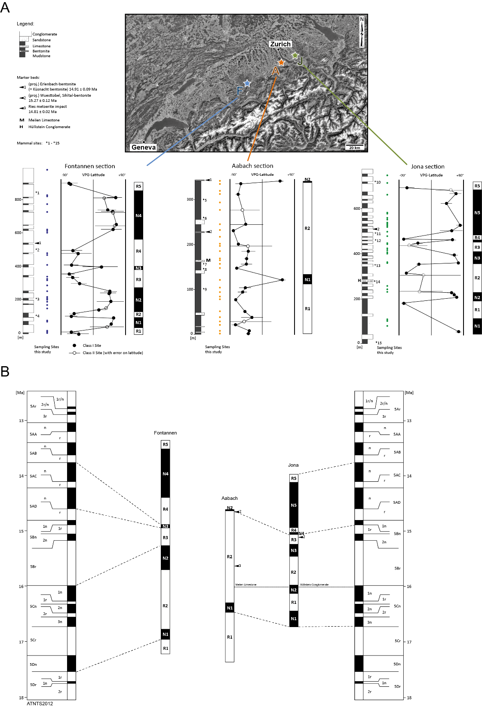
Figure S1: Pedogenic carbonate nodule ages of Swiss Molasse Basin sections were calculated based on local magnetostratigraphy. A) Local magnetostratigraphies, sampling locations of pedogenic carbonates and lithostratigraphies for each section. Magnetostratigraphies from (Kempf et al., 1997; Kempf and Matter, 1999; Schlunegger et al., 1996). Also shown are stratigraphic positions of marker beds and mammal sites (*¹ projected Oeschgraben (MN 6), *² Chatzloch (Frohberg, MN 5), *³ Vermes 1 (MN 5), *⁴ Tägermaustrasse (MN 4), *⁵ projected Hirschengrabentunnel (uppermost MN 5), *6 Tobelholz (middle/ upper MN 5), *7 Aabach 2 (middle MN 5), *8 Aabach 3 (middle MN 5), *9 Käpfnach-Rotwegstollen (middle MN5), *¹⁰ Bachtel-Ornberg (uppermost MN 6), *11 Frohberg (MN 5), *12 Tobel Hombrechtikon (upper MN 5), *13 Güntisberg (middle MN 5), *14 Martinsbrünneli (middle MN 5), *15 Hubertingen MN 4b). Mammal sites after (Kälin, 1997) and (Bolliger, 1992). B) Correlation of magnetostratigraphies with the astronomically tuned Neogene timescale ATNTS2012 after ((Hilgen et al., 2012).

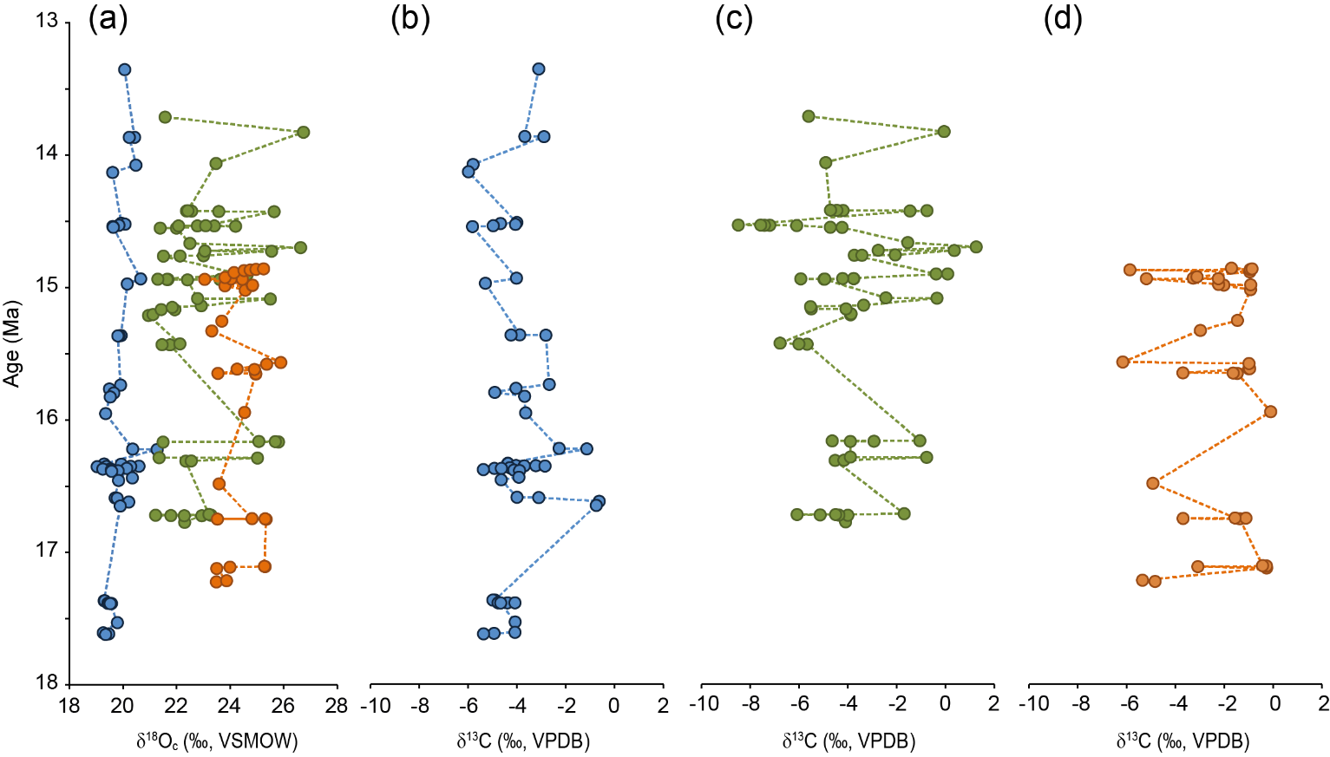
Figure S2: Pedogenic carbonate δ¹⁸O and δ¹³C values of the Swiss Molasse Basin sections plotted against their ages. We show only the mean value for each carbonate bearing horizon. A) δ¹⁸O values of the sections Fontannen (blue circles), Jona (green circles) and Aabach (orange circles). B–C) For purposes of visualization pedogenic carbonate δ¹³C values are shown separately for each section (B: Fontannen, C: Jona, and D: Aabach).

Figure S3: Pedogenic carbonate mean δ¹⁸O_{c} vs. δ¹³C values of the Swiss Molasse Basin sections (averaged per horizon, blue, green, and orange circles) for the time interval 15.5–14.0 Ma. Paleoelevation estimates are based on the first quartile (lowest 25%) mean δ¹⁸O_{c} values, which are highlighted in the same colour code, but with a black border. We also show values of individual nodules (grey circles, in total n=204 for all three sections). We link the positive covariance between δ¹⁸O_{c} and δ¹³C values to local environmental conditions prevailing during soil carbonate formation. A strong positive correlation is typically found in pedogenic carbonates formed during dry conditions, when soil water evaporation and water stress in plants are intensified. Such conditions can promote a bias to increased δ¹⁸O_{c} values, which would lead to an overestimation of the paleoelevation. We therefore rely only on the lowest 25% of averaged δ¹⁸O_{c} values for elevation calculation.

Site | Proxy | Sampling locations | Sample material | Study
Swiss Molasse Basin  (near sea-level site) | δ¹⁸O, δ¹³C | Fontannen section | Pedogenic carbonate nodules | Campani et al. (2012), complemented with additional samples
 | δ¹⁸O, δ¹³C | Jona section | Pedogenic carbonate nodules | This study
 | δ¹⁸O, δ¹³C | Aabach section | Pedogenic carbonate nodules | This study
 | T (Δ₄₇) | Fontannen section | Pedogenic carbonate nodules | Methner et al. (2020), recalibrated for this study
 | T (Δ₄₇) | Jona section | Pedogenic carbonate nodules | This study
 | T (Δ₄₇) | Aabach section | Pedogenic carbonate nodules | This study
Simplon Fault Zone  (high-Alpine site) | δD | Simplon Fault Zone | Phyllosilicates (muscovite, biotite, and chlorite) | Campani et al. (2012)

S6
Table 1: Samples from near sea-level and high-Alpine sites used for mid-Miocene paleoelevation reconstruction of the Central Alps.

S7

Data tables (δ¹⁸O, δ¹³C, Δ₄₇)
Data tables can be found in a separate EXCEL file accompanying this manuscript and supplementary information.

Table T1
Pedogenic carbonate oxygen (δ¹⁸O, VSMOW, ‰) and carbon (δ¹³C, VPDB, ‰) stable isotope values and calculated oxygen (δ¹⁸O_{w}, VSMOW, ‰) isotope values for meteoric (soil) water.

Table T2
Clumped isotope compositions (δ⁴⁷, Δ₄₇) for pedogenic carbonate samples, empirical transfer function (ETF) for the respective periods of application, and derived carbonate formation temperatures following Petersen et al. (2019).

Table T3
Measured δ⁴⁷ (‰) and Δ₄₇ (‰) values of CO₂ gases equilibrated at 1000°C (“heated gases”, “HG”) and at 25°C (“25G”) used for calculation of the empirical transfer function (ETF) for the respective periods of application.

Table T4
Δ₄₇ values (in ‰) for standard material listed for respective time intervals of clumped isotope measurements.

Table T5
Calculated paleoelevation differences Δz (m) between low-elevation Swiss Molasse Basin (SMB) sections Fontannen and Jona and high-elevation Simplon Fault Zone (SFZ) for the time interval 15.5 Ma–14.0 Ma.

References
Bajnai, D., Fiebig, J., Tomašových, A., Milner Garcia, S., Rollion-Bard, C., Raddatz, J., Löffler, N., Primo-Ramos, C. and Brand, U.: Assessing kinetic fractionation in brachiopod calcite using clumped isotopes, Sci. Rep., 8(1), 1–13, doi:10.1038/s41598-017-17353-7, 2018.
Bolliger, T.: Kleinsäugerstratigraphie in der Miozänen Hörnlischüttung (Ostschweiz)., Doc. naturae 75., 1–296, 1992.
Botsyun, S., Ehlers, T. A., Mutz, S. G., Methner, K., Krsnik, E. and Mulch, A.: Opportunities and Challenges for Paleoaltimetry in “Small” Orogens: Insights From the European Alps, Geophys. Res. Lett., 47(4), doi:10.1029/2019GL086046, 2020.
Burkhard, M. and Kalkreuth, W.: Coalification in the northern Wildhorn nappe and adjacent units, western Switzerland. Implications for tectonic burial hostories, , (1), 47–64, 1989.
Campani, M., Mulch, A., Kempf, O., Schlunegger, F. and Mancktelow, N.: Miocene paleotopography of the Central Alps, Earth Planet. Sci. Lett., 337–338, 174–185, doi:10.1016/j.epsl.2012.05.017, 2012.
Cederbom, C. E., van der Beek, P., Schlunegger, F., Sinclair, H. D. and Oncken, O.: Rapid extensive erosion of the North Alpine foreland basin at 5–4 Ma, Basin Res., 23(5), 528–550, doi:https://doi.org/10.1111/j.1365-2117.2011.00501.x, 2011.
Coplen, T. B.: Calibration of the calcite-water oxygen-isotope geothermometer at Devils Hole, Nevada, a natural laboratory, Geochim. Cosmochim. Acta, 71(16), 3948–3957, doi:10.1016/j.gca.2007.05.028, 2007.
Currie, B. S., Rowley, D. B. and Tabor, N. J.: Middle Miocene paleoaltimetry of southern Tibet: Implications for the role of mantle thickening and delamination in the Himalayan orogen, Geology, 33(3), 181–184, doi:10.1130/G21170.1, 2005.
Daëron, M., Blamart, D., Peral, M. and Affek, H. P.: Absolute isotopic abundance ratios and the accuracy of Δ47 measurements, Chem. Geol., 442(August), 83–96, doi:10.1016/j.chemgeo.2016.08.014, 2016.
Dennis, P. F., Vinen, S., Marca-bell, A. and Rowe, P. J.: MIRA: a new isotope ratio mass spectrometer for clumped isotope studies of CO2, , 1–25, 2013.
Eiler, J. M.: Paleoclimate reconstruction using carbonate clumped isotope thermometry, Quat. Sci. Rev., 30(25–26), 3575–3588, doi:10.1016/j.quascirev.2011.09.001, 2011.
Fiebig, J., Hofmann, S., Löffler, N., Lüdecke, T., Methner, K. and Wacker, U.: Slight pressure imbalances can affect accuracy and precision of dual inlet-based clumped isotope analysis, Isotopes Environ. Health Stud., 52(1–2), 12–28, doi:10.1080/10256016.2015.1010531, 2016.
Fiebig, J., Bajnai, D., Löffler, N., Methner, K., Krsnik, E., Mulch, A. and Hofmann, S.: Combined high-precision ∆48 and ∆47 analysis of carbonates, Chem. Geol., 522(February), 186–191, doi:10.1016/j.chemgeo.2019.05.019, 2019.
Gubler, T., Meier, M. and Oberli, F.: Bentonites as time markers for sedimentation of the Upper Freshwater Molasse: geological observations corroborated by high-resolution single-Zircon U-Pb ages., Jahresversammlung der Schweizerischen Akad. der Naturwissenschaften, (172), 12–13, 1992.
Henkes, G. A., Passey, B. H., Grossman, E. L., Shenton, B. J., Pérez-Huerta, A. and Yancey, T. E.: Temperature limits for preservation of primary calcite clumped isotope paleotemperatures, Geochim. Cosmochim. Acta, 139, 362–382, doi:10.1016/j.gca.2014.04.040, 2014.
Hilgen, F. J., Lourens, L. J., Van Dam, J. A., Beu, A. G., Boyes, A. F., Cooper, R. A., Krijgsman, W., Ogg, J. G., Piller, W. E. and Wilson, D. S.: The Neogene Period., 2012.
Kälin, D.: The Mammal zonation of the Upper Marine Molasse of Switzerland reconsidered. A local biozonation of MN 2-MN 5, Aguilar, J.-P., Legend. S., Michaux, J. (Eds.), Actes du Congre`s BiochroM’97. Me´m. Trav. E.P.H.E. Montpellier 21 BiochroM’97, 21(January 1997), 515–535, 1997.
Kälin, D. and Kempf, O.: High-resolution stratigraphy from the continental record of the Middle Miocene Northern Alpine Foreland Basin of Switzerland, Neues Jahrb. für Geol. und Paläontologie - Abhandlungen, 254(1), 177–235, doi:10.1127/0077-7749/2009/0010, 2009.
Kempf, O. and Matter, A.: Magnetostratigraphy and depositional history of the Upper Freshwater Molasse (OSM) of eastern Switzerland, Eclogae Geol. Helv., 92(1), 97–103, doi:10.5169/seals-168650, 1999.
Kempf, O., Bolliger, T., Kalin, D., Engesser, B., Matter, A., Moyen, I. A. and Avant, D. E. L.: New Magnetostratigraphic Calibration of Early to Middle Miocene Mammal Biozones of the North Alpine Foreland Basin, , 547–561, 1997.
Kim, S.-T. and O’Neil, J. R.: Equilibrium and nonequilibrium oxygen isotope effects in synthetic carbonates, Geochim. Cosmochim. Acta, 61(16), 3461–3475, 1997.
Kim, S. T., Mucci, A. and Taylor, B. E.: Phosphoric acid fractionation factors for calcite and aragonite between 25 and 75 °C: Revisited, Chem. Geol., 246(3–4), 135–146, doi:10.1016/j.chemgeo.2007.08.005, 2007.
Mazurek, M., Hurford, A. J. and Leu, W.: Unravelling the multi-stage burial history of the Swiss Molasse Basin: integration of apatite fission track, vitrinite reflectance and biomarker isomerisation analysis, Basin Res., 18(1), 27–50, doi:https://doi.org/10.1111/j.1365-2117.2006.00286.x, 2006.
Methner, K., Campani, M., Fiebig, J., Löffler, N., Kempf, O. and Mulch, A.: Middle Miocene long-term continental temperature change in and out of pace with marine climate records, Sci. Rep., 10(1), 1–10, doi:10.1038/s41598-020-64743-5, 2020.
Petersen, S. V., Defliese, W. F., Saenger, C., Daëron, M., Huntington, K. W., John, C. M., Kelson, J. R., Bernasconi, S. M., Colman, A. S., Kluge, T., Olack, G. A., Schauer, A. J., Bajnai, D., Bonifacie, M., Breitenbach, S. F. M., Fiebig, J., Fernandez, A. B., Henkes, G. A., Hodell, D., Katz, A., Kele, S., Lohmann, K. C., Passey, B. H., Peral, M. Y., Petrizzo, D. A., Rosenheim, B. E., Tripati, A., Venturelli, R., Young, E. D. and Winkelstern, I. Z.: Effects of Improved 17O Correction on Interlaboratory Agreement in Clumped Isotope Calibrations, Estimates of Mineral-Specific Offsets, and Temperature Dependence of Acid Digestion Fractionation, Geochemistry, Geophys. Geosystems, 20(7), 3495–3519, doi:10.1029/2018GC008127, 2019.
Poage, M. A. and Chamberlain, C. P.: Empirical relationships between elevation and the stable isotope composition of precipitation and surface waters: Considerations for studies of paleoelevation change, Am. J. Sci., 301(1), 1–15, 2001.
Quade, J., Leary, R., Dettinger, M. P., Orme, D., Krupa, A., Decelles, P. G., Kano, A., Kato, H., Waldrip, R., Huang, W. and Kapp, P.: Resetting Southern Tibet : The serious challenge of obtaining primary records of Paleoaltimetry, Glob. Planet. Change, 191(April), 103194, doi:10.1016/j.gloplacha.2020.103194, 2020.
Rowley, D. B. and Garzione, C. N.: Stable isotope-based paleoaltimetry, Annu. Rev. Earth Planet. Sci., 35(January), 463–508, doi:10.1146/annurev.earth.35.031306.140155, 2007.
Rowley, D. B., Pierrehumbert, R. T. and Currie, B. S.: A new approach to stable isotope-based paleoaltimetry: Implications for paleoaltimetry and paleohypsometry of the High Himalaya since the late Miocene, Earth Planet. Sci. Lett., 188(1–2), 253–268, doi:10.1016/S0012-821X(01)00324-7, 2001.
Rybach, L. and Bodmer, P.: Die geothermischen Verhältnisse der Schweizer Geotraverse im Abschnitt Basel-Luzern, Eclogae Geol. Helv., 73/2, 501–512, 1980.
Schegg, R.: Thermal maturity of the Swiss Molasse Basin : indications for paleogeothermal anomalies ? Thermal maturity ofthe Swiss Molasse Basin : Indications for paleogeothermal anomalies ? 1 ) By, 1992.
Schegg, R. and Leu, W.: Analysis of erosion events and palaeogeothermal gradients in the North Alpine Foreland Basin of Switzerland, Geol. Soc. Spec. Publ., 141, 137–155, doi:10.1144/GSL.SP.1998.141.01.09, 1998.
Schlunegger, F., Burbank, D. W., Matter, A., Engesser, B. and Mödden, C.: Magnetostratigraphic calibration of the Oligocence to Middle Miocene (30-15 Ma) mammal biozones and depositional sequences of the Swiss Molasse Basin, Eclogae Geol. Helv., 89(2), 753–788, doi:10.5169/seals-167923, 1996.
Schmieder, M., Kennedy, T., Jourdan, F., Buchner, E. and Reimold, W. U.: A high-precision 40Ar/39Ar age for the Nördlinger Ries impact crater, Germany, and implications for the accurate dating of terrestrial impact events, Geochim. Cosmochim. Acta, 220, 146–157, doi:https://doi.org/10.1016/j.gca.2017.09.036, 2018.
Wacker, U., Fiebig, J. and Schöne, B.: Clumped isotope analysis of carbonates: comparison of two different acid digestion techniques, Rapid Commun. Mass Spectrom., 27, 1631–1642, doi:10.1002/rcm.6609, 2013.
Wacker, U., Fiebig, J., Tödter, J., Schöne, B. R., Bahr, A., Friedrich, O., Tütken, T., Gischler, E. and Joachimski, M. M.: Empirical calibration of the clumped isotope paleothermometer using calcites of various origins, Geochim. Cosmochim. Acta, 141, 127–144, doi:10.1016/j.gca.2014.06.004, 2014.

