Journal of Vegetation Science
SUPPORTING INFORMATION
High species turnover and low intraspecific trait variation in plant species assemblages on an oceanic island
Dagmar M. Hanz¹, Mirela Beloiu², Raja Wipfler², Carl Beierkuhnlein^{2,3,4}, Richard Field⁵, Anke Jentsch^{3,6}, Ole R. Vetaas⁷ and Severin D.H. Irl^{1,3}
¹Biogeography and Biodiversity Lab, Institute of Physical Geography, Goethe University Frankfurt, Frankfurt, Germany
²Department of Biogeography, University of Bayreuth, Bayreuth, Germany
³BayCEER, Bayreuth Centre of Ecology and Environmental Research, University of Bayreuth, Bayreuth, Germany
⁴GIB Geographical Institute Bayreuth, Bayreuth, Germany
⁵University of Nottingham, School of Geography, University Park Campus, Nottingham NG7 2RD, England
⁶Department of Disturbance Ecology, University of Bayreuth, Bayreuth, Germany
⁷Department of Geography, University of Bergen, Bergen, Norway

Appendix S1. List of endemic and non-endemic species
Table S1.1 List of endemic and non-endemic species sampled in all plots (n = 44) at the coastal succulent scrub of La Palma, Canary Islands. For each species the number of plots it occured in and the number of measured individuals is given.
Family | Species | Floristic status | No.  plots | No. individuals
Agavaceae | Agave americana | non-endemic | 1 | 40
Apiaceae | Astydamia latifolia | non-endemic | 4 | 7
Asclepiadaceae | Periploca laevigata | non-endemic | 21 | 34
Asteraceae | Argyranthemum frutescens frutescens | endemic | 1 | 5
Asteraceae | Artemisia thuscula | endemic | 9 | 2
Asteraceae | Kleinia neriifolia | endemic | 33 | 5
Asteraceae | Pericallis papyraceae | endemic | 1 | 5
Asteraceae | Phagnalon saxatile | non-endemic | 3 | 34
Asteraceae | Phagnalon umbelliforme | endemic | 7 | 5
Asteraceae | Pulicaria viscosa | non-endemic | 1 | 8
Asteraceae | Reichardia ligulata | endemic | 2 | 53
Asteraceae | Schizogyne sericea | non-endemic | 20 | 7
Asteraceae | Tolpis santosii | endemic | 1 | 96
Boraginaceae | Ceballosia fruticosa fruticosa | endemic | 3 | 20
Boraginaceae | Echium brevirame | endemic | 24 | 22
Brassicaceae | Lobularia canariensis intermedia | endemic | 2 | 105
Brassicaceae | Lobularia maritima | non-endemic | 1 | 1
Cactaceae | Opuntia dillenii | non-endemic | 11 | 21
Cactaceae | Opuntia maxima | non-endemic | 9 | 12
Convollariaceae | Asparagus umbellatus | endemic | 1 | 5
Crassulaceae | Aeonium arboreum holochrysum | endemic | 10 | 8
Crassulaceae | Aeonium canariense christii | endemic | 3 | 147
Crassulaceae | Aeonium davidbramwellii | endemic | 8 | 90
Crassulaceae | Aeonium goochiae | endemic | 1 | 10
Crassulaceae | Aeonium hierrense | endemic | 1 | 16
Euphorbiaceae | Euphorbia balsamifera | non-endemic | 4 | 8
Euphorbiaceae | Euphorbia canariensis | endemic | 6 | 5
Euphorbiaceae | Euphorbia lamarckii broussonetii | endemic | 25 | 43
Fabaceae | Bituminaria bituminosa | non-endemic | 11 | 37
Fabaceae | Retama rhodorhizoides | endemic | 13 | 25
Frankeniaceae | Frankenia capitata | endemic | 5 | 1
Globulariaceae | Globularia salicina | non-endemic | 4 | 87
Hypericaceae | Hypericum canariense | non-endemic | 1 | 15
Lamiaceae | Lavandula canariensis | endemic | 24 | 27
Lamiaceae | Micromeria herpyllomorpha herpyllomorpha | endemic | 11 | 4
Oleaceae | Jasminum odoratissimum | non-endemic | 2 | 6
Plumbaginaceae | Limonium imbricatum | endemic | 2 | 32
Plumbaginaceae | Limonium pectinatum | endemic | 4 | 10
Polygonaceae | Rumex lunaria | endemic | 12 | 66
Rhamnaceae | Rhamnus crenulata | endemic | 4 | 24
Rubiaceae | Rubia fruticosa fruticosa | non-endemic | 18 | 3
Rutaceae | Ruta pinnata | endemic | 1 | 70
Zygophyllaceae | Fagonia cretica | non-endemic | 1 | 2

Appendix S2. Variation in traits of entire, endemic and non-endemic plant assemblages
Table S2.1 Pearson’s correlation coefficient between precipitation, heat load index, soil nitrogen, soil phosphorus and soil pH across plant assemblages (n = 44) along the coastal succulent scrub of La Palma, Canary Islands.
 | Precipitation | Heat load index | Soil nitrogen | Soil phosphorus | Soil pH
Heat load index | -0.607 | - | - | - | -
Soil nitrogen | 0.225 | -0.399 | - | - | -
Soil phosphorus | -0.184 | 0.174 | 0.209 | - | -
Soil pH | -0.590 | 0.344 | -0.424 | 0.210 | -
Species richness | 0.454 | -0.676 | 0.242 | -0.141 | -0.400

Table S2.2 Relative contribution of total variation in community-weighted mean trait values due to species turnover, intraspecific variation, and their covariation across a) endemic and b) non-endemic plant assemblages on La Palma, Canary Islands.
 | - Endemic |  |  |  | - Non-endemic
 | Plant height | Leaf area | Leaf thickness |  | Plant height | Leaf area | Leaf thickness
Intraspecific variation | 0.31 | 0.18 | 0.28 |  | 0.41 | 0.07 | 0.06
Species turnover | 0.46 | 0.98 | 0.81 |  | 0.33 | 0.81 | 0.89
Covariation | 0.23 | -0.17 | -0.09 |  | 0.27 | 0.12 | 0.05

Table S2.3 Small sample-size corrected Akaike Criterion (AICc) and explained variation (adjusted R²) of multiple regression models analysing the effect of precipitation, heat load index, soil nitrogen, soil phosphorus and soil pH on specific and fixed averages in a) plant height, b) leaf area and c) leaf thickness of entire, endemic and non-endemic plant assemblages along the coastal succulent scrub of La Palma, Canary Islands.
 | - Plant height |  |  |  |  |  |  | - Leaf area
Models | Entire |  | Endemic |  | Non-endemic |  |  | Entire |  | Endemic |  | Non-endemic
 | AICc | R² | AICc | R² | AICc | R² |  | AICc | R² | AICc | R² | AICc | R²
Specific average | 15.7 | 0.27 | 47.6 | 0.24 | 10.7 | 0.17 |  | 76.9 | 0.51 | 64.6 | 0.48 | 112.9 | 0.62
Fixed average | -31.0 | 0.18 | 9.0 | 0.14 | -33.0 | 0.14 |  | 73.0 | 0.41 | 69.1 | 0.23 | 113.6 | 0.58
 | - Leaf thickness
Models | Entire |  | Endemic |  | Non-endemic
 | AICc | R² | AICc | R² | AICc | R²
Specific average | 59.3 | 0.44 | 63.8 | 0.20 | 92.9 | 0.35
Fixed average | 49.4 | 0.49 | 64.6 | 0.19 | 88.6 | 0.36

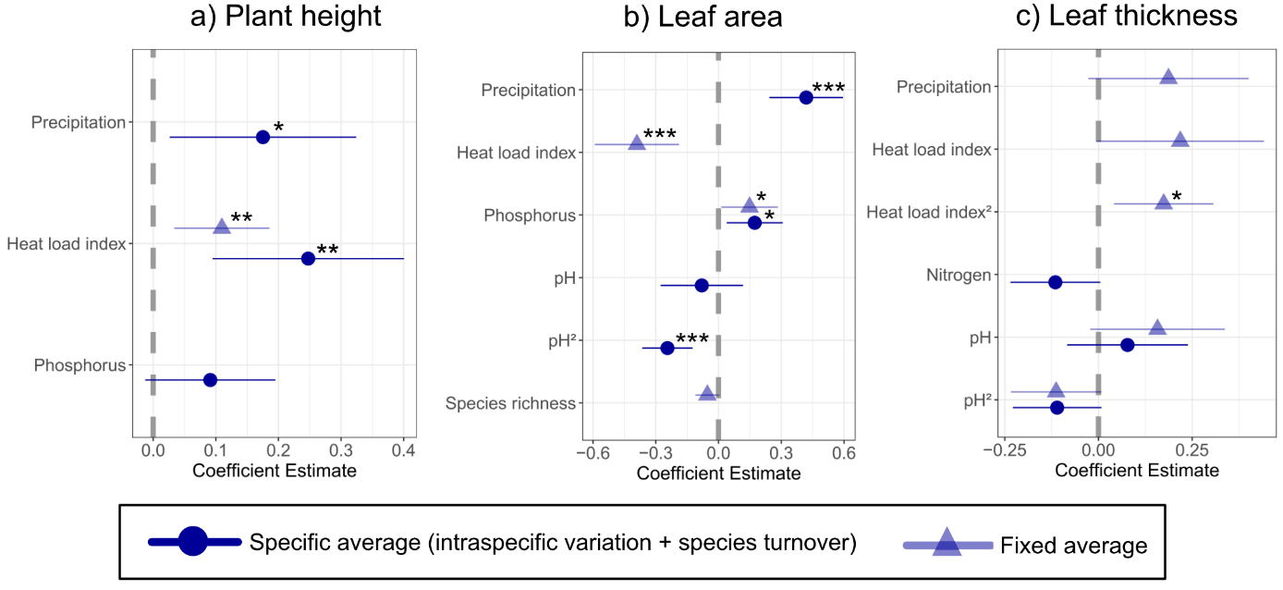
Figure S2.1 Multiple regression models of precipitation, heat load index, soil nitrogen, soil phosphorus and soil pH on specific averages and fixed averages of a) plant height, b) leaf area and c) leaf thickness in endemic plant assemblages (n = 44) at the coastal succulent scrub of La Palma, Canary Islands. Dark circles denote the specific averages (species turnover and intraspecific variation); light triangles denote fixed averages only. Standardized estimates are provided for each predictor. Error bars represent confidence intervals of the coefficient estimates. Asterisks denote statistical significance (*** p < 0.001; ** p < 0.01; * p < 0.05).
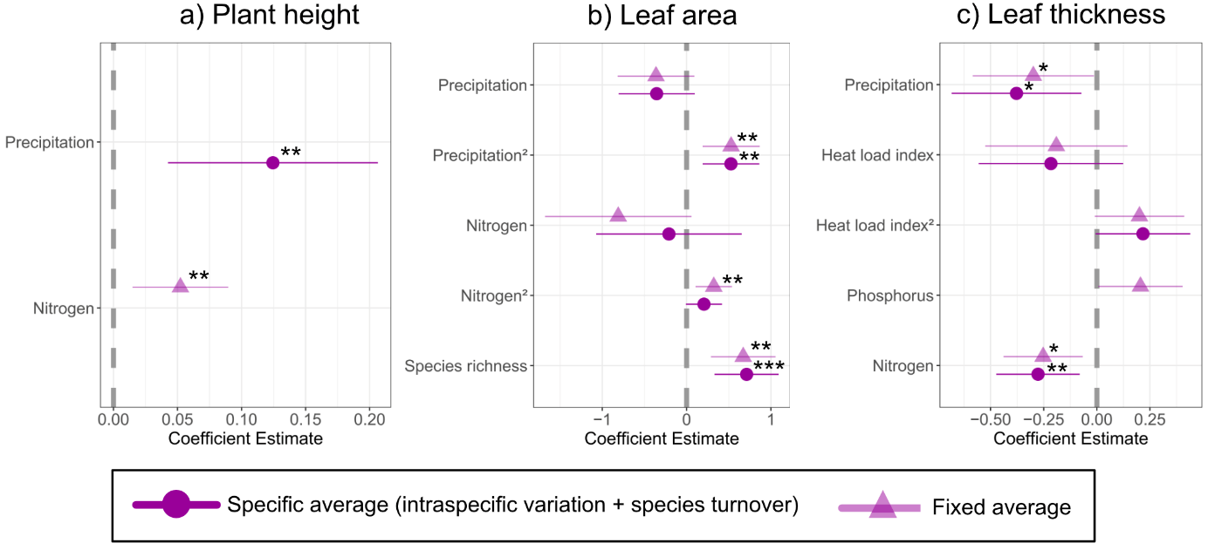
Figure S2.2 Multiple regression models of precipitation, heat load index, soil nitrogen, soil phosphorus and soil pH on specific averages and fixed averages of a) plant height, b) leaf area and c) leaf thickness in non-endemic plant assemblages (n = 44) at the coastal succulent scrub of La Palma, Canary Islands. Dark circles denote the specific averages (species turnover and intraspecific variation); light triangles denote fixed averages only. Standardized estimates are provided for each predictor. Error bars represent confidence intervals of the coefficient estimates. Asterisks denote statistical significance (*** p < 0.001; ** p < 0.01; * p < 0.05).

