Table S1 – List of the investigated samples. The mineral assemblage is shown in modal order. Mineral abbreviations after Siivola & Schmid (2007).
Sample | Classification | Latitude | Longitude | Assemblage | Accessories
SP304 | Quartz schist | 44° 4'16.45"N | 10° 7'40.69"E | Qtz, Wmca, Chl, Hem, Rt | Tur, Zrn, Ap
SP305 | Metaconglomerate | 44° 4'13.52"N | 10° 7'40.57"E | Qtz, Wmca, Cld, Hem, Rt | Tur, Zrn, Ap
SP306 | Schist | 44° 4'14.80"N | 10° 7'43.49"E | Qtz, Wmca, Chl, Kfs | Tur, Zrn, Ap
SP307 | Metabasite | 44° 4'14.60"N | 10° 7'45.29"E | Pl, Ep, Chl, Act, Qtz, Ttn | Op
SP308b | Cld schist | 44° 4'18.62"N | 10° 8'21.54"E | Qtz, Cld, Wmca (Ms + Pg), (Py), Gr, Rt | Tur, Zrn, Mnz, Ap
SP309 | Crenulated schist | 44° 4'15.54"N | 10° 8'3.94"E | Wmca, Qtz, Hem, Chl, Rt | Tur, Zrn, Ap
SP312 | Impure marble | 44° 3'51.83"N | 10° 8'20.92"E | Cb, Wmca, Qtz | Op
SP313 | Metabreccia | 44° 4'0.67"N | 10° 8'29.47"E | Qtz, Wmca, Hem, Ep | Tur, Zrn, Mnz, Ap
SP316 | Ky schist | 44° 3'30.66"N | 10° 8'29.80"E | Wmca, Ky, Qtz, Hem | Tur, Zrn, Ap
SP317 | Cld schist | 44° 4'3.62"N | 10° 8'57.60"E | Qtz, Cld, Wmca, Gr | Tur, Zrn, Ap
SP318 | Metabasite | 44° 3'56.15"N | 10° 7'53.69"E | Ep, Chl, Ttn, Act | Op
SP319 | Ky metabreccia | 44° 4'26.57"N | 10° 8'8.89"E | Qtz, Wmca (Ms, Pg), Ky, Cld, Hem, Rt, Prl | Tur, Zrn, Ap
SP319A | Metabreccia | 44° 4'27.66"N | 10° 8'8.21"E | Qtz, Wmca, Hem, Rt | Tur, Zrn, Ap
SP326 | Schist | 44° 4'20.07"N | 10° 9'0.42"E | Wmca, Qtz, Hem, Rt | Tur
SP327 | Metabasite | 44° 4'20.28"N | 10° 8'59.56"E | Qtz, Ep, Chl, Act, Ttn | Op
SP328 | Schist | 44° 4'20.75"N | 10° 8'59.79"E | Qtz, Wmca, Chl, Hem | Tur, Zrn, Ap
SP329 | Cld metasandstone | 44° 4'22.43"N | 10° 8'57.31"E | Wmca (Ms, Pg), Qtz, Cld, Hem, Rt | Tur, Zrn, Ap
SP332 | Cld schist | 44° 4'23.70"N | 10° 8'32.91"E | Cld, Wmca (Ms), Chl, Qtz, Hem, Rt, Ep | Aln, Tur, Zrn, Ap
SP337 | Cld metasandstone | 44° 3'52.51"N | 10° 9'38.89"E | Cld, Wmca, Qtz, Hem, Rt | Tur, Zrn, Ap
SP338 | Cld metasandstone | 44° 3'51.95"N | 10° 9'57.03"E | Cld, Qtz, Wmca, Hem, Rt | Tur, Zrn, Ap
SP339 | Cld metasandstone | 44° 3'47.98"N | 10°10'4.54"E | Qtz, Wmca, Cld, Hem, Rt | Tur, Zrn, Ap
SP340 | Schist | 44° 1'22.27"N | 10°12'15.58"E | Wmca, Qtz, Chl, Hem, Rt | Tur, Zrn, Ap
SP342 | Metabreccia | 44° 1'13.79"N | 10°12'6.82"E | Wmca, Qtz, Hem, Tur, Py, Rt | Zrn, Ap

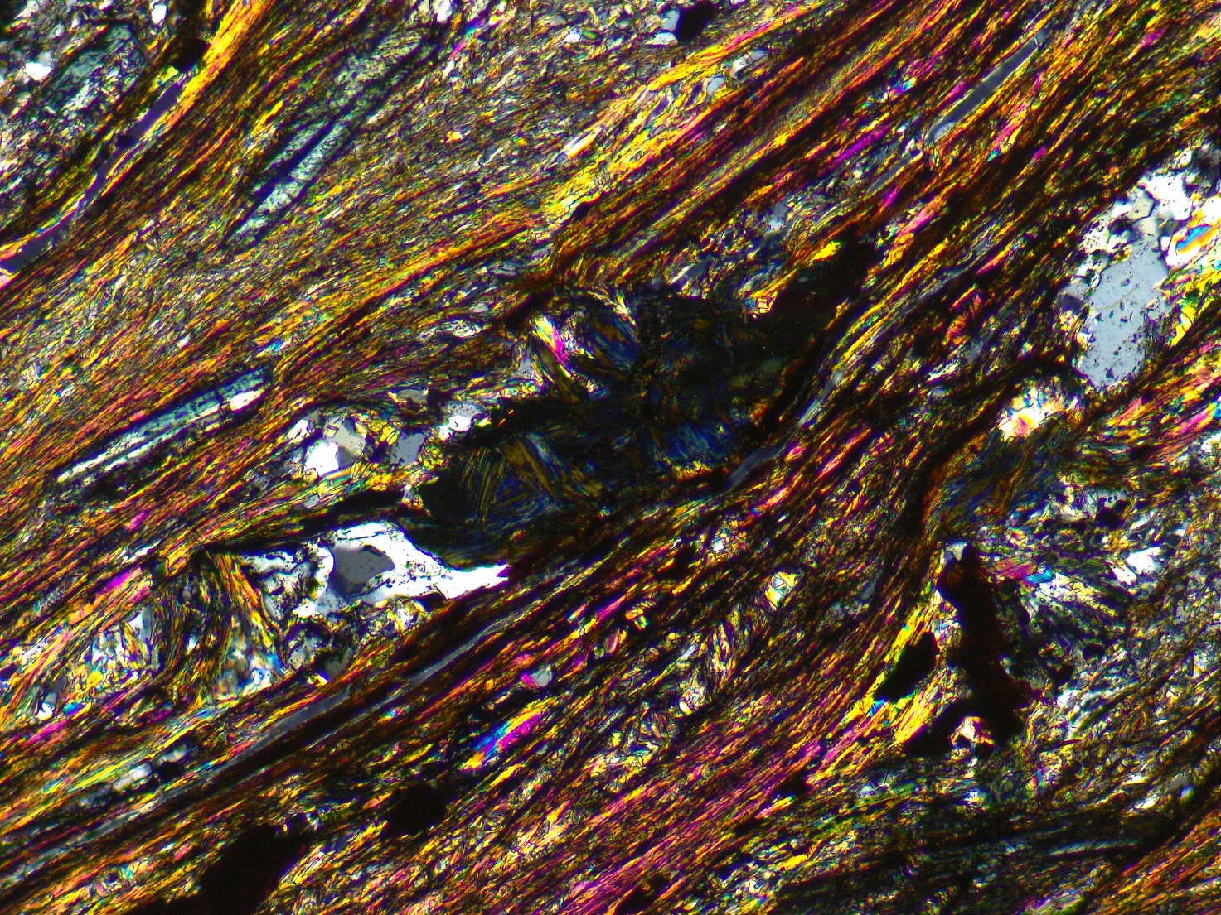
Figure S1 – Masses of chlorite (deep Berlin blue colors, mostly at the center of the image) in the chloritoid + graphite schist sample. These are often present as masses or as pseudomorphs over chloritoid, indicating that they formed as an alteration or retrograde product. Field of view: 3 mm.

List of mineral abbreviations
This section provides a list of the mineral abbreviations used in the text and figures (after Siivola & Schmid, 2007).
Ab: albite
Act: actinolite
Aln: allanite
And: andalusite
Ap: apatite
Bt: biotite
Chl: chlorite
Cld: chloritoid
Cph: carpholite
Dsp: diaspore
Ep: epidote
Fsp: feldspar
Gln: glaucophane
Gr: graphite
Grt: garnet
Hem: hematite
Ilm: ilmenite
Jd: jadeite
Ky: kyanite
Lws: lawsonite
Mag: magnetite
Mnz: monazite
Mrg: margarite/Ca-white mica
Ms: muscovite/K-white mica
Op: opaque minerals * note: this abbreviation is used only for samples whose opaques were not identified
Pg: paragonite/Na-white mica
Pl: plagioclase
Prl: pyrophyllite
Py: pyrite
Qtz: quartz
Rt: rutile
Sil: sillimanite
St: staurolite
Stp: stilpnomelane
Ttn: titanite
Tur: tourmaline
Wmca: white mica (comprises K-white mica/muscovite and Na-white mica/paragonite)
Zrn: zircon

