Geochemistry, Geophysics, Geosystems
Supporting Information for
Fluid-mediated Mass Transfer between Mafic and Ultramafic rocks in Subduction Zones
E. A. Codillo^{*1,3}, F. Klein², B. Dragovic⁴, H. R. Marschall^{3,5}, E. Baxter⁶, M. Scambelluri⁷, E. Schwarzenbach‬⁸
¹Massachusetts Institute of Technology-Woods Hole Oceanographic Institution Joint Program in Oceanography/Applied Ocean Science and Engineering, Woods Hole, Massachusetts 02543, USA, ²Department of Marine Chemistry and Geochemistry, Woods Hole Oceanographic Institution, 266 Woods Hole Road, Woods Hole Massachusetts 02543, USA, ³Department of Geology and Geophysics, Woods Hole Oceanographic Institution, 266 Woods Hole Road, Woods Hole Massachusetts 02543, USA, ⁴School of the Earth, Ocean & Environment, University of South Carolina, Columbia, SC 29208, USA, ⁵Institut für Geowissenschaften, Goethe Universität Frankfurt, Altenhöferalle 1, 60438 Frankfurt am Main, Germany, ⁶Department of Earth and Environmental Sciences, Boston College, Chestnut Hill, Massachusetts 02467, USA, ⁷Department of Earth Sciences, University of Genova, Corso Europa 26, 16132 Genova, Italy, ⁸Institut für Geologische Wissenschaften, Freie Universität Berlin, Malteserstr. 74–100, 12249 Berlin, Germany

Contents of this file
Methods with references
Mineralogy, geochemistry, and petrophysical properties
Phase equilibria and reaction-path modeling
Mass-balance calculations
Figures S1 to S10

Additional Supporting Information
Table S1. Bulk-rock major, trace elements, and Sr isotope compositions, and petrophysical properties.
Table S2. Thermal analysis of representative samples from each zone measured by TGA-DSC.
Table S3. Representative garnet core and rim compositions in each zone measured by EPMA
Table S4. Representative garnet rim-to-rim compositions along line transects measured by EPMA.
Table S5. Composition of amphiboles determined by EPMA.
Table S6. Composition of clinopyroxene determined by EPMA.
Table S7. Composition of chlorite determined by EPMA.
Table S8. Composition of epidote determined by EPMA.
Table S9. Compositions of serpentine and talc determined by EPMA.
Table S10. Compositions of ilmenite and titanite determined by EPMA.
Table S11. Modal mineralogy of representative simple rock-types used in the reaction-path modelling.

Methods
Mineralogy, geochemistry, and petrophysical properties
Samples were inspected in transmitted and reflected light using a Zeiss AxioImager 2 microscope, with mineral identification complemented by scanning electron microscopy, confocal Raman spectroscopy, and electron microprobe analyses (EPMA). Bulk-rock LOI translates to bulk H₂O from TG-DSC measurements (Figure S2-S3; Supplementary Table).
Analyses were performed at Woods Hole Oceanographic Institution (Woods Hole, MA) unless noted otherwise. Raman spectroscopy was carried out using a Horiba LabRam HR confocal Raman microscopy system. Analyses were conducted using a 100x objective with a numerical aperture of 0.9, a blue laser with a wavelength of 473 nm, and a 100 µm confocal hole diameter. The lateral spatial resolution was approximately 1 µm. We chose a grating with 600 grooves per mm and a slit size of 100 µm for most analyses. Raman spectra were collected between 100–2200 cm⁻¹ (5 s and five accumulations for most analyses) for most silicate phases, and 3500–3800 cm⁻¹ for serpentine minerals (10 s and five accumulations). The collected spectra were processed with the LabSpec 6 software for background subtraction and were compared with reference spectra (Downs, 2006; Lafuente et al., 2015; Petriglieri et al., 2015).
Compositions of minerals were determined using a JEOL JXA-8200 SuperProbe (Massachusetts Institute of Technology) and a JEOL-JXA-8530F ‘HyperProbe’ field-emission (Yale University) electron probe microanalyzer. Analyses were performed using a 15 kV accelerating voltage and a 10 nA beam current. The beam was fully focused for nominally-anhydrous minerals and defocused to 10 μm diameter for hydrous minerals. Data reduction was done using the CITZAF package. Counting times were 40 seconds on peak, and 20 seconds on background except for Na, which was analyzed first for 10 seconds on peak and 5 seconds on background. All the minerals (i.e. silicates, oxides, sulfides) were quantified using natural silicate and oxide standards.
To constrain mineral abundances on a thin section scale, mineral distribution maps were constructed on whole thin sections using a Zeiss Gemini Sigma 300VP Scanning Electron microscope (SEM) with a silicon drift detector (SDD) Bruker Qantax XFlash 6|60 and the mineralogic software from Zeiss at the Freie Universität Berlin. The measurements were carried out at an acceleration voltage of 20 kV, an aperture size of 120 µm and a dwell time of 0.008 s at a pixel size of 0.5 µm². Average counts per pixel were on the order of 5000-6000 counts and the mineral evaluation was performed after EMP analyses on the same samples.
The bulk-rock concentrations of the collected samples were analyzed using X-ray fluorescence (XRF) for major elements and inductively coupled plasma mass spectrometry (ICP-MS) technique for trace elements at GeoAnalytical Laboratory at Washington State University (Pullman, WA) following established procedures (Johnson et al., 1999). The bulk-rock Fe(III) /Fe_{T} (i.e. Fe_{T} = Fe(II) + Fe(III)) was determined by mass balance from Fe_{T} contents measured using XRF and acid titration of Fe(II) conducted at Activation Laboratories (Ancaster, Canada) following standard protocols (Wilson, 1955). Bulk-rock Sr isotope measurements were performed on selected samples using an IsotopX Phoenix thermal ionization mass spectrometer (TIMS) at Boston College (Boston, MA) following the protocols of Baxter and DePaolo (2002). The bulk-rock Rb concentrations were taken from the trace element measurements at WSU. An age correction of 40 Ma (Starr et al., 2020) was applied.
To determine the individual contribution of each hydrous phase to the bulk-rock volatile budget, we performed simultaneous thermogravimetric analysis (TGA) and differential scanning calorimetry (DSC) of rock powders using a TA Instruments SDT Q600 instrument. Approximately 20–40 mg of homogenous rock powder was heated in N₂ gas atmosphere at a rate of 10°C/min from 50 to 1100°C and a flow rate of 50 ml/min to determine the mass loss and heat flow, both of which reflect the formation and/or breakdown of specific minerals during heating. The skeletal density (pre-dried at 105 °C for 24 h) of samples was determined using helium-pycnometry (Micromeritics AccuPyc II). The magnetic susceptibility (K) was measured using a Bartington MS2B sensor with a Bartington MS2 magnetic susceptibility meter.

Phase equilibria and reaction-path modeling
In order to provide constraints on the pressure and temperature conditions of mass transfer and rock hybridization, equilibrium thermodynamic modeling of representative bulk compositions was performed. P-T pseudosections were computed using the program Perple_X (version 6.9.0; Connolly, 2009) and the internally consistent dataset (db5.5; 2003) of Holland and Powell (1998) in the MnO-Na₂O-CaO-FeO-MgO-Al₂O₃-SiO₂-H₂O-TiO₂-O₂ (MnNCFMASHTO) chemical system. Activity-composition models were used for the following phases: feldspar (Holland and Powell, 2003), spinel (White et al., 2002) , chlorite, garnet, epidote and chloritoid (Holland and Powell, 1998), clinopyroxene (Green et al., 2007), white mica (Coggon and Holland, 2002), and amphibole (Diener and Powell, 2012) . Quartz, lawsonite, rutile and titanite were assumed to be pure (stoichiometric) phases. The fluid phase was assumed to be pure H₂O. As the whole rock water content can have a control on the mineral assemblage, T-M_{H2O} pseudosections were calculated. For all metagabbroic samples, the observed LOI content provided unrealistic mineral assemblages and P-T stabilities, e.g. garnet is calculated to be stable at unrealistically low pressure and temperatures (~300 °C and ~0.5 GPa). Additionally, for the distal Fe-Ti gabbroic lithologies, it is likely that during prograde metamorphism and isothermal decompression, some degree of dehydration occurred. As such, we assumed water to be in excess. The measured whole rock chemistries of samples B06 (Zone IV) and B10 (Zone V) were utilized for modeling the prograde to peak portion of the P-T evolution (i.e. the P-T conditions of garnet growth initiation, where appropriate). Use of the whole rock chemistry in determining the peak P-T conditions was deemed inappropriate, given the high abundance (up to 20% by volume) of chemically zoned garnet porphyroblasts (Lanari and Engi, 2017), and as such, the matrix chemistry was used. The matrix compositions for these samples were calculated by subtracting volumetrically-average garnet compositions (determined by EPMA traverse), at volume abundances of ~15 and 10% (inferred by SEM mineral maps), respectively, from the whole rock composition. For the matrix compositions, phase equilibria were calculated in the Na₂O-CaO-FeO-MgO-Al₂O₃-SiO₂-H₂O-TiO₂-O₂ (NCFMASHTO) chemical system, assuming all MnO was sequestered to form garnet. The Fe₂O₃ contents for the whole rock compositions were taken from the Fe titration results, and are taken to be maximum values for Fe³⁺/Fe_{total}. The Fe₂O₃ contents used for the P-T pseudosection calculations were further constrained by estimation using T-M_{Fe2O3} pseudosections. Finally, representative compositions from Zones I (sample B13) and III (samples B01 and B03) were modelled, using the same parameters above (where appropriate) and coupled with petrographic observations and SEM mineral maps (where applicable), to determine the portion of the inferred P-T path (i.e. peak to post-peak) at which these lithologies last equilibrated.
In addition, thermodynamic reaction-path models were set up to assess the alteration history and concomitant mineralogical changes during a fluid-mediated reaction between hydrated ultramafic (serpentinites) and metamorphosed crustal rocks at subduction zone conditions. Along with P-T constraints from equilibrium pseudosection and garnet isopleth models, results of reaction-path models were compared with mineral assemblages from petrographic observations. Models were calculated using the EQ3/6 software package (Wolery, 1992) with the Deep Earth Water Model (DEW) database containing equilibrium constants of reactions involving minerals and aqueous species (Huang and Sverjensky, 2019; Sverjensky, 2019). We used equation of state for water of Zhang and Duan (2005), and the dielectric constant from Sverjensky et al. (2014).Thermodynamic calculations were performed over a range of P-T conditions (i.e. bracketing the prograde-peak-retrograde P-T conditions) and a range of fluid-to-rock (f/r) ratios. Activity coefficients were calculated using the B-dot equation (Helgeson, 1969). Minerals with solid-solutions such as olivine (forsterite-fayalite), garnet (pyrope-almandine-grossular), clinopyroxene (diopside-hedenbergite-jadeite), calcic amphibole (tremolite-ferrotremolite), and chlorite (clinochlore-chamosite) are included in the database. Solid solutions for some minerals present in the studied samples (e.g., serpentine, Na-Ca amphibole) have not been implemented in the database yet. Similarly, ilmenite, rutile, and titanite are present in the studied samples but are not implemented in the current thermodynamic database. We suppressed periclase to account for metastable mineral equilibria. In a first modelling step, an aqueous fluid was allowed to equilibrate with a serpentinite assemblage (i.e. antigorite + diopside clinopyroxene (Cpx) + magnetite ± brucite) using EQ3. This is an iterative process where in every calculation, the predicted fluid composition is checked if it is saturated with only serpentinite assemblage only. In cases where the predicted fluid composition is saturated with other minerals other than the desired serpentinite assemblage, the pH is slightly modified until the fluid becomes saturated with only the serpentinite assemblage. Note that we do not model the serpentinization of a peridotite. Rather, we calculated the composition of an aqueous fluid buffered by serpentinite assemblage. The oxygen fugacity of the fluid (fO₂) is set to values within the redox stability of magnetite that are bound by the hematite-magnetite buffer (HM) and quartz-fayalite-magnetite buffer (QFM). Because serpentinite of Zone I does not contain clinopyroxene, we evaluated possible effects of clinopyroxene on the fluid composition over a range of temperatures. The models predict that the presence of clinopyroxene in serpentinite does not significantly affect the concentrations of dissolve Mg, Si, and Ca when compared with clinopyroxene-free serpentinite. Since the current thermodynamic database does not allow for Fe speciation in serpentine mineral, the reducing capacity of serpentinites is diminished and hematite is favored to saturate. This renders the predicted oxygen fugacity and hydrogen concentration of equilibrium pore fluids uncertain. Since hematite is not observed in the studied rock samples, we suppressed hematite in the models. This model setup is consistent with the presence of magnetite in the studied serpentinites. Subsequently, once the fluid is saturated with only the desired serpentinite assemblage, the fluid was allowed to react with either a model oxide gabbro similar to the ones reported in Voltri Massif (Tribuzio et al., 1996) or an eclogite (representative of eclogitic metagabbro in Zone V; Figure S6). The starting compositions of the model oxide gabbro and eclogite are summarized in Table S10. For comparison, the oxide gabbro has relatively higher SiO₂, Al₂O₃, and CaO, but has lower FeO* concentrations than the eclogite. The fluid-rock interaction simulation is performed under isothermal and isobaric conditions at varying fluid-to-rock mass ratios (f/r). The gabbro-fluid model explores the possibility that fluid-mediated mass transfer occurred during prograde to peak metamorphism, modifying the bulk composition of each zone, before reaching peak eclogite-facies metamorphism and post-peak retrograde conditions. In comparison, the eclogite-fluid model explores the possibility that the fluid-mediated mass transfer only occurred at post-peak eclogite-facies and retrograde conditions. In each simulation, fluids that are equilibrated with serpentinite are titrated with 1 kg of gabbro/eclogite under isobaric and isothermal conditions. The fluid-to-rock mass ratio (f/r) decreases with increasing reaction progress (ξ). Importantly, we implemented titration models which can be used to assess heterogeneous phase equilibria in an advective system (e.g., fluid percolation and reaction along a high permeability pathway such as veins or lithologic boundaries) and in a diffusive system (e.g., fluid-mediated diffusive transfer at the boundary of a crustal rock and serpentinite, where the fluid composition is buffered by the rock) (Bach and Klein, 2009). Despite the simplifications and limitations in the modeling approach, the reaction-path models can simulate the evolving fluid-rock equilibria starting from the serpentinites towards the serpentinite-metagabbro contact and into the metagabbro/eclogite interior with increasing ξ (equivalent to decreasing f/r ratios).

Mass-balance calculations
To quantify chemical and mass changes associated with the formation of metasomatic reaction zones between serpentinite and metagabbro, quantitative mass balance calculations were performed (Gresens, 1967). We utilized the major element composition of the most distal eclogitic metagabbro (B10 in Zone V) as a basis to compute chemical and mass changes of subsequently more reacted rocks in Zones II to IV. We focused on the changes in the metagabbro side because of the lack of significant modal and chemical changes in the serpentine domain (Zone I). We adopted a method that utilizes an immobile element as a geochemical reference frame as it allows for the evaluation of rock mass and individual element changes (Ague and van Haren, 1996; Ague, 2017; Ague and Nicolescu, 2014; Grant, 1986; Penniston-Dorland and Ferry, 2008). Mobility of most major and trace elements during high-pressure metamorphism and metasomatism have been documented in exhumed high pressure rocks (Ague, 2017). In this study, scandium displays generally constant bulk-rock composition across the metagabbro, except for sample B12 (Figure. 6b). It is likely that the analyzed B12 sample contained very little oxide phase that likely host the bulk of Sc. However, the lack of a thin section for this sample preludes further scrutiny. The fluid immobility of Sc makes it an ideal candidate as a reference element. Uranium and Th also display fluid immobility and can be used as reference elements (Ague, 2017). We selected Sc as the geochemical reference frame over U and Th because of the larger analytical uncertainties associated with the very low abundances of U and Th in these rocks. In addition, the good agreement between the bulk-rock Sc concentrations measured by XRF and solution ICP-MS gives further confidence on the reliability of our Sc concentrations. For comparison, using Th as the reference element gave similar trends of enrichment and depletion of major elements as with Sc but the quantitative estimates of gains and losses using Th were systematically larger. We only assessed the chemical changes of major elements after illustrating that the rare-earth element (REE) concentration of the most distal samples may already have been modified during prograde subduction (see section 4.2). When mass balance calculations are performed for REE, the strong LREE depletion in distal Zone V samples would artificially lead to unrealistic chemical changes in LREE (> 1000 %) in the more reacted samples.
In our studied transect, Zone II and III experienced significant gains in Mg, LOI, Ni, losses in Ca, and variable changes in Si, Al, and Fe. Zone IV experienced significant gains in Ca without significant changes in other elements. Elemental changes in Si, Al, and Fe are variable across zones II, III and IV (Figure S9). Accounting for thickness of each zone and rock densities, the total mass of element that was gained or lost for each zone can be calculated. The results show that for the most dominant and characteristic chemical changes, Zone II and III gained ~110 kg/m² MgO and ~51 kg/m² H₂O, and lost ~12 kg/m² CaO. In addition, calculations show that Zone IV gained ~104 kg/m² CaO and ~17 kg/m² MgO.

References
Ague, J., van Haren, J., 1996. Assessing metasomatic mass and volume changes using the bootstrap, with application to deep crustal hydrothermal alteration of marble. Economic Geology 91, 1169–1182. https://doi.org/10.2113/gsecongeo.91.7.1169
Ague, J.J., 2017. Element mobility during regional metamorphism in crustal and subduction zone environments with a focus on the rare earth elements (REE). American Mineralogist 102, 1796–1821. https://doi.org/10.2138/am-2017-6130
Ague, J.J., Nicolescu, S., 2014. Carbon dioxide released from subduction zones by fluid-mediated reactions. Nature Geoscience 7, 355.
Bach, W., Klein, F., 2009. The petrology of seafloor rodingites: Insights from geochemical reaction path modeling. Lithos 112, 103–117. https://doi.org/10.1016/j.lithos.2008.10.022
Baxter, E.F., DePaolo, D.J., 2002. Field measurement of high temperature bulk reaction rates II: Interpretation of results from a field site near Simplon Pass, Switzerland. American Journal of Science 302, 465–516. https://doi.org/10.2475/ajs.302.6.465
Coggon, R., Holland, T.J.B., 2002. Mixing properties of phengitic micas and revised garnet-phengite thermobarometers. Journal of Metamorphic Geology 20, 683–696. https://doi.org/10.1046/j.1525-1314.2002.00395.x
Connolly, J.A.D., 2009. The geodynamic equation of state: What and how. Geochemistry, Geophysics, Geosystems 10. https://doi.org/10.1029/2009GC002540
Diener, J.F.A., Powell, R., 2012. Revised activity–composition models for clinopyroxene and amphibole. Journal of Metamorphic Geology 30, 131–142. https://doi.org/10.1111/j.1525-1314.2011.00959.x
Downs, R.T., 2006. The RRUFF Project: an integrated study of the chemistry, crystallography, Raman and infrared spectroscopy of minerals. Program and Abstracts of the 19th General Meeting of the International Mineralogical Association in Kobe, Japan. https://doi.org/O03-13
Grant, J.A., 1986. The isocon diagram; a simple solution to Gresens’ equation for metasomatic alteration. Economic Geology 81, 1976–1982. https://doi.org/10.2113/gsecongeo.81.8.1976
Green, E., Holland, T., Powell, R., 2007. An order-disorder model for omphacitic pyroxenes in the system jadeite-diopside-hedenbergite-acmite, with applications to eclogitic rocks. American Mineralogist 92, 1181–1189. https://doi.org/10.2138/am.2007.2401
Gresens, R.L., 1967. Composition-volume relationships of metasomatism. Chemical Geology 2, 47–65. https://doi.org/10.1016/0009-2541(67)90004-6
Helgeson, H.C., 1969. Thermodynamics of hydrothermal systems at elevated temperatures and pressures. Am J Sci 267, 729. https://doi.org/10.2475/ajs.267.7.729
Holland, T., Powell, R., 2003. Activity–composition relations for phases in petrological calculations: an asymmetric multicomponent formulation. Contributions to Mineralogy and Petrology 145, 492–501. https://doi.org/10.1007/s00410-003-0464-z
Holland, T.J.B., Powell, R., 1998. An internally consistent thermodynamic data set for phases of petrological interest. Journal of Metamorphic Geology 16, 309–343. https://doi.org/10.1111/j.1525-1314.1998.00140.x
Huang, F., Sverjensky, D.A., 2019. Extended Deep Earth Water Model for predicting major element mantle metasomatism. Geochimica et Cosmochimica Acta 254, 192–230. https://doi.org/10.1016/j.gca.2019.03.027
Lafuente, B., Downs, R.T., Yang, H., Stone, N., 2015. Highlights in Mineralogical Crystallography, in: Armbruster, T., Danisi, R.M. (Eds.), . De Gruyter (O), pp. 1–30. https://doi.org/10.1515/9783110417104-003
Lanari, P., Engi, M., 2017. Local Bulk Composition Effects on Metamorphic Mineral Assemblages. Reviews in Mineralogy and Geochemistry 83, 55–102. https://doi.org/10.2138/rmg.2017.83.3
McDonough, W.F., Sun, S. -s., 1995. The composition of the Earth. Chemical Geology 120, 223–253. https://doi.org/10.1016/0009-2541(94)00140-4
Penniston-Dorland, S.C., Ferry, J.M., 2008. Element mobility and scale of mass transport in the formation of quartz veins during regional metamorphism of the Waits River Formation, east-central Vermont. American Mineralogist 93, 7–21. https://doi.org/10.2138/am.2008.2461
Petriglieri, J.R., Salvioli-Mariani, E., Mantovani, L., Tribaudino, M., Lottici, P.P., Laporte-Magoni, C., Bersani, D., 2015. Micro-Raman mapping of the polymorphs of serpentine. Journal of Raman Spectroscopy 46, 953–958. https://doi.org/10.1002/jrs.4695
Starr, P.G., Broadwell, K.S., Dragovic, B., Scambelluri, M., Haws, A.A., Caddick, M.J., Smye, A.J., Baxter, E.F., 2020. The subduction and exhumation history of the Voltri Ophiolite, Italy: Evaluating exhumation mechanisms for high-pressure metamorphic massifs. Lithos 376–377, 105767. https://doi.org/10.1016/j.lithos.2020.105767
Sverjensky, D.A., 2019. Thermodynamic modelling of fluids from surficial to mantle conditions. Journal of the Geological Society 176, 348. https://doi.org/10.1144/jgs2018-105
Sverjensky, D.A., Harrison, B., Azzolini, D., 2014. Water in the deep Earth: The dielectric constant and the solubilities of quartz and corundum to 60kb and 1200°C. Geochimica et Cosmochimica Acta 129, 125–145. https://doi.org/10.1016/j.gca.2013.12.019
Tribuzio, R., Messiga, B., Vannucci, R., Bottazzi, P., 1996. Rare earth element redistribution during high-pressure–low-temperature metamorphism in ophiolitic Fe-gabbros (Liguria, northwestern Italy): Implications for light REE mobility in subduction zones. Geology 24, 711–714. https://doi.org/10.1130/0091-7613(1996)024<0711:REERDH>2.3.CO;2
White, R.W., Powell, R., Clarke, G.L., 2002. The interpretation of reaction textures in Fe-rich metapelitic granulites of the Musgrave Block, central Australia: constraints from mineral equilibria calculations in the system K2O–FeO–MgO–Al2O3–SiO2–H2O–TiO2–Fe2O3. Journal of Metamorphic Geology 20, 41–55. https://doi.org/10.1046/j.0263-4929.2001.00349.x
Wolery, T.J., 1992. EQ3/6, a software package for geochemical modeling of aqueous systems: Package overview and installation guide (Version 7.0). United States. https://doi.org/10.2172/138894
Zhang, Z., Duan, Z., 2005. Prediction of the PVT properties of water over wide range of temperatures and pressures from molecular dynamics simulation. Physics of the Earth and Planetary Interiors 149, 335–354. https://doi.org/10.1016/j.pepi.2004.11.003

SUPPLEMENTARY FIGURES
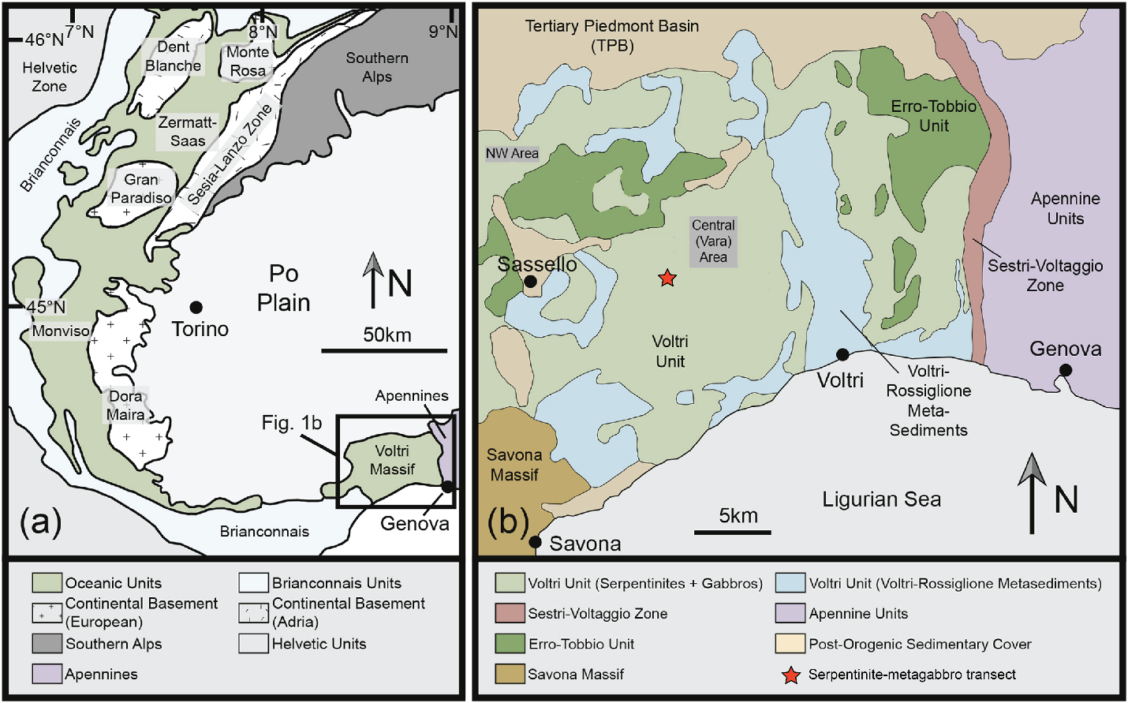

Figure S1. Geological maps of the Western Alps and the Voltri Massif modified from Starr et al. (2020). (a) Simplified geological map of the Western Alps, showing the broad distribution of oceanic rocks, continental massifs, and sedimentary units. The black box outlines the area shown in Figure. 1b. (b) Geologic map of the study area. The location of the studied serpentinite-metagabbro transect is indicated by red star.

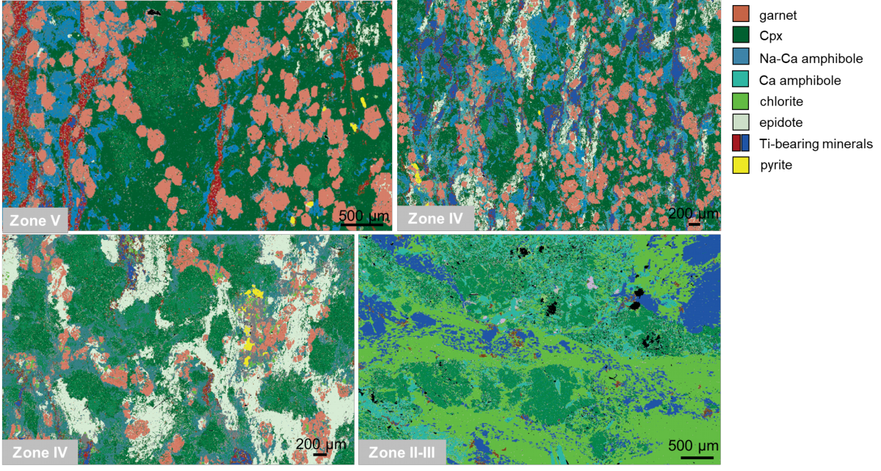

Figure S2. Representative thin-section EDS chemical maps of the different metasomatic reaction zones.

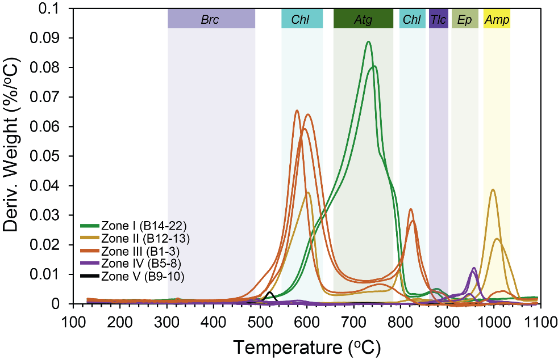

Figure S3. Thermal analysis of representative samples from each zone. First derivative (deriv.) of mass loss between ~150 and ~1100 °C. Shading indicates mass loss via dehydroxylation reaction of hydrous phases, such as brucite, chlorite, serpentine (antigorite), talc, epidote, and amphibole.
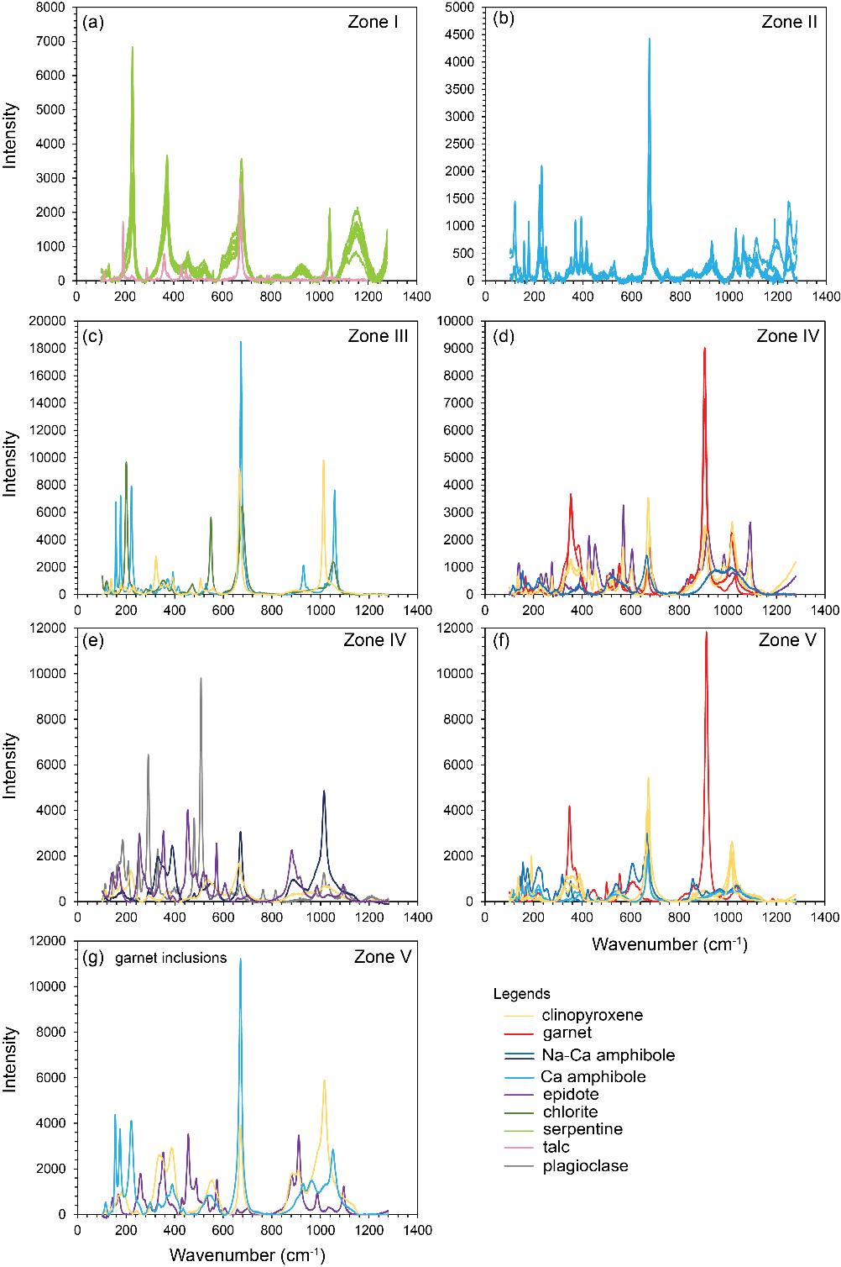

Figure S4. Representative Raman spectra of the major minerals that comprise the different metasomatic reaction zones.

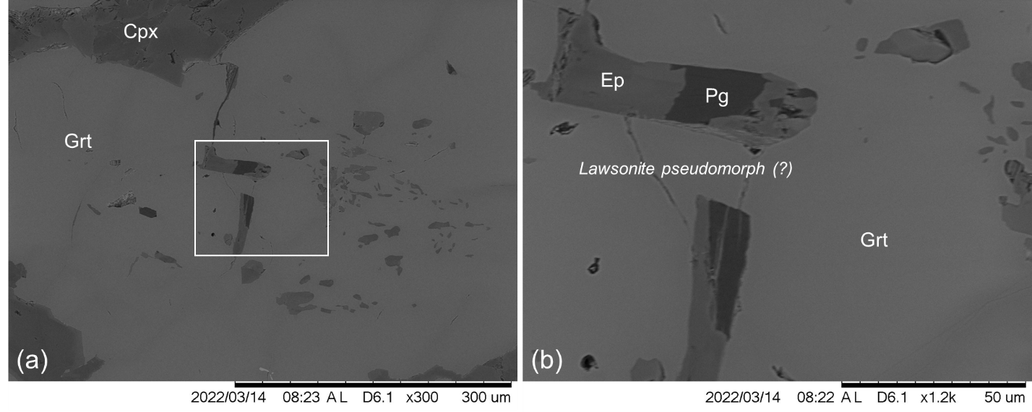
Figure S5. Representative thin-section back-scatter election image of garnet inclusions (epidote and paragonite) inferred to be pseudomorphic after lawsonite in sample B10 (Zone V).

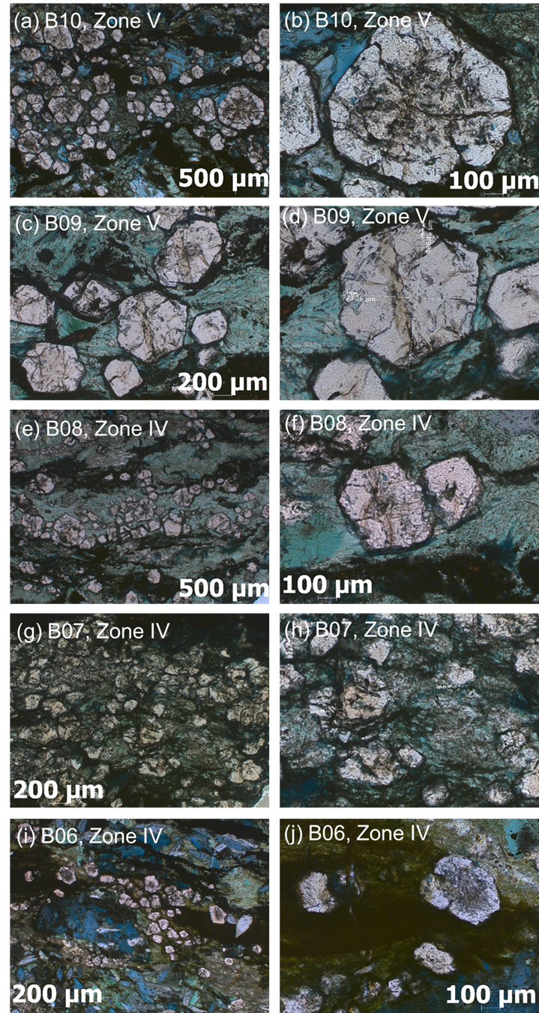

Figure S6. Thin-section photomicrographs showing representative garnets from different zones that were measured by EPMA and were used in pseudosection modeling.

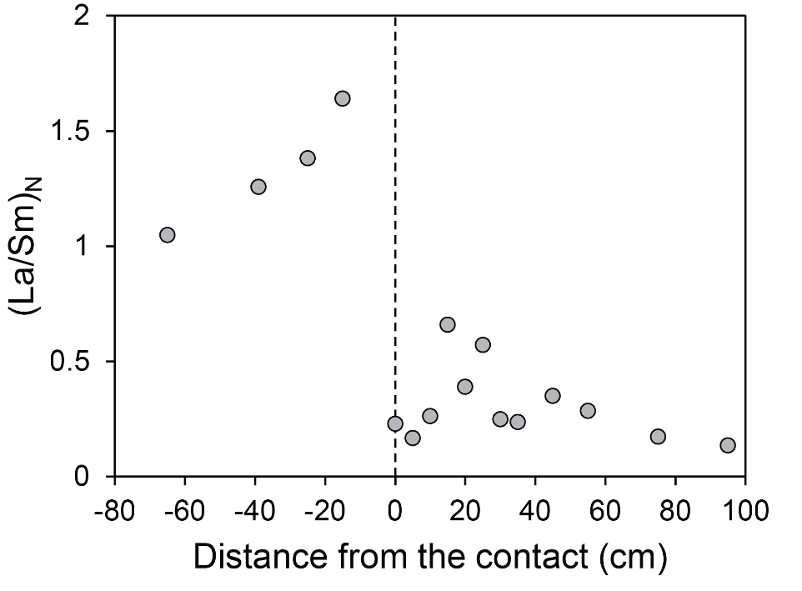

Figure S7. Primitive mantle-normalized (La/Sm)_{N} ratio across the serpentinite-metagabbro transect. Primitive mantle is from McDonough and Sun (1995).

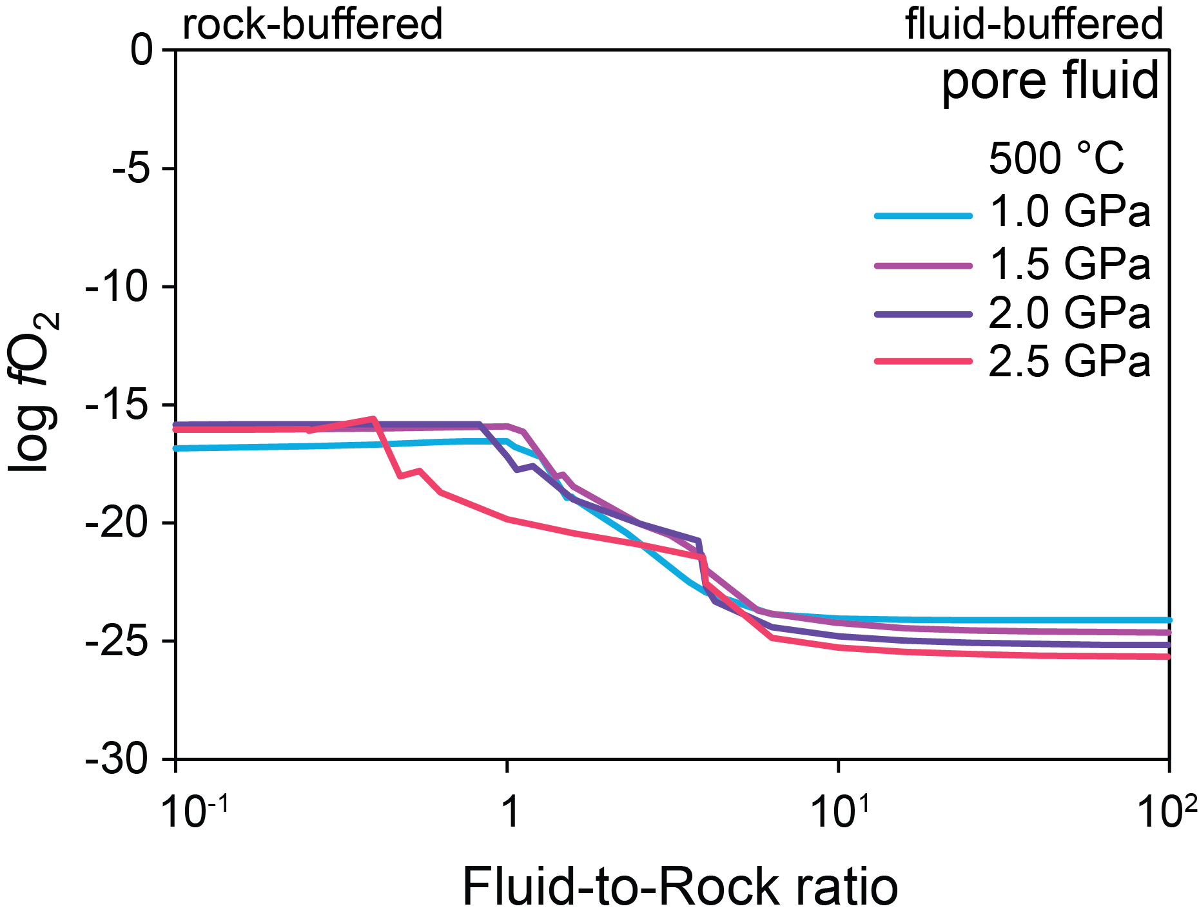

Figure S8. Predicted oxygen fugacity (fO₂) of the equilibrium fluid during high P-T metasomatism as a function of fluid-to-rock mass ratio. A fluid equilibrated with serpentinite (at f/r ~100) is subsequently allowed to react with oxide gabbro at 500 °C, 1.0–2.5 GPa. The f/r decreases as gabbro is titrated into the fluid.

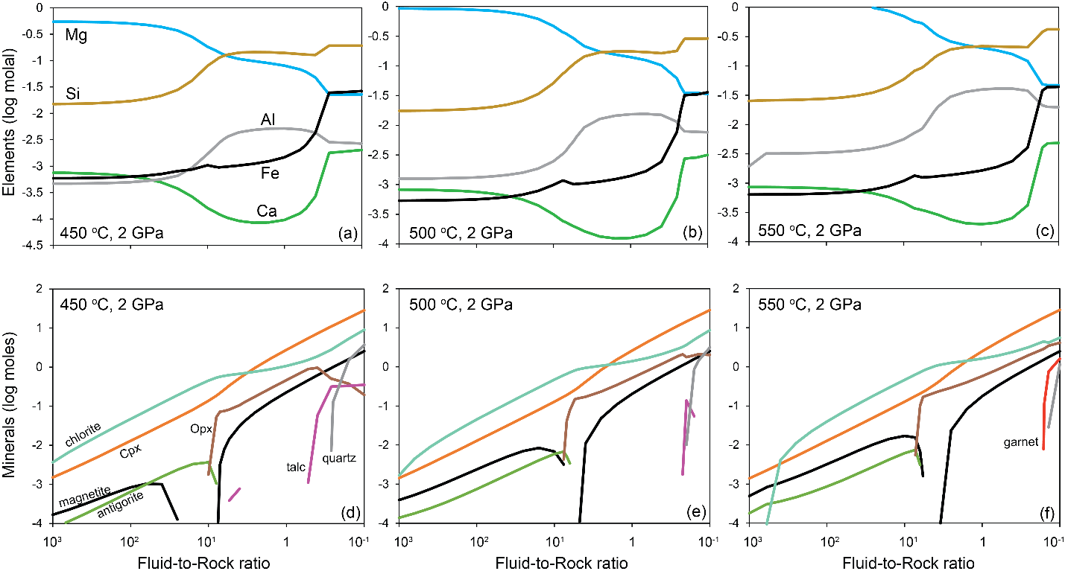
Figure S9. Predicted alteration mineralogy and fluid composition during high P-T metasomatism as a function of fluid-to-rock mass ratio. A fluid equilibrated with serpentinite (at f/r > 1000) is subsequently allowed to react with eclogitic metagabbro in Zone V at 450–550 °C, 2.0 GPa. The f/r decreases as eclogite is titrated into the fluid.

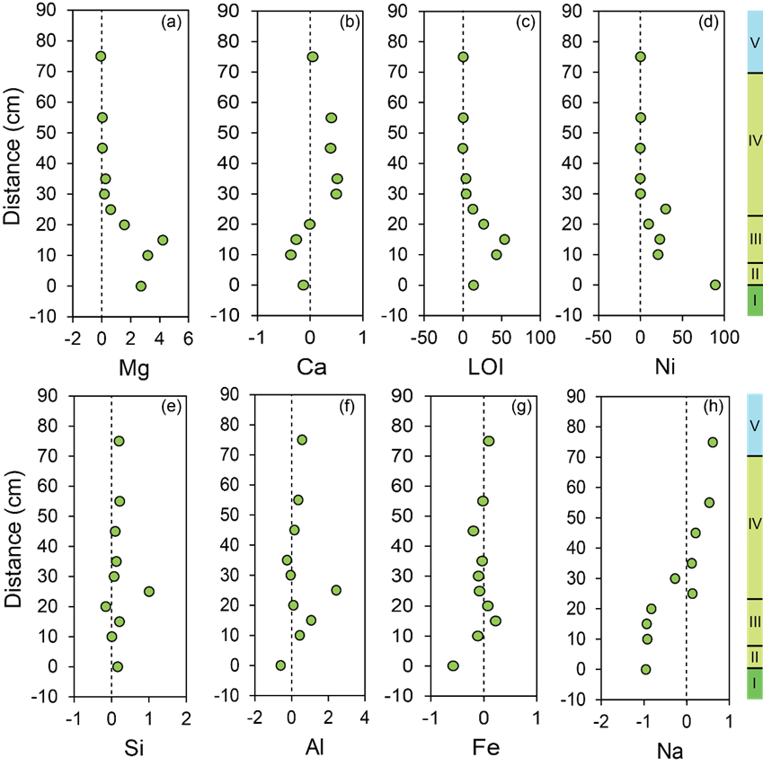

Figure S10. Mass changes for elements shown as fractions (values/100). Negative values indicate mass loss, positive values indicate gain. Details and assumptions on mass balance calculations are provided in the supplementary.

