Supplementary Material:
A)

B)
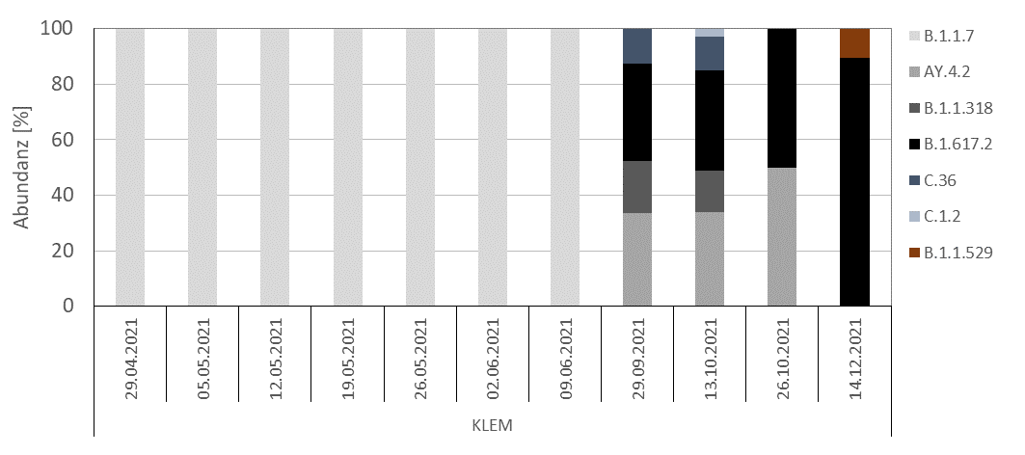
Supplementary Figure 1: Relative SARS-CoV-2 variant distribution. A) Epidemiological data on SARS-CoV-2 cases including the variant specific portions in NRW were obtained from the official data repository of the Federal Robert Koch Institute (RKI) in charge of public health surveillance. B) Relative proportion of SARS-CoV-2 variants as determined by NGS-sequencing of wastewater samples derived from KLEM at the indicated sampling dates.

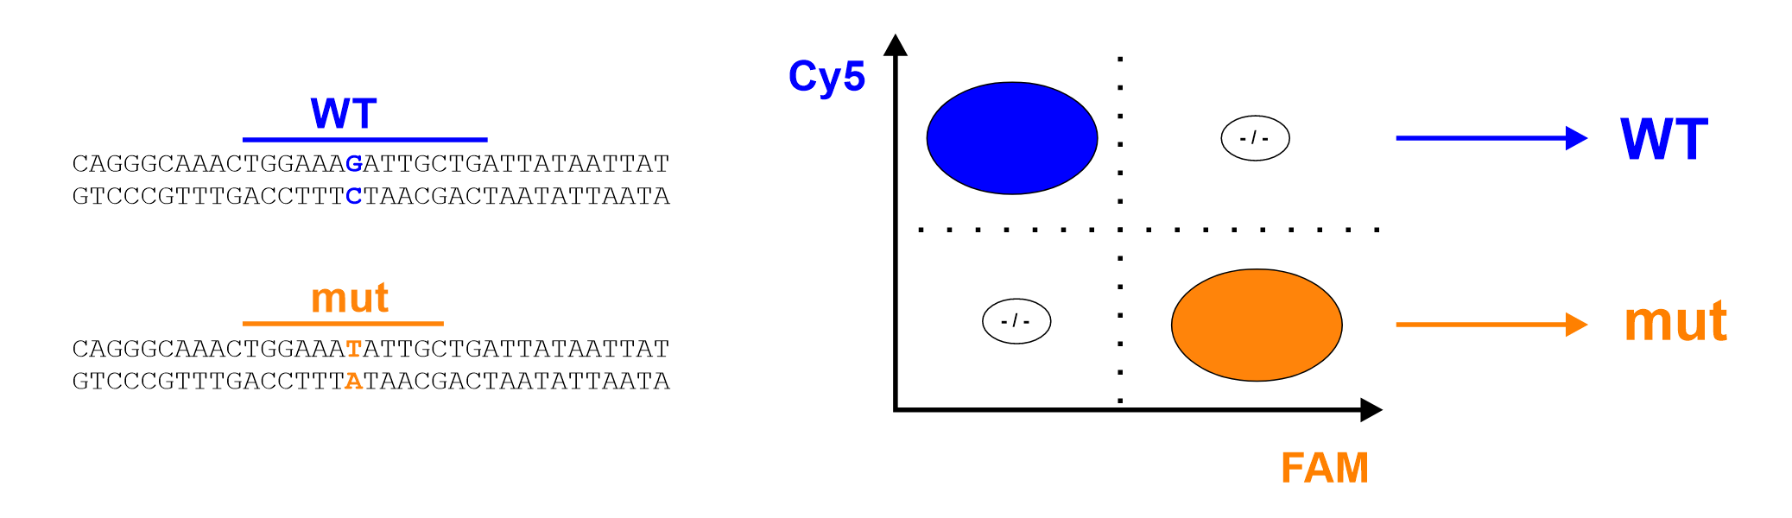
B)
A)

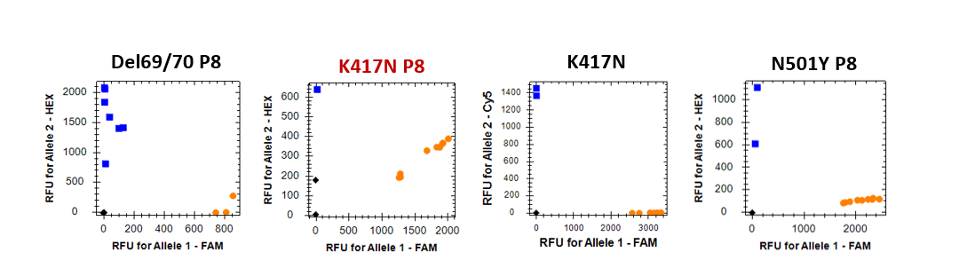
C)

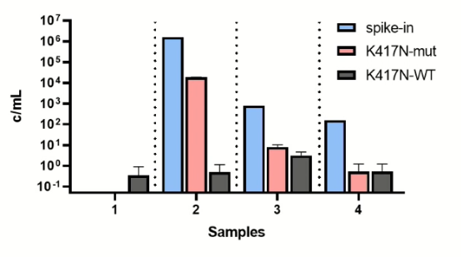
Supplementary Figure 2: Specificity and sensitivity of different SARS-CoV-2 target genes.
A) To evaluate the proportion of SARS-CoV-2 RNA carrying a specific substitution, we used a multiplex approach based on the simultaneous use of two differently labeled LNA probes. Together with a single forward- and reverse-primer, a FAM-labelled locked-nucleic acid (LNA) probe for the detection of a specific mutation and a Cy5-labelled LNA probe for the detection of SARS-CoV-2 RNA lacking the respective substitution were combined a single PCR reaction. B) Samples spiked with inactivated SARS-CoV-2 were used for assay validation and VoCs carrying the respective mutation were successfully detected in the FAM-channel (orange dots). The allelic discrimination plot revealed a crosstalk between the Cy5- and FAM-channel in the primer-probe pair “K417N P8” (highlighted in red), while Del69/70 P8, K417N and N501Y P8 exhibited high specificity in both fluorescence channels. P8: SARS-CoV-2 Variant Panel-8 Targets Kit (Promega) C) The primer-probe pair K417N (purchased from IDT) was evaluated in wastewater spiked with different amounts of K417N-carrying SARS-CoV-2 variants (blue bars). The samples 1 to 4 originate from a single wastewater sample.
Supplementary Table 1: Sequences of primers and probes used for SARS-CoV-2 detection. All assays were verified for specific detection of SARS-CoV-2 by RT-qPCR using samples spiked with authentic SARS-CoV-2 as described above. “+” indicates LNA positions. FAM, 5' 6-FAM (Fluorescein) modification; ZEN, internal quencher for fluorescence-quenched probes (IDT). 3IABkFQ, 3' Iowa Black FQ quencher; 3IAbRQSp, 3' Iowa Black RQ quencher; Cy5, 5' Cy5 fluorescence dye.
primer/probe | SARS-CoV-2 gene | Sequence (5′–3′)
N1 probe | N | FAM/ACCCCGCAT/ZEN/TACGTTTGGTGGACC/3IABkFQ/
N2 probe | N | FAM/ACAATTTGC/ZEN/CCCCAGCGCTTCAG/3IABkFQ/
N1 fwd | N | GACCCCAAAATCAGCGAAAT
N1 rev | N | TCTGGTTACTGCCAGTTGAATCTG
N2 fwd | N | TTACAAACATTGGCCGCAAA
N2 rev | N | GCGCGACATTCCGAAGAA
K417N fwd | S | GAGGTGATGAAGTCAGACAAATC
K417N rev | S | AGCTATAACGCAGCCTGTAA
K417 wt probe | S | Cy5/TGG+AA+A+G+ATT+G+CT/3IAbRQSp/
K417 mt probe | S | FAM/TG+GAA+A+T+ATTG+CT+GA/3IABkFQ/

