Global Ecology and Biogeography

**SUPPORTING INFORMATION**

**Climatic and biogeographic drivers of functional diversity in the flora of the Canary Islands**

**APPENDIX S3.** Calculation of environmental variables

Monthly mean temperature and monthly total precipitation were interpolated on a 500 m x 500 m grid cell scale from a dense net of climate measurements (n = 155 for temperature and n = 305 for precipitation) provided by the Agencia Estatal de Meteorología (AEMET). Climate interpolation included spatial variables, elevation, aspect, slope, rain shadow effects and precipitation increases caused by orographic lift of air masses (assuming northerly wind directions from 020°) as well as cloud cover (Platnick et al., 2015) as explanatory variables in a multiple regression (for temperature) and a boosted regression tree model (for precipitation; Irl, Obermeier, Beierkuhnlein & Steinbauer, 2020). In the Teide violet communities above 2400 m a.s.l. (del Arco Aguilar, González-González, Garzón-Machado & Pizarro-Hernández, 2010) we can find cold and dry environments which are very rare and different from the environmental conditions that are found elsewhere in the Canary Islands. Hence, we removed grid cells over 2400 m a.s.l. to avoid spatial autocorrelation and approximate an even distribution of grid cells along the remaining environmental gradient. This has only a minor effect on our analyses as alien species mainly do not occur at higher elevations and can hence not be compared to endemic and non-endemic native species there. Monthly mean temperature was used to calculate potential evapotranspiration according to the Thornthwaite equation (Thornthwaite, 1948) using the ‘SPEI’ package in R (Beguería & Vicente-Serrano, 2017). Subsequently, we calculated the Humidity Index after UNEP (1992) which is given by:

$Humidity index=\frac{\sum_{i}^{12}{\frac{P_{i}}{{PET}_{i}}}}{12}$,

where P is the monthly mean precipitation and PET the monthly potential evapotranspiration. The Humidity index is useful as it classifies the type of climate in relation to water availability (UNEP, 1992). Humidity index ranged approximately from 0.07 (arid) to 2.05 (humid) across the five islands (Table 1; Figure S3.1a).

We further calculated geographical isolation per grid cell based on the distance to climatically similar land mass (Weigelt & Kreft, 2013). Geographical isolation was quantified as the distance of a grid cell to the nearest terrestrial area on the continent that has a mean annual temperature within 1°C, following Steinbauer et al. (2016). Only the focal grid cell and grid cells beyond the archipelago were used in this calculation because endemism is defined at the archipelago level. Mean annual temperature for the continent was obtained from 1 km x 1 km resolution CHELSA data (Karger et al., 2017). Processing of spatial data was done using the R package ‘raster’ (Hijmans, 2019). Geographical isolation of the island grid cells ranged from 196.5 km to 885 km to the closest continental grid cell with similar environmental conditions (Table 1; Figure S3.1b).

We calculated topographic complexity per grid cell as it relates to the rate of elevational change in response to changes in location (Amatulli *et al.*, 2018) and can therefore act as a surrogate for habitat heterogeneity (Irl et al., 2015). We estimated topographic complexity per grid cell by using a moving window approach that calculates the surface area for a cell based on slope information from a specified set of smaller grid cells (in this study 20 x 20 grid cells; after Jenness, 2004):

$Topographic complexity index = \frac{\sum_{500mx500m}{}(\frac{{Area}_{25mx25m}}{cos \left({Slope}_{25mx25m }\right) })}{{Area}_{500mx500m}}$,

where Area25mx25m is the area per grid cell from a 25 m x 25 m digital elevation model (DEM; GRAFCAN, 2019), Slope25mx25m the slope (in radians) of each grid cell from the same DEM in degrees, and Area500mx500m the area per grid cell from a 500 m x 500 m DEM containing all grid cells form the 25 m x 25 m DEM. Topographic complexity ranged from 1 (flat) to 2.17 (high complexity; Table 1; Figure S3.1c).

Furthermore, we calculated geological age per grid cell as it represents a proxy for plant nutrient availability (Lambers, Raven, Shaver & Smith, 2008) which is known to generate functional diversity (Lambers, Brundrett, Raven & Hopper, 2011). We derived geological age per grid cell from a continuous digital geological map of Spain (scale 1:50,000; Bellido Mulas, Pineda Velasco, Gómez Sainz de Aja & Barrera, 2020). We calculated geological age as the mean age of the geological time period that we assigned to each grid cell of the Canary Islands based on the geological map. Mean geological age per grid cell ranged from 6 ka to 13.8 Ma (Table 1; Figure S3.1d).

For further analyses we ln-transformed the humidity and topographic complexity index to approximate normality and subsequently centred and scaled all environmental variables, yielding estimates in standard deviation units per grid cell. After standardisation, we calculated correlation coefficients (Pearson’s r) between the environmental variables, as well as elevation (Table S3.1).

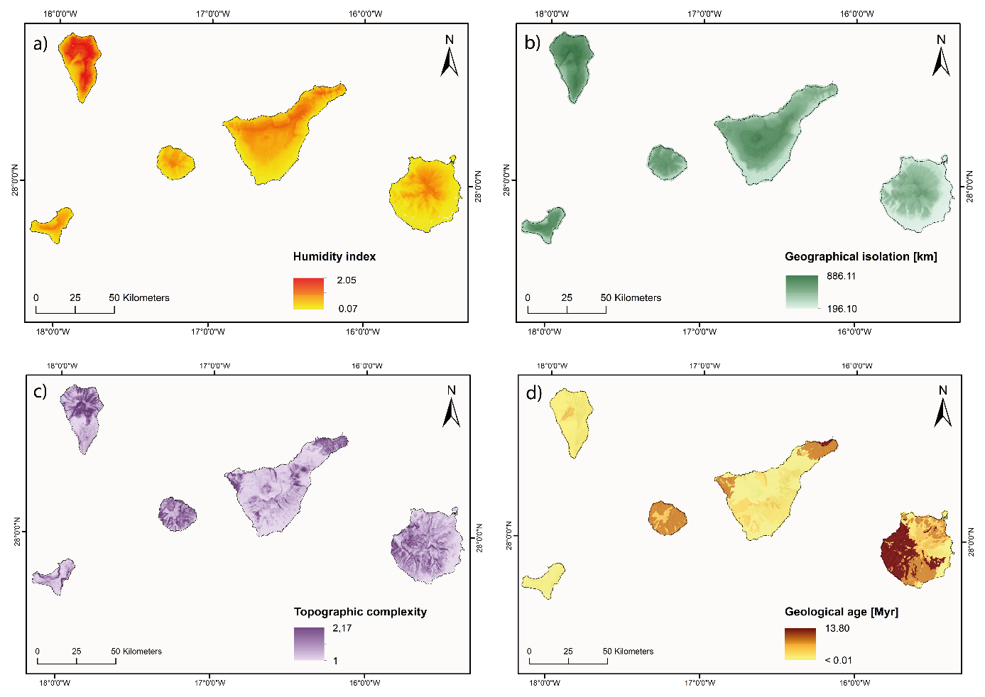

**Figure S3.1.** Climatic and biogeographic variables across the Canary Islands. a) Humidity was quantified as mean annual precipitation in relation to mean annual potential evapotranspiration per grid cell, b) geographical isolation was quantified as the distance of a grid cell to the nearest terrestrial area on the continent that has a mean annual temperature within 1°C, c) topographic complexity per grid cell was estimated by calculating the ratio between 3D and 2D surface area, e) geological age per grid cell was derived from a continuous digital geological map of Spain (scale 1:50,000; Bellido Mulas et al., 2020).

**Table S3.1.** Pearson’s correlation coefficient between humidity, geographical isolation, topographic complexity and geological age on the Canary Islands based on 500 m x 500 m grid cells. Coefficients given in black are based on observed FDSES grid cells (n = 3,065), coefficients given in grey are based on modelled FDSES grid cells (n = 17,095).

|  |  |  |  |  |  |
| --- | --- | --- | --- | --- | --- |
|  | **Log – Humidity** | **Geographical isolation** | **Log – Topographic complexity** | **Geological age** | **Elevation** |
| **Log - Humidity** | - | 0.891 | 0.244 | -0.291 | 0.781 |
| **Geographical isolation** | 0.804 | - | 0.296 | -0.302 | 0.784 |
| **Log – Topographic complexity** | 0.191 | 0.379 | - | 0.371 | 0.210 |
| **Geological age** | -0.198 | -0.128 | 0.418 | - | -0.129 |
| **Elevation** | 0.720 | 0.723 | 0.189 | -0.045 | - |

**References**

Amatulli, G., Domisch, S., Tuanmu, M.N., Parmentier, B., Ranipeta, A., Malczyk, J. & Jetz, W. (2018) Data Descriptor: A suite of global, cross-scale topographic variables for environmental and biodiversity modeling. *Scientific Data*, **5**, 180040.

Beguería, S. & Vicente-Serrano, S.M. (2017) SPEI: Calculation of the Standardised Precipitation-Evapotranspiration Index.

Bellido Mulas, F., Pineda Velasco, A., Gómez Sainz de Aja, J.A. & Barrera, J.L. (2020) Mapa Geológico Digital continuo E. 1:25:000, Zona Canarias. *GEODE. Mapa Geológico Digital continuo de Espana*.

del Arco Aguilar, M.J., González-González, R., Garzón-Machado, V. & Pizarro-Hernández, B. (2010) Actual and potential natural vegetation on the Canary Islands and its conservation status. *Biodiversity and Conservation*, **19**, 3089–3140.

GRAFCAN (2019) Cartográfica de Canarias.

Hijmans, R.J. (2019) raster: Geographic Data Analysis and Modeling.

Irl, S.D.H., Obermeier, A., Beierkuhnlein, C. & Steinbauer, M.J. (2020) Climate controls plant life form patterns on a high-elevation oceanic island. *Journal of Biogeography*, **47**, 2261–2273.

Irl, S.D.H., Harter, D.E.V., Steinbauer, M.J., Gallego Puyol, D., Fernández-Palacios, J.M., Jentsch, A. & Beierkuhnlein, C. (2015) Climate vs. topography - spatial patterns of plant species diversity and endemism on a high-elevation island. *Journal of Ecology*, **103**, 1621–1633.

Jenness, J.S. (2004) Calculating landscape surface area from digital elevation models. *Wildlife Society Bulletin*, **32**, 829–839.

Karger, D.N., Conrad, O., Böhner, J., Kawohl, T., Kreft, H., Soria-Auza, R.W., … Kessler, M. (2017) Climatologies at high resolution for the earth’s land surface areas. *Scientific Data*, **4**, 1–20.

Lambers, H., Brundrett, M.C., Raven, J.A. & Hopper, S.D. (2011) Plant mineral nutrition in ancient landscapes: High plant species diversity on infertile soils is linked to functional diversity for nutritional strategies. *Plant and Soil*, **348**, 7–27.

Lambers, H., Raven, J.A., Shaver, G.R. & Smith, S.E. (2008) Plant nutrient-acquisition strategies change with soil age. *Trends in Ecology and Evolution*, **23**, 95–103.

Platnick, S., Ackerman, S.A., King, M.D., Meyer, K., Menzel, W.P., Holz, R.E., … Yang, P. (2015) MODIS atmosphere L2 cloud product (06_L2). *NASA MODIS Adaptive Processing System*.

Steinbauer, M.J., Field, R., Grytnes, J.A., Trigas, P., Ah-Peng, C., Attorre, F., … Beierkuhnlein, C. (2016) Topography-driven isolation, speciation and a global increase of endemism with elevation. *Global Ecology and Biogeography*, **25**, 1097–1107.

Thornthwaite, C.W. (1948) An Approach toward a Rational Classification of Climate. *Geographical Review*, **38**, 55–94.

UNEP (1992) *World Atlas of Desertification*, Edward Arnold, London.

Weigelt, P. & Kreft, H. (2013) Quantifying island isolation - insights from global patterns of insular plant species richness. *Ecography*, **36**, 417–429.