Global Ecology and Biogeography

**SUPPORTING INFORMATION**

**Climatic and biogeographic drivers of functional diversity in the flora of the Canary Islands**

**APPENDIX S5.** Phylogenetic signal at the genus- and assemblage level

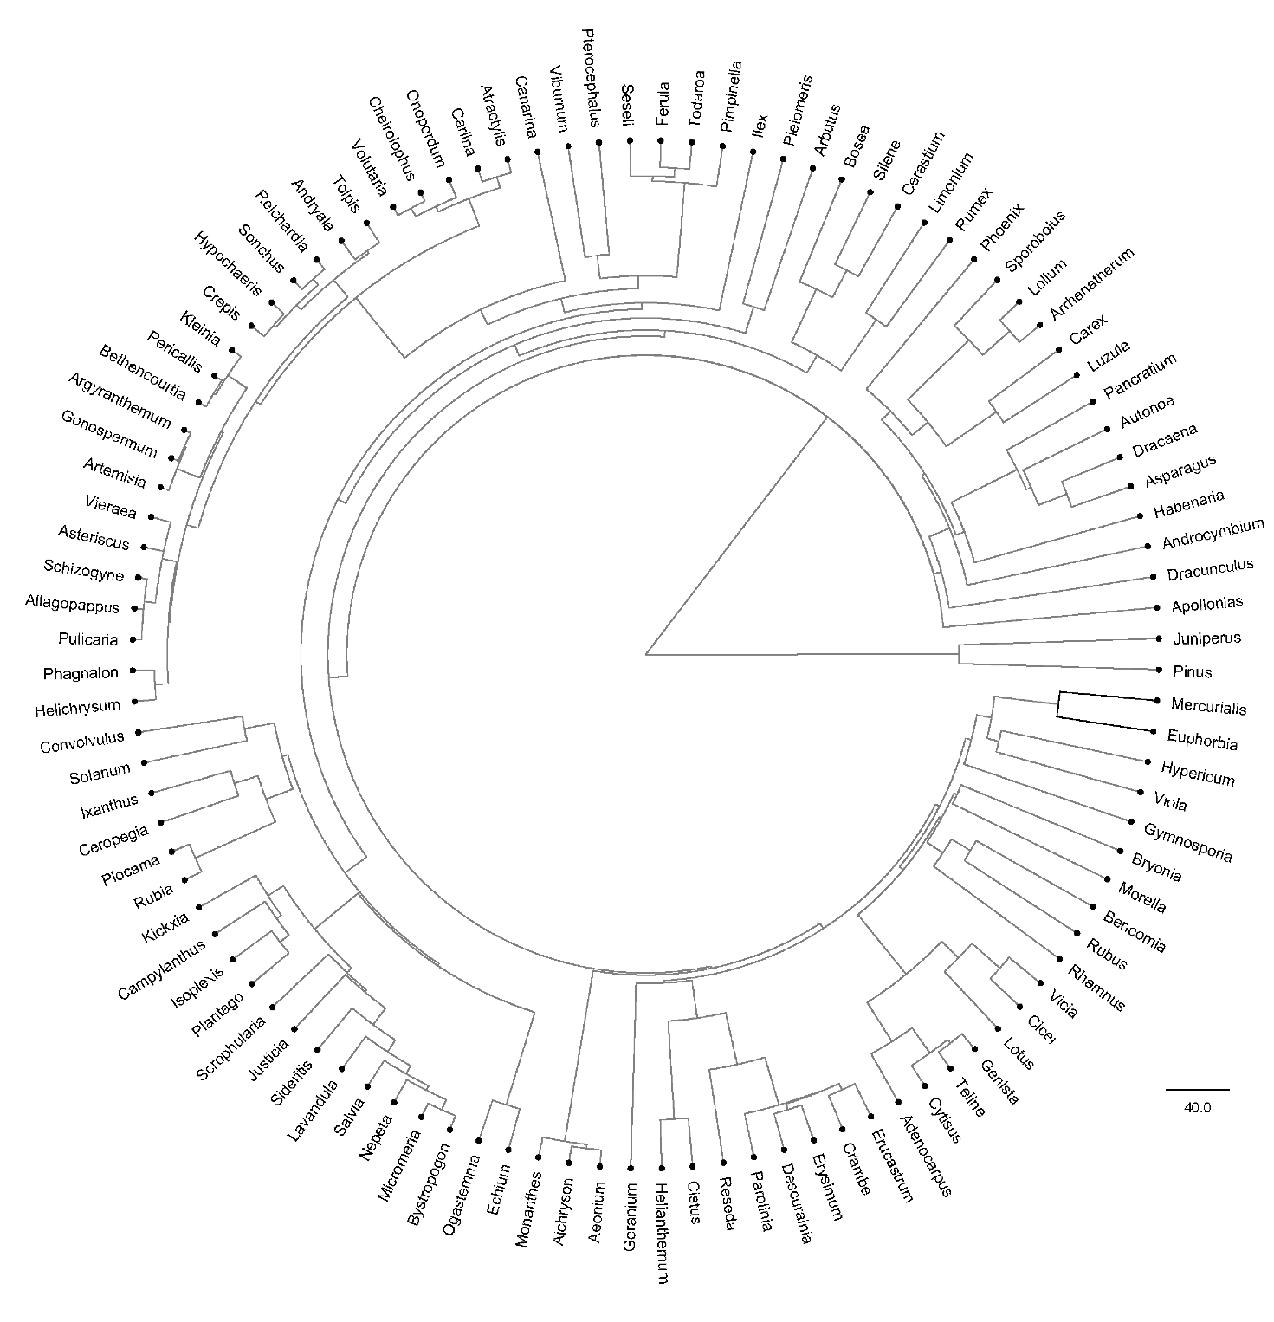

a)

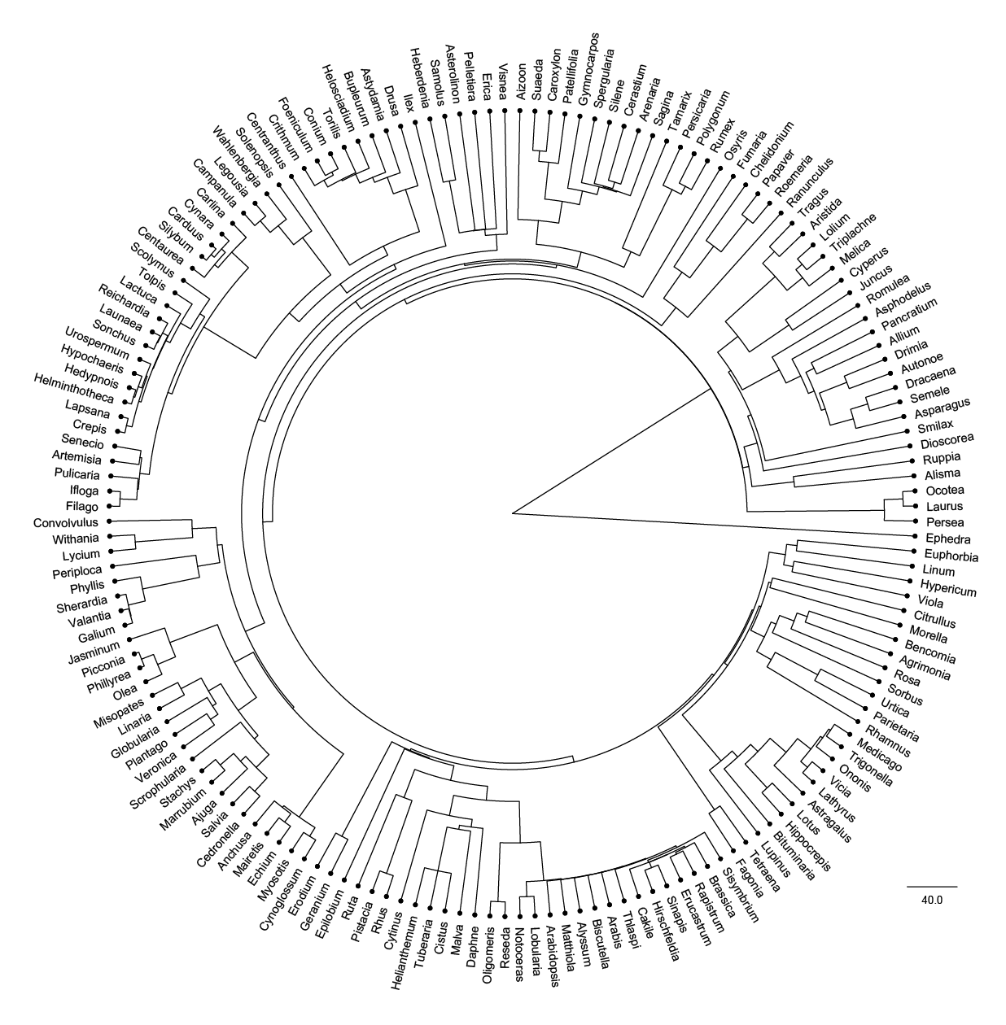

b)

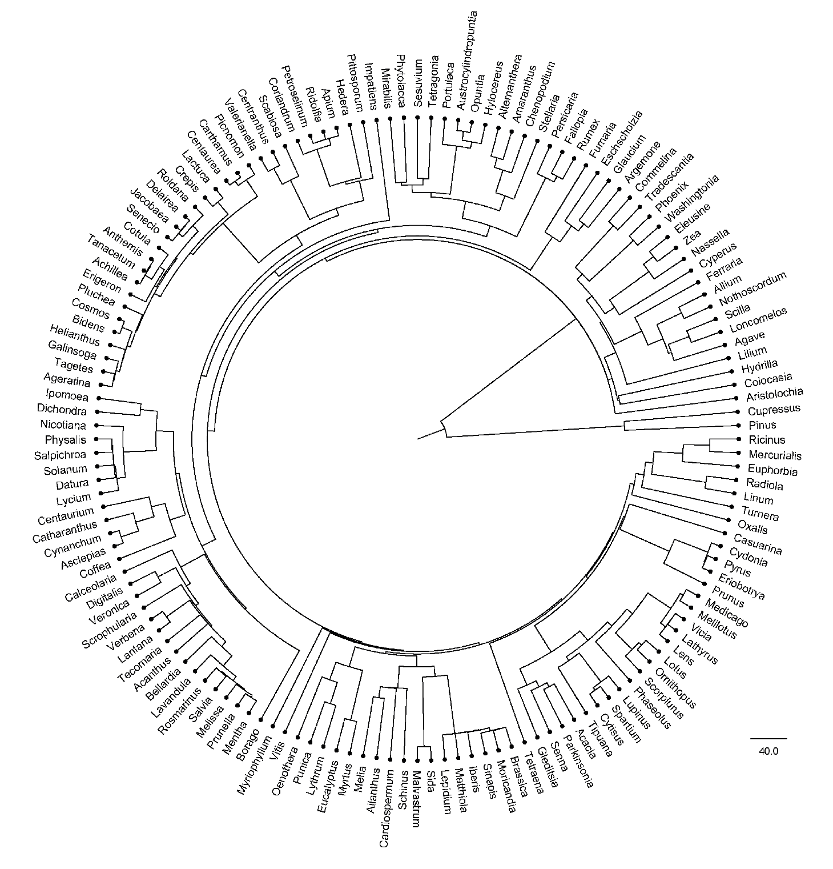

c)

**Figure S5.4**. Phylogenetic tree of **a)** 103 endemic, **b)** 166 non-endemic native and **c)** 147 alien plant genera of the Canary Islands. The trees were pruned from the global seed plant phylogeny from Smith & Brown (2018).