Global Ecology and Biogeography

**SUPPORTING INFORMATION**

**Climatic and biogeographic drivers of functional diversity in the flora of the Canary Islands**

**APPENDIX S6.** Results of models accounting for collinearity and of models using modelled species occurrence data

**Table S6.2.** Explained variation of generalised linear models (GLM) and spatial autoregressive (SAR) models analysing the combined effect of **a)** humidity, topographic complexity and geological age and **b)** geographical isolation, topographic complexity and geological age on FDSES of endemic, non-endemic native and alien seed plant assemblages based on 500 m x 500 m grid cells across the Canary Islands. FDSES is based on four functional traits (plant height, leaf length, flower length and fruit length) and was calculated for grid cells with occurrence-based data (n = 3,065). Percentage of total deviance explained (% dev.), Akaike Information Criterion (AIC) and Moran’s I are given. Model coefficients of SEMs are given in Figure S6.6.

|  |  |  |  |  |  |  |
| --- | --- | --- | --- | --- | --- | --- |
| **a)** | GLM | | | SAR | | |
| % dev. | AIC | Moran’s I | % dev. | AIC | Moran’s I |
| Endemic | 26.1 | 9818.1 | 0.57 | 53.1 | 8433.1 | -0.08 |
| Non-endemic native | 18.3 | 10928 | 0.68 | 60.2 | 8736 | -0.10 |
| Alien | 6.6 | 10418 | 0.63 | 48.8 | 8584.7 | -0.09 |
| **b)** | GLM | | | SAR | | |
| % dev. | AIC | Moran’s I | % dev. | AIC | Moran’s I |
| Endemic | 18.9 | 10105 | 0.60 | 51.8 | 8514.5 | -0.09 |
| Non-endemic native | 12.6 | 11134 | 0.71 | 60.0 | 8748.1 | -0.11 |
| Alien | 3.4 | 10524 | 0.64 | 48.6 | 8598.9 | -0.09 |

**Table S6.3.** Explained variation of generalised linear models (GLM) and spatial autoregressive (SAR) models analysing the combined effect of humidity, geographical isolation, topographic complexity and geological age on FDSES of endemic, non-endemic native and alien seed plant assemblages based on 500 m x 500 m grid cells across the Canary Islands. FDSES is based on four functional traits (plant height, leaf length, flower length and fruit length) and was calculated for grid cells with modelled data (n = 17,094). Percentage of total deviance explained (% dev.), Akaike Information Criterion (AIC) and Moran’s I are given. Model coefficients of SEMs are given in Figure S6.7.

|  |  |  |  |  |  |  |
| --- | --- | --- | --- | --- | --- | --- |
|  | GLM | | | SAR | | |
| % dev. | AIC | Moran’s I | % dev. | AIC | Moran’s I |
| Endemic | 34.6 | 52114 | 0.48 | 54.9 | 45767 | -0.09 |
| Non-endemic native | 50.7 | 59856 | 0.52 | 68.1 | 52406 | -0.10 |
| Alien | 39.4 | 57818 | 0.54 | 61.8 | 49948 | -0.10 |

**Table S6.4.** Phylogenetic signal in the trait variation of endemic, non-endemic native and alien seed plants of the Canary Islands, using Blomberg’s *K* statistic. n is the number of genera with trait data represented in the given phylogeny. Asterisks indicate statistical significance (*p < 0.05, **p < 0.01, ***p < 0.001).

|  |  |  |  |
| --- | --- | --- | --- |
|  | **Genus level** | | |
| **Endemic**  **(n = 103)** | **Non-endemic native**  **(n = 166)** | **Alien**  **(n = 147)** |
| ***K*** | ***K*** | ***K*** |
| **Plant height** | 2.568*** | 0.370*** | 1.902*** |
| **Leaf length** | 0.584* | 0.258* | 0.345 |
| **Flower length** | 0.201 | 0.210 | 0.173 |
| **Fruit Length** | 0.814* | 0.248* | 0.426*** |

**Figure 6.5** Correlogram of the response variable (functional diversity), the simple linear model and the spatial error model analysing the relationship between functional diversity and humidity, geographical isolation, topographic complexity and geological age in **a)** endemic, **b)** non-endemic native and **c)** alien plant species assemblages on the Canary Islands.

**Figure S6.6.** Multi-predictor spatial autoregressive models of **a)** humidity (HUM), topographic complexity (TCI) and geological age (GA) and **b)** geographical isolation (ISO) topographic complexity (TCI) and geological age (GA) on modelled FDSES of endemic (n = 313 species), non-endemic native (n = 291 species) and alien plant species assemblages (n = 216 species) on the Canary Islands. FDSES is based on four functional traits (plant height, leaf length, flower length and fruit length) and was calculated for occurrence-based data based on 500 m x 500 m grid cells (n = 3,065). Shown are the respective best models according to a model comparison approach. Standardised estimates are provided for each predictor. Error bars represent confidence intervals of the coefficient estimates. Asterisks denote statistical significance (*** p < 0.001; ** p < 0.01; * p < 0.05).

**Figure S6.7.** Multi-predictor spatial autoregressive models of humidity (HUM), geographical isolation (ISO), topographic complexity (TCI) and geological age (GA) on modelled FDSES of endemic (n = 313 species), non-endemic native (n = 291 species) and alien plant species assemblages (n = 216 species) on the Canary Islands. FDSES is based on four functional traits (plant height, leaf length, flower length and fruit length) and was calculated for modelled data based on 500 m x 500 m grid cells (n = 17,094). Shown are the respective best models according to a model comparison approach. Standardised estimates are provided for each predictor. Error bars represent confidence intervals of the coefficient estimates. Asterisks denote statistical significance (*** p < 0.001; ** p < 0.01; * p < 0.05).

**Figure S6.8.** Modelled FDSES of plant assemblages based on 500 m x 500 m grid cells (n = 17,094) along **a)** humidity, **b)** geographical isolation, **c)** topographic complexity and **d)** geological age gradients across the Canary Islands. Functional diversity is based on four functional traits (growth height, leaf length, flower length and fruit length) of 313 endemic, 291 non-endemic native and 216 alien plant species. Lines show the trends of the models given in Figure S6.7 and Table S6.3.

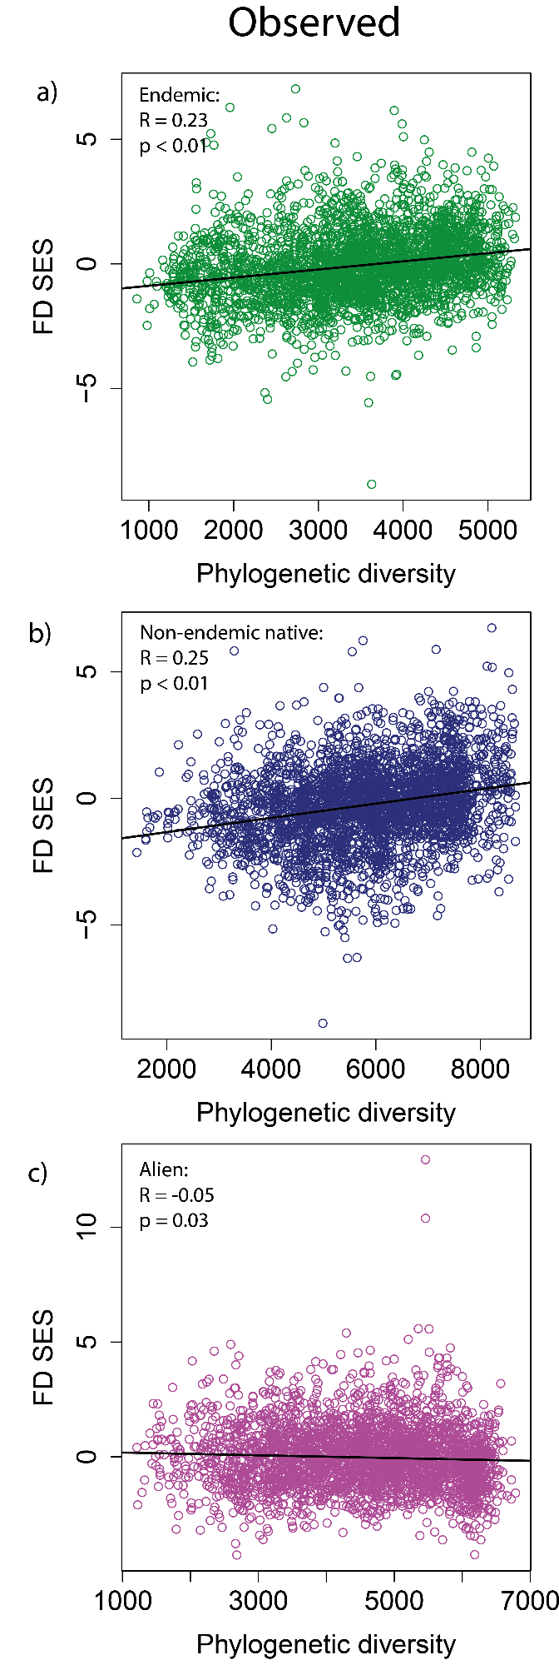

**Figure S6.9.** Pearson’s correlation between FDSES and phylogenetic diversity based on 500 m x 500 m grid cells for observed **a)** endemic (n = 3,065), **b)** non-endemic (n = 3,063) and **c)** alien (n = 3,056) species assemblages. R is Pearson’s correlation coefficient and p indicates the statistical significance. Simple linear regression lines are depicted on the graphs for a clearer visualisation of the trends.