Siderophile and chalcophile elements in spinels, sulphides and native Ni in strongly metasomatised xenoliths from the Bultfontein kimberlite (South Africa)

Sonja Aulbach, Andrea Giuliani, Marco L. Fiorentini, Raphael Baumgartner, Dany Savard, Vadim S. Kamenetsky, Stefano Caruso, Leonid V. Danyushevky, Will Powell⁸, William L. Griffin

Appendix 1: Prior work, methods and challenges

1. Prior work

1.1 Nickel-enriched spinel harzburgite (Ni-harzburgite)
Sample XM1/422, a coarse-grained, granular, spinel harzburgite, contains symplectites (spinel + clinopyroxene + orthopyroxene), in part overprinted by Ni-rich phases (Fig. 2A,D; Giuliani et al., 2013a). The mineralisation was probably produced by a Ni-rich, alkali and Cl-bearing C-O-H fluid or carbonate melt in the shallow mantle (T ~ 700°C; P = 2.6-2.8 GPa; Table 1) (Giuliani et al., 2013a). This metasomatic episode was temporally related to kimberlite magmatism in the Kimberley area based on modelling of Ni diffusion into porphyroblastic olivine adjacent to native Ni and heazlewoodite grains (t ≤ 2 Myr; Giuliani et al., 2013a). The origin of the fluid is unclear; however, Ni and other metals were at least partly sourced from an external source (Giuliani et al., 2013a). Prior whole-rock analysis (Holwell et al., 2019) reveals Ir and Ru abundances close to Primitive Mantle (PM), and steadily decreasing PGE abundances to Pd, with supra-PUM Au/Pd (Fig. 7A). Relative to PM, Mo is ~100x enriched, Bi and As are weakly enriched (2-3x), and Te, Ag and Zn are weakly depleted (<10x).

1.2 Phlogopite-rich spinel peridotites (phl-peridotites)
Xenolith sample XM1/142 is a coarse-grained, granular, spinel harzburgite, which includes abundant phlogopite, minor clinopyroxene, and rare K-richterite and pentlandite.
Sample XM1/341 is a moderately coarse-grained, phlogopite-rich spinel lherzolite where phlogopite, clinopyroxene, LIMA and minor pentlandite are in close textural association (Giuliani et al., 2014b, 2016a, 2018). In sample XM1/345, cm-thick, coarse-grained veins of phlogopite with lesser ilmenite, LIMA, clinopyroxene and sulphide occur in a coarse-grained, spinel harzburgite matrix (Giuliani et al., 2014b, 2018). These phlogopite-rich peridotite samples derive from similar depths (~3.0-3.8 GPa; Table 1), where phlogopite metasomatism beneath Kimberley is most intense (Waters and Erlank, 1988; Fitzpayne et al., 2020). Previous in-situ S isotope analyses of pentlandite revealed similar δ³⁴S values of between -2‰ and -6‰, which suggest contribution by recycled sedimentary components (Giuliani et al., 2016a). A role for subducted recycled material in the source of these metasomatic agents is confirmed by N and O isotope analyses of phlogopite, clinopyroxene and other phases in these xenoliths (Fitzpayne et al., 2019a). U/Pb dating of LIMA minerals in samples XM1/341 and XM1/345 shows that metasomatism of these samples by Ti-rich silicate melts was broadly coeval with formation of the Karoo large igneous province at ~180-185 Ma (Giuliani et al., 2014b). Combined trace-element and in-situ Sr isotope analyses of LIMA minerals further indicate that metasomatism was mediated by multiple melts with variable geochemical and isotopic composition (Giuliani et al., 2018). Conversely, U/Pb dating of zircon from a MARID-like off-cut of sample XM1/142 returned an age of ~82-83 Ma (Konzett et al., 2000), which is similar to the ~88 Ma emplacement age of the Bultfontein kimberlite (Fitzpyane et al., 2020). Whether this age is due to resetting of the U/Pb chronometer at the time of kimberlite magmatism or reflects the true age of metasomatism remains unknown. Ru/Ir in one of the measured whole rocks (Holwell et al., 2019) is supra-PM and in the other ~PUM, with decreasing normalised abundances from Ru to Pt and supra-PUM Au/Pd (Fig. 7C,D). Relative to PM, Mo and As are >10 times enriched relative to PM, while Te, Ag, Bi, Pb and Zn are within ±10x PM.

1.3 MARID
Sample BLFX-3 has a foliated texture and consists of alternating bands enriched in phlogopite and K-richterite, respectively. Ilmenite is widespread in both phlogopite-rich and amphibole-rich layers, whereas clinopyroxene and rutile are absent. This sample contains secondary calcite-rich veins with diopside and minor barite and pectolite. These veins are similar to those documented by Fitzpayne et al. (2018b) and are probably related to metasomatism by carbonate-rich kimberlitic fluids or melts at mantle depths or during/after xenolith transport.

1.4 Polymict breccias
Mantle polymict breccias (or peridotites) consist of mixtures of mantle-derived porphyroclasts (mainly olivine, garnet, clinopyroxene and orthopyroxene) of variable composition and therefore origin (e.g., garnets of peridotitic, eclogitic, pyroxenitic, websteritic and megacrystic paragenesis (Giuliani et al., 2012, 2013b; Wyatt and Lawless, 1984; Zhang et al., 2001, 2003). The preservation of large compositional heterogeneity, including variable δ¹⁸O values (Zhang et al., 2000, 2001), in these and other polymict breccias is widely accepted to indicate formation shortly before entrainment by kimberlite magmas (Giuliani et al., 2014a; Höfer et al., 2009; Lawless et al., 1979; Pokhilenko, 2009; Zhang et al., 2000, 2003). This inference is confirmed by a U/Pb age of ~83 Ma for a zircon from one of the Kimberley polymict breccias (sample BD2666; Table 1; Lawless et al., 1979). Indistinguishable Hf isotope compositions between ilmenite in sample DU-1 (εHf_{i} = +2 to +3; Giuliani et al., 2013b) and kimberlites from the Kimberley area (Nowell et al., 2004; Woodhead et al., 2019) supports a genetic kinship between polymict breccias and kimberlite magmas whereby polymict breccias represent failed kimberlite intrusions at mantle depths (Giuliani et al., 2014a; Lawless et al., 1979; Pokhilenko, 2009). In-situ S isotope analyses of pentlandite and chalcopyrite from sample DU-1 provide δ³⁴S values of between -1‰ and -5‰ (Table 1; Giuliani et al., 2016b), which appear to be consistent with the involvement of recycled material in the deep source of the Kimberley kimberlites (Giuliani et al., 2019).

2. Methods

2.1. Sulphide imaging and element analyses
Sulphide minerals in polished thin sections and epoxy mounts were initially examined under reflected light using a petrographic microscope. Sulphide microstructures were further investigated on carbon-coated thin sections at the University of Melbourne, using a Philips (FEI) XL30 Environmental Scanning Electron Microscope (ESEM) TMP, equipped with an Oxford INCA energy-dispersive X-ray spectrometer (EDS), as detailed in Giuliani et al. (2016a).

The major element compositions of sulphide minerals were determined at the University of Melbourne using a Cameca SX50 Electron Microprobe, which is equipped with four vertical Wavelength Dispersive Spectrometers (WDS), following procedures outlines in Giuliani et al. (2016a). The analytical conditions included beam acceleration voltage 15 kV, beam current 35 nA, and beam diameter of 2 μm; detection limits of 300 ppm for most elements and 0.20 wt.% for oxygen. Natural and synthetic standards, including fragments of troilite, galena, Ni metal, Cu metal, Co metal and Zn metal, were employed for instrumental calibration. For the determination of oxygen concentrations, we adopted a specific set up where a detector (crystal PC1 – synthetic Si-W) was dedicated to measure oxygen x-rays, with natural wollastonite used for calibration. Data reduction was undertaken using the PAP matrix correction software, and results are reported in Appendix 2.

Trace element concentrations in sulphides were acquired in situ by laser ablation microprobe inductively-coupled mass spectrometry (LAM-ICPMS) at two institutions, as indicated in Appendix 3. At CODES Analytical Laboratories, University of Tasmania, a RESOlution 193 nm excimer laser microprobe coupled to an Agilent 7700 quadrupole mass-spectrometer was employed, following protocols detailed in Gilbert et al. (2013). Conditions include laser fluence of 2.7 J/cm², laser frequency 5 Hz and laser beam size between 30 and 70 microns depending on the grain size. Nickel or iron concentrations determined from EPMA were used as the internal standard (⁶⁰Ni, ⁵⁷Fe) and sensitivity was calibrated against reference materials NIS3, STDGL2-b2 and Po724-T (Danyushevsky et al., 2011; Gilbert et al., 2013). Argide production rates were determined and corrections for the interference of Ni, Cu and Zn argides on Ru, Rh and Pd, as well as corrections for the isobaric interference of ¹⁰⁶Cd on ¹⁰⁶Pd were carried out following Gilbert et al. (2013). Typical detection limits are shown with sample results in Appendix 3.

At Macquarie University, an Agilent 7700 ICP-MS coupled to a Photon Machines 193 nm Analyte Excite laser ablation system was employed. Conditions include spot sizes between 25 and 50 micron (depending on grain size and homogeneity). Quantification was achieved using the synthetic sulphide standard PGE-A (Alard et al., 2000) containing Ru, Rh, Pd, Os, Ir, Au, As, Se, Te, Pb and Bi as determined by PIXE, and reference glass NIST610 for additional elements (Zn, Ga, Mo, Sb and Re). Ni contents as determined by EPMA was used as internal standard for native Ni (90 wt%), S contents for fresh sulphides and S contents intermediate between fresh sulphides (e.g., pentlandite) and secondary sulphides (e.g., heazlewoodite) for mixed samples. Typical detection limits are shown with sample results in Appendix 3. Only elements calibrated against the sulphide standard are considered quantitative. Abundances for elements calibrated against reference glass NIST610 are considered semi-quantitative. Concentrations of the PGE and Au acquired at Macquarie University were corrected using factors given in Gilbert et al. (2013). Argide interferences can cause spuriously high apparent Ru, Rh and Pd abundances of Cu- or Ni-rich sulphides. A detailed comparison, using only inclusion-free pentlandite analyses, reveals no correlation of Ru with Ni, suggesting that ⁶¹Ni⁴⁰Ar interference on ¹⁰¹Ru was negligible (Fig. S1A). In contrast, there is a strong positive correlation between Cu and Rh resulting from interference of ⁶³Cu⁴⁰Ar on ¹⁰³Rh (Fig. S1B). This relationship breaks down at Cu concentrations <4000 ppm, and those results are considered accurate. There is no correlation between Cu with Zn, hence there appears to be no significant effect of ⁶⁸Zn⁴⁰Ar on ¹⁰⁸Pd from which Pd abundances were quantified (Fig. S1C). To err on the side of caution, we consider only samples with Zn concentrations <200 ppm.

2.2. Spinel imaging and element analyses
Quantitative wavelength dispersive X-ray spot and map analysis of major and minor elements was performed using a JEOL 8530F field-emission gun electron probe micro-analyser at the Centre for Microscopy, Characterisation and Analysis of the University of Western Australia (CMCA-UWA). Prior to analysis the samples were coated with a 20-nm carbon film. The operating conditions for spot analysis were 40 degrees take-off angle, and a beam energy of 20 kV. The beam was fully focused to give a spot size of about 1 μm with a 50-nA beam current. Elements were acquired using analysing crystals LiF for V kα, Fe kα, Ti kα, Cr kα, Mn kα, Ni kα, Zn kα, and TAP for Mg kα, Al kα. Counting times were 20 s for Fe, 40 s for Al, Cr, and 80 s for Mg, Ti, V, Mn, Ni, and Zn. The standards employed were an assortment of commercially available metals, oxides, and silicates. The Probe for EPMA© software package was utilised to apply multiple corrections such as: background corrections through the mean atomic number methodology (Donovan and Tingle, 1996); dead-time corrections on unknown and standard intensities, matrix absorption corrections through the ZAF algorithm (Armstrong, 1988), drift correction for standard intensities, and on-peak interference corrections as appropriate (Donovan et al., 1993). Five to ten spots per grain, including cores and rims, were typically analysed. Grain averages and averages for multiple grains per sample are reported in Appendix 4. Additional data were collected at the University of Melbourne using equipment and protocols described in Giuliani et al. (2013a).

Quantitative chemical maps were acquired using the calibration setup described above for Ti, Zn, Cr, Al, Fe, Ni, Mn, and V. Detection limit maps were acquired for these elements and applied as the minimum cut-off values for all elaborated maps. Map acquisition utilised a 100-nA beam current with a 1x1 µm pixel dimension, and 100 ms dwell time per pixel. Data were processed using the Calc-Image© software package. A representative map is shown in Fig. S2.

Trace element concentrations were determined in situ by LAM-ICPMS at Université du Québec à Chicoutimi (LabMaTer) following methods outlined in Pagé et al. (2012) and Arguin et al. (2016), employing an ASI RESOlution S-155 Excimer laser ablation microprobe (193 nm) coupled with an Agilent 7900 Series. Analytical conditions included a fluence of 5 J cm–2, a frequency of 15 Hz and a beam diameter of 33 or 100 μm. Quantification was achieved used reference materials PO-727 (Memorial University) for S, PGE and Au, and GSE-1G and MASS-1 (USGS) for other trace elements, with ⁵⁷Fe as the internal standard. Abundances of elements calibrated against MASS-1 (Cu, Se, Cd, Te, Pb, Bi) are regarded as semi-quantitative, though useful to reveal whether any of these elements are present at significant levels in spinel. Nickel and Cu argide interferences on Ru, Rh and Pd isotopes were corrected using measured argide production rates and amount to 0.00015% for the interference of ⁶¹Ni⁴⁰Ar on ¹⁰¹Ru, 0.0036% for the interference of ⁶³Cu⁴⁰Ar on ¹⁰³Rh and 0.010% for interference of ⁶⁵Cu⁴⁰Ar on ¹⁰⁵Pd. Silicon and Ca isotopes were monitored to identify silicate-contaminated spots and such analyses are not considered. Several sulphide and chromite reference materials (synthetic Fe sulphide JB-mss5 doped with 20–65 ppm of Au and each PGE: J. Brenan, Dalhousie University, Canada; pressed Fe-Zn-Cu-S powder pellet MASS-1, United States Geological Survey; chromite M1A from Thetford Mines ophiolite: Pagé and Barnes, 2009; Pagé et al., 2012; chromite AX-37 from the Alexo komatiite; Arguin et al., 2016) were measured as unknowns to check accuracy (note that Rh and Pd for MASS-1 are not quantifiable due to its Cu-rich matrix requiring too large a correction; cf. Baumgartner et al., 2017).

3. Challenges for quantitative element determination in mantle sulphides

3.1 Inclusions
In mantle peridotite xenoliths that were originally depleted beyond sulphide exhaustion, but experienced “resulphidation”, inclusions of PGM (platinum-group minerals) and/or IPGE (Ir-group PGE = Os, Ir, Ru) alloy are common (e.g., Luguet et al., 2007; Lorand et al., 2010). PGM may also saturate from metasomatic melts in which their solubility is low (e.g., O'Neill et al., 1995). Tellurides, arsenides and other intermetallic compounds have been described (Lorand et al., 2010; 2013). In this study, concentrations of single elements or groups of elements several times greater than those determined in the majority of analyses in a single mineral and sample suggest that micro-inclusions were-co-ablated. Depending on their size, ablation of these inclusions may produce spikes or more sustained peaks in the time-resolved spectra. Thus, some analyses are mixtures between sulphide and inclusions, as listed in Appendix 3. The presence of such inclusions and the chemical compositions of inclusion-contaminated analyses have petrogenetic implications that will be discussed. Native Ni is free from such inclusions at the micron-scale resolution permitted by optical and electron microscopy methods or the duration of one element sweep during LAM ICPMS analysis.

3.2 Ablation of mixed sulphide minerals
Mantle sulphides typically are Ni-rich and may contain significant amounts of Cu (e.g., Lorand and Grégoire, 2006). A common challenge in the determination of trace elements in sulphide minerals from mantle xenoliths is the decomposition of Ni-rich high-temperature monosulphides into low-temperature assemblages (e.g., Alard et al., 2000), which is accompanied by differential redistribution of trace elements into the newly stabilised minerals (e.g., van Acken et al., 2010). This implies that trace-element abundances determined in one low-temperature mineral are not necessarily representative of the bulk sulphide at mantle depths. This can be remedied by analysing all low-temperature minerals and reconstructing the original bulk sulphide using modal abundances, which is feasible for major elements determined by EPMA with a resolution of a few micron (e.g., Aulbach et al., 2004). However, fine intergrowths or preferential alteration of part of the low-temperature assemblage, with Fe-rich BMS more affected than Ni- and Cu-rich ones (e.g., Aulbach et al., 2019) precludes this approach for the much larger volume sampled by LAM. One solution is to analyse the entire sulphide (e.g., Burness et al., 2020), although this may fail to capture chalcopyrite, which is typically concentrated at the rims of the sulphide assemblage (e.g., Alard et al., 2002).

Mixed sulphide phases were ablated in several instances, such as co-ablation of heazlewoodite with pentlandite in MARID sample BLXF-3 and in polymict breccia DU-1 and with chalcopyrite in polymict breccia JJG1414, and co-ablation of chalcopyrite with pentlandite in polymict breccias DU-1, BD2666 and JJG1414 (Appendix 3). The effect is assessed for pentlandite and heazlewoodite in sample DU-1 where a large number of inclusion-free analyses is available. Whereas for the transition metals (e.g., Co and Cu; Fig. S3A) the mixtures are largely intermediate between the pure sulphide minerals, these relationships break down for the chalcophile elements (e.g., Zn and Pb; Fig. S3B) or the PGE (Fig. S3C), where the distinctions between the pure phases also become unclear. The abundances of some trace elements (Pb, Ru) are higher in the mixtures than in the pure minerals (note that the internal standard was roughly adjusted to account for the relative contribution of the mixed phases), begging the question whether the formation of the intergrowths is the result of a non-isochemical process (e.g., ingress of fluid aiding low-temperature re-equilibration). In order to avoid complication from the analyses of such mixtures, we describe and discuss results only for pure minerals.

3.3 Serpentinisation – intergrowth with magnetite and serpentine.
Secondary non-sulphide minerals form upon low-temperature serpentinisation, such as magnetite and serpentine. This applies to sulphides in mantle xenoliths from the Kaapvaal craton (Lorand and Grégoire, 2006) including this study (Section 3). These secondary minerals form fine intergrowths with remnant “primary” sulphide (Fig. 4), and are sampled together during LAM-ICPMS analyses. Given the subordinate volume and the generally trace element-poor nature of secondary magnetite, especially if co-existing with pentlandite (Boutroy et al., 2014), it is possible that co-ablation dilutes the abundances of strongly siderophile elements. Replacement by non-sulphides affects in particular the margins and, in some case, cores of pentlandite grains in phlogopite-rich spinel peridotite and MARID samples, and varies in extent from complete obliteration of the original sulphide to minor alteration (Fig. 4). Although replacement by magnetite and heazlewoodite dominates in the polymict breccias, portions of large Fe-Ni-Cu sulphides are fresh, facilitating LAM sampling of pure phases. Likewise, native Ni and associated heazlewoodite are largely free of silicate and magnetite. To further test the effect of co-ablation of serpentine and magnetite, we plot trace elements against Si in inclusion-free pentlandite. Elevated Si is strongly correlated to elevated Mn, and weakly and inconsistently to Ti, Ga, Zn, Te, Re, but not, or not conclusively, to Co, As, Se, Mo, Ag, Sb, Pb, Bi, Os, Ir, Ru, Pt or Au, and does not appear to dilute Ni (examples plotted in Fig. S4). Although we report all compositions in Appendix 3, we describe and discuss in the main text only analyses with <40,000 ppm Si. Using this cut-off, only Zn (r² = 0.13) is weakly, and Re (r² = 0.54, n = 41 excluding three outliers) and Mn (r² = 0.48) are more strongly affected. The effect on Zn is considered negligible and Mn is not used in the discussion. Conversely, Re abundances are corrected using the regression, with y = 0.000003*Si (ppm) + 0.0284.

Additional References
Alard, O., Griffin, W.L., Pearson, N.J., Lorand, J.P., O'Reilly, S.Y., 2002. New insights into the Re-Os systematics of sub-continental lithospheric mantle from in situ analysis of sulphides. Earth and Planetary Science Letters 203, 651-663.
Aulbach, S., Griffin, W.L., Pearson, N.J., O'Reilly, S.Y., Kivi, K., Doyle, B.J., 2004. Mantle formation and evolution, Slave Craton: constraints from HSE abundances and Re-Os isotope systematics of sulfide inclusions in mantle xenocrysts. Chemical Geology 208, 61-88.
Boutroy, E., Dare, S.A.S., Beaudoin, G., Barnes, S.-J., Lightfoot, P.C., 2014. Magnetite composition in Ni-Cu-PGE deposits worldwide: application to mineral exploration. Journal of Geochemical Exploration 145, 64-81.
Danyushevsky, L., Robinson, P., Gilbert, S., Norman, M., Large, R., McGoldrick, P., Shelley, M., 2011. Routine quantitative multi-element analysis of sulphide minerals by laser ablation ICP-MS: Standard development and consideration of matrix effects. Geochemistry-Exploration Environment Analysis 11, 51-60.
Donovan, J.J., Snyder, D.A., Rivers, M.L., 1993. An Improved Interference Correction for Trace Element Analysis. Microbeam Analysis 2, 23-28.
Donovan, J.J., Tingle, T.N., 1996. An Improved Mean Atomic Number Correction for Quantitative Microanalysis. Journal of Microscopy 2, 1-7.
Fitzpayne, A., Giuliani, A., Phillips, D., Hergt, J., Woodhead, J.D., Farquhar, J., Fiorentini, M.L., Drysdale, R.N., Wu, N., 2018b. Kimberlite-related metasomatism recorded in MARID and PIC mantle xenoliths. Mineralogy and Petrology 112, 71-84.
Giuliani, A., Martin, L.A.J., Soltys, A., Griffin, W.L., 2019. Mantle-like oxygen isotopes in kimberlites determined by in situ SIMS analyses of zoned olivine. Geochimica Et Cosmochimica Acta 266, 274-291.
Höfer, H.E., Lazarov, M., Brey, G.P., Woodland, A.B., 2009. Oxygen fugacity of the metasomatizing melt in a polymict peridotite from Kimberley. Lithos 112, 1150-1154.
Nowell, G.M., Pearson, D.G., Bell, D.R., Carlson, R.W., Smith, C.B., Kempton, P.D., Noble, S.R., 2004. Hf isotope systematics of kimberlites and their megacrysts: New constraints on their source regions. Journal of Petrology 45, 1583-1612.
O'Neill, H.S.C., Dingwell, D.B., Borisov, A., Spettel, B., Palme, H., 1995. Experimental petrochemistry of some highly siderophile elements at high temperatures, and some implications for core formation and the mantle's early history. Chemical Geology 120, 255-273.
Pagé, P., Barnes, S.-J., 2009. Trace elements signature of chromites from podiform chromitites of the Thetford Mines Ophiolite, Québec, Canada: products of boninitic melt migration. Economic Geology 104, 997-1018.
van Acken, D., Becker, H., Walker, R.J., McDonough, W.F., Wombacher, F., Ash, R.D., Piccoli, P.M., 2010. Formation of pyroxenite layers in the Totalp ultramafic, massif (Swiss Alps) - Insights from highly siderophile elements and Os isotopes. Geochimica Et Cosmochimica Acta 74, 661-683.
Woodhead, J., Hergt, J., Giuliani, A., Maas, R., Phillips, D., Pearson, D.G., Nowell, G., 2019. Kimberlites reveal 2.5-billion-year evolution of a deep, isolated mantle reservoir. Nature 573, 578-581.
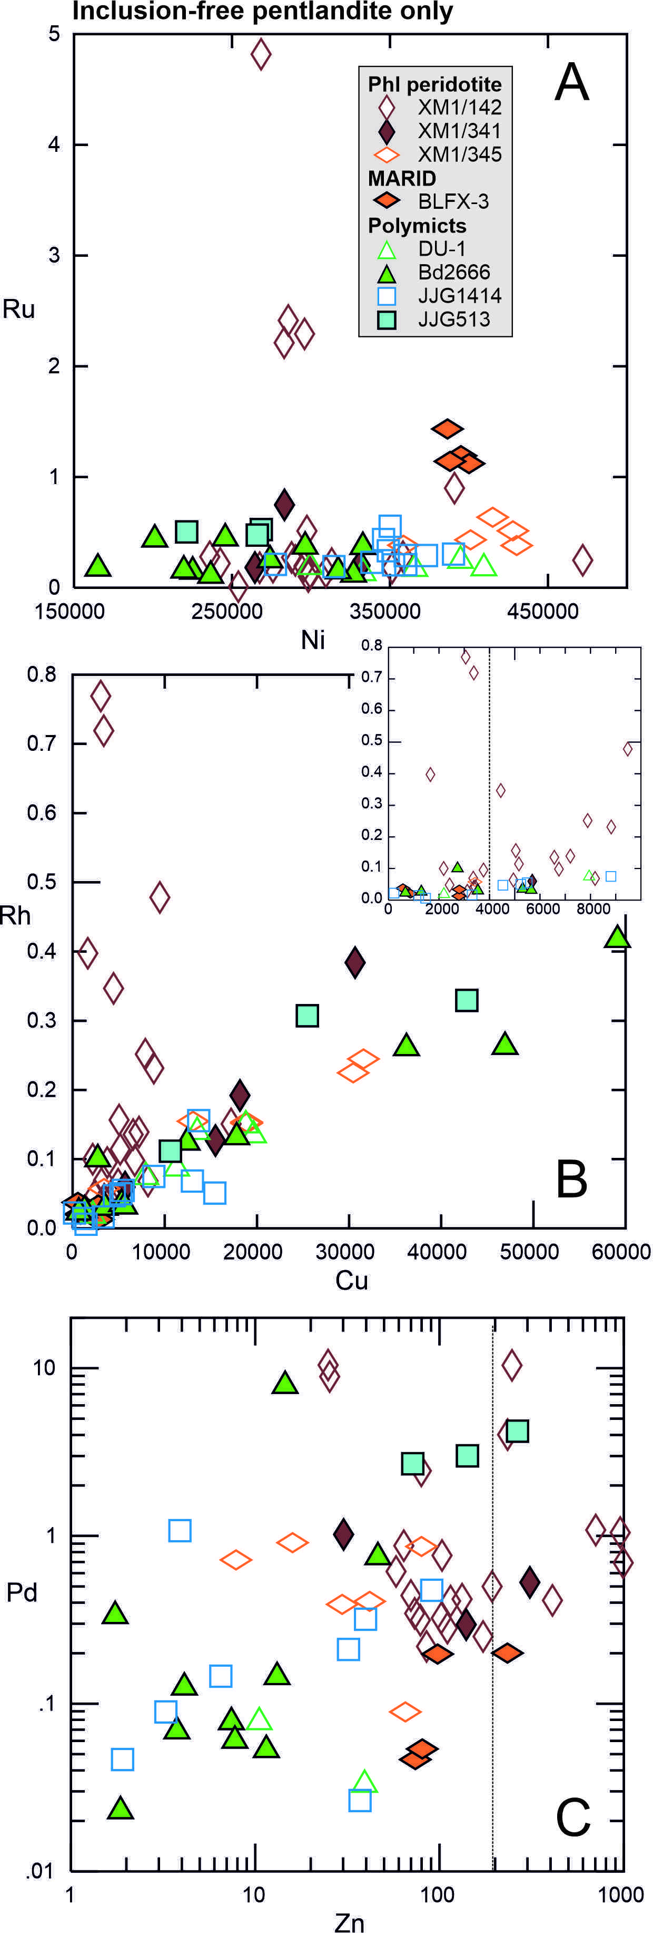
Figure S1 A. Ru as a function of Ni; B. Rh as a function of Cu; and C. Pd as a function of Zn (ppm) illustrating the effect of Ni-, Cu- and Zn-argide interferences. Only pure pentlandite analyses are shown to remove scatter arising from co-ablation of inclusions or mixed sulphide analyses. Inset in B shows area at lower Cu contents with a suggested cut-off below which argide interferences appear insignificant (stippled line). Stippled line in C similarly delimits Zn abundances below which argide interferences are undetectable.

Figure S2 Representative X-Ray elemental maps of major and minor elements in spinel in sample XM1-341_1
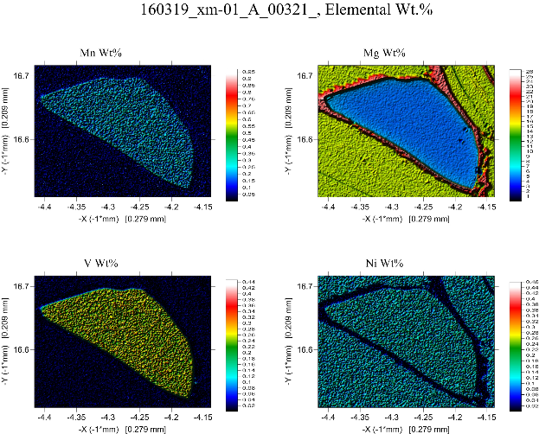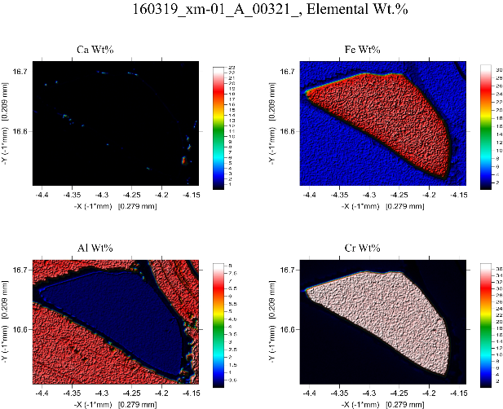
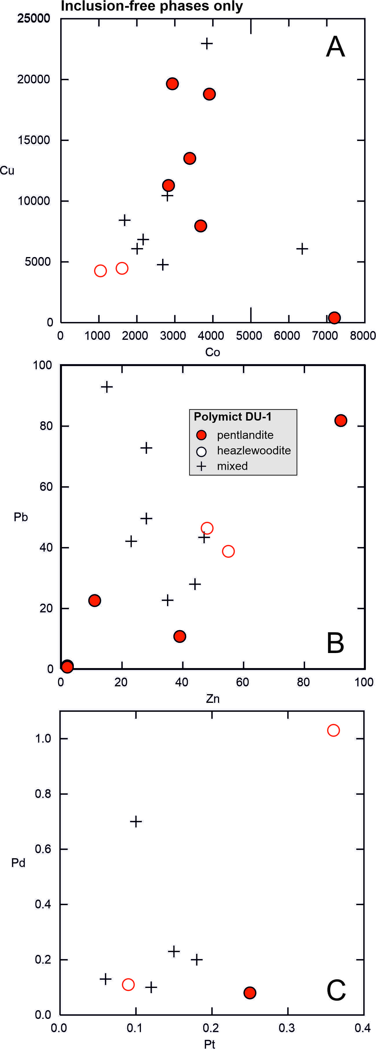
Figure S3 Trace-element abundances (ppm) in pure pentlandite and heazlewoodite vs. mixed analyses in polymict breccia DU-1, illustrating the effect of co-ablating mixed, intergrown sulphide phases. Only inclusion-free analyses are shown.

Figure S4 Trace element abundances (ppm) in pure pentlandite as a function of Si content, illustrating the effect of co-ablating secondary serpentine intergrown with sulphide minerals.
