**Supplements**

Table :Overview on selected test substances

and their respective CAS number. All chemicals were obtained in a purity ≥ 95 %.

|  |  |  |
| --- | --- | --- |
| **Test substance** | **CAS** | **Concentration [µM]** |
| DMSO | CAS: 67-68-5 |  |
| Aldicarb | 116-06-3 | 0.1, 0.33, 0.66, 1 |
| Diazinon | 333-41-5 | 1, 5, 10, 15 |
| Diazoxon | 962-58-3 | 0.5, 1, 2, 4 |
| Dichlorvos | 62-73-7 | 20, 22.5, 25, 30 |
| Paraoxon-ethyl | 311-45-5 | 0.01, 0.03, 0.06, 1 |
| Paraoxon-methyl | 950-35-6 | 1, 3.3, 6.6, 10 |
| TDCPP | 13674-87-8 | 0.1, 0.5, 1, 2 |
| DEHP | 117-81-7 | 0.5, 1, 5, 10 |
| MEHP | 4376-20-9 | 0.1, 0.5, 1, 5 |
| 4-NP | 104-40-5 | 0.1, 0.5, 1, 2 |

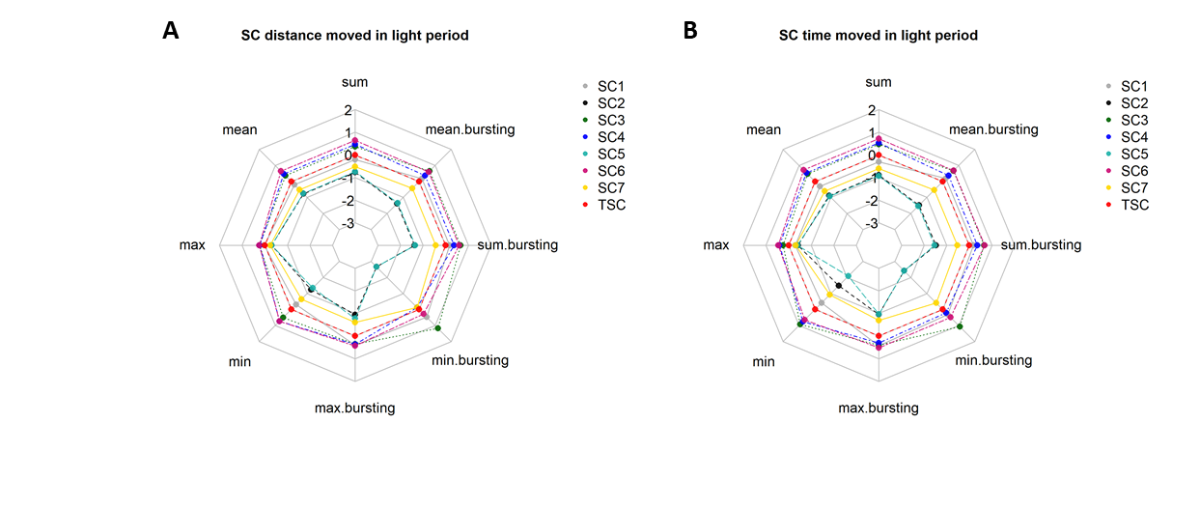

Figure S 1: Behavioural response of 5 dpf eleutheroembryos during the light period

Plotted data depict respective controls normalised to the mean of all controls (NTC/ STC) from the same condition (distance/duration) and log2 transformed. A) shows the distance moved by SCs and B) the time moved during the light period. SC= solvent control (0.01 % DMSO), TSC= total SC.

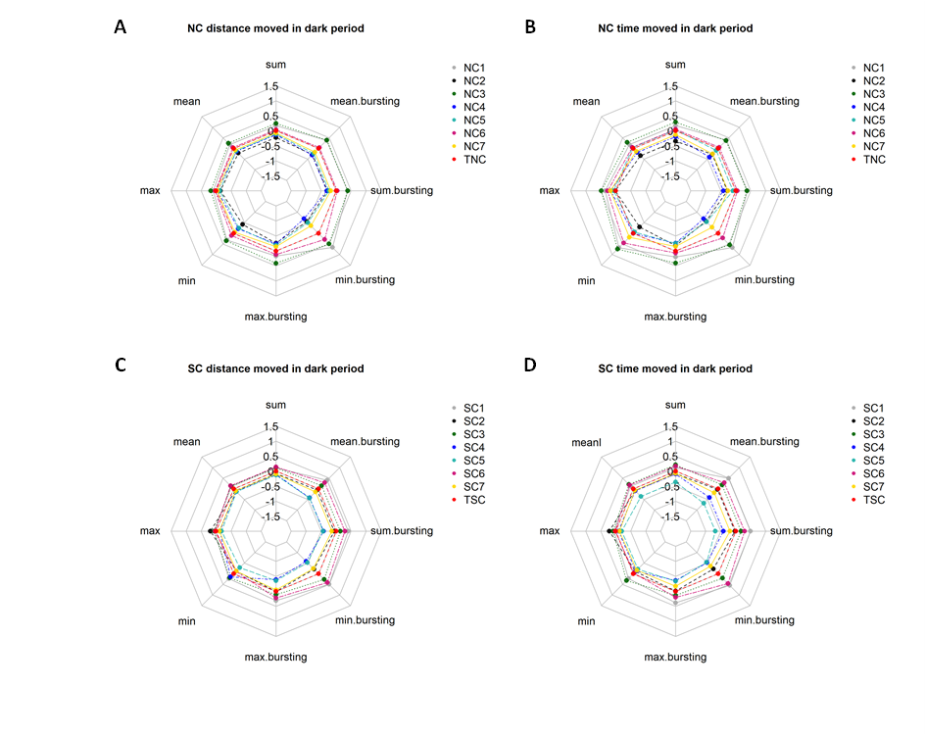

Figure S 2: Behavioural response of 5 dpf eleutheroembryos during the dark period.

Plotted data depict respective controls normalised to the mean of all controls (NTC/ STC) from the same condition (distance/duration) and log2 transformed. A) and C) show the distance moved by NCs and SCs during the dark period. B) and D) show the time moved of NC´s and SC´s during the dark period. NC= negative control (zfet), SC= solvent control (0.01 % DMSO), TSC= total SC.



Figure S 3: Violin plot

of TNC and TSC data for the respective parameter (distance/ time) and illumination condition (l= light, d= dark). Data were used for 95th percentile calculations and determination of cut-off values.

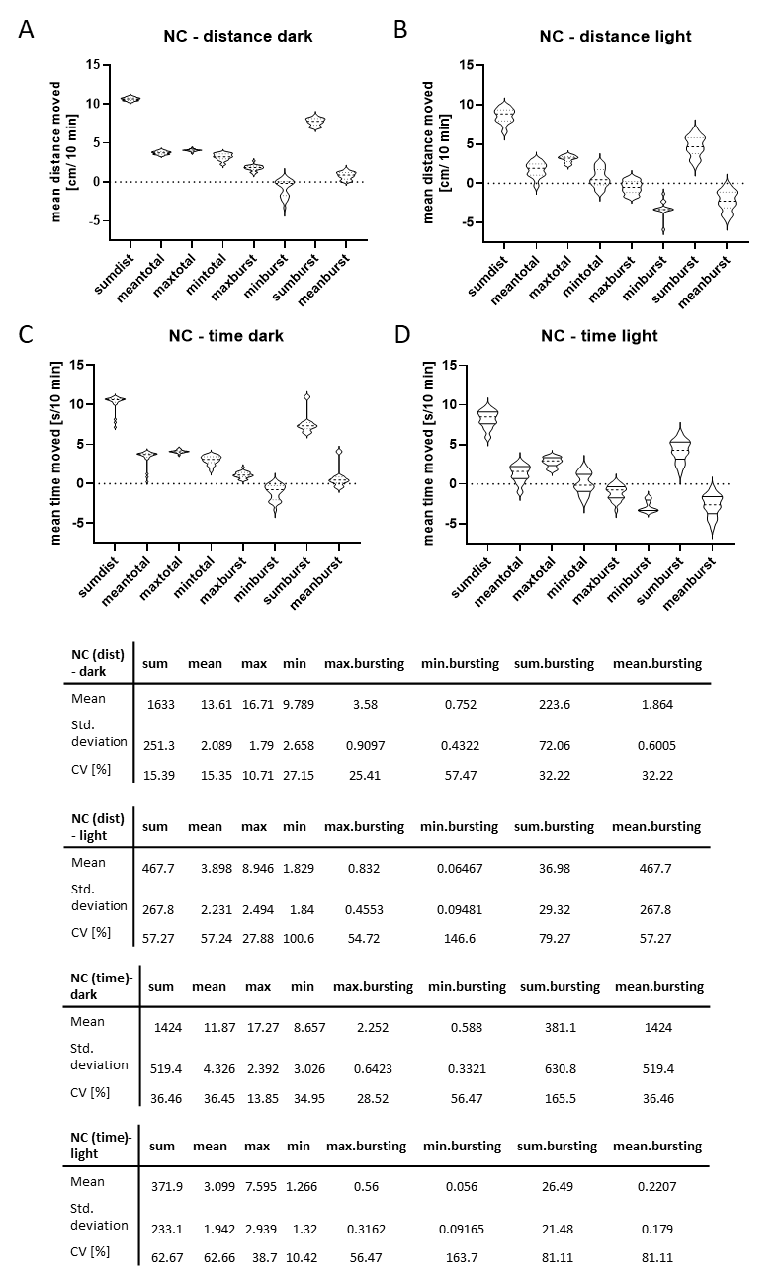

Figure S: Test parameter variability.

Figures A-D depict the variability of selected test parameters from negative control (NC) data during either dark (A & C) or light period (B & D) and as either distance (A & B) or time (C & D) moved. For better visualisation, raw data was log2 transformed using GraphPad Prism 8. The accompanying tables give the respective mean values, standard deviation and coefficient of variation in %. As evident from both figures and tables; variability between illumination conditions varied strongly. NC data were chosen for this analysis to depict the variability in controls in relation to each other.

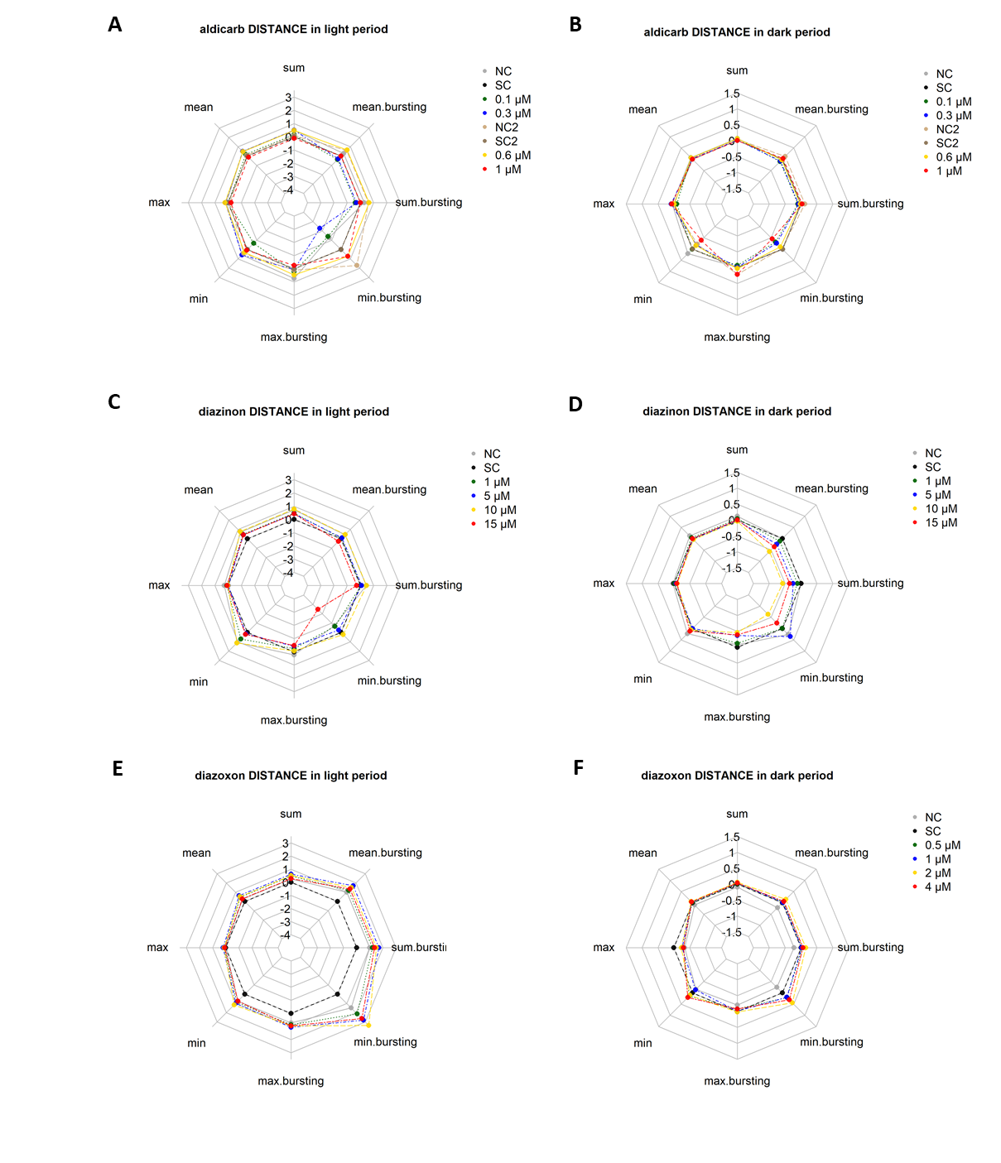

Figure S : Results from the LDT test using 5 dpf eleutheroembryos exposed for five days

to A) and B) aldicarb, C) and D) diazinon, E) and F) diazoxon, G) and H) dichlorvos. Radar charts depict behavioural parameters regarding the distance moved by embryos in light (A), C), E), G)) and darkness (B), D), F), H)). Sum/ mean total = sum/ mean total distance moved by embryos, max./min. total= mean of maximum/minimum total distance moved by embryos, max./min. bursting= mean of maximal/minimal distance moved by embryos during burst, sum/mean bursting= sum/mean total distance moved by embryos during burst. Maximum/minimum refers to the farthest/shortest distance measured for embryonic movement. SC =0.01% DMSO, n= 3 (diazinon, dichlorvos), n= 4(aldicarb and diazoxon)

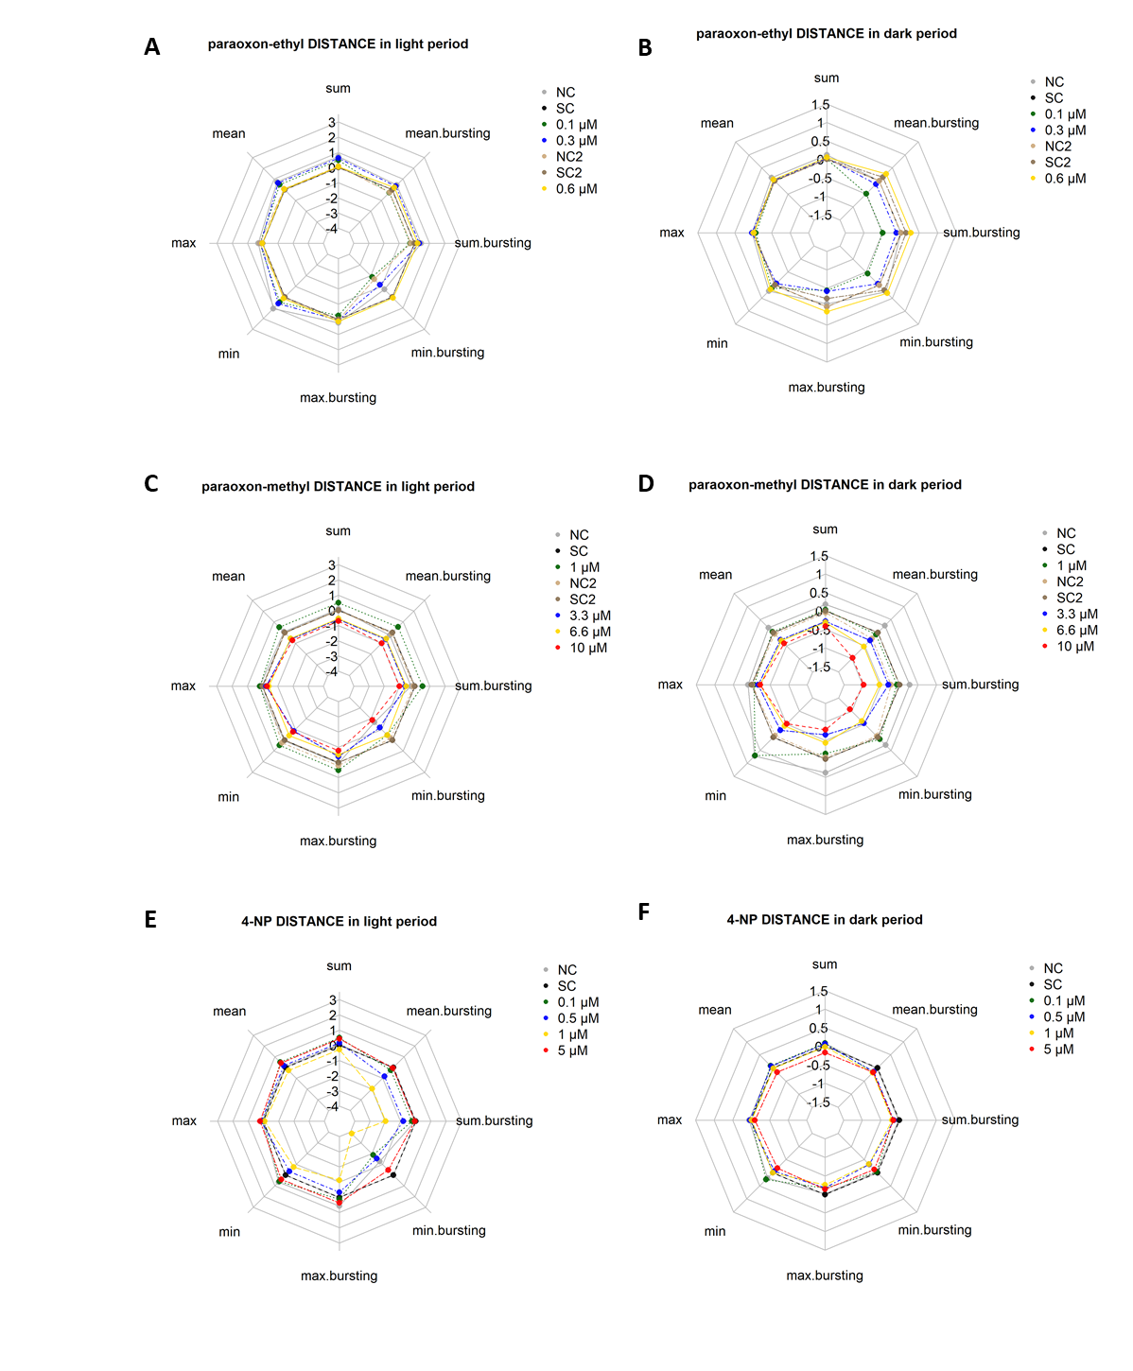

Figure S: Results from the LDT test using 5 dpf eleutheroembryos exposed for five days

to A) and B) paraoxon-ethyl, C) and D) paraoxon-methyl, E) and F) 4-NP. Radar charts depict behavioural parameters regarding the distance moved by embryos in light (A), C), E), G)) and darkness (B), D), F), H)). Sum/ mean total = sum/ mean total distance moved by embryos, max./min. total= mean of maximum/minimum total distance moved by embryos, max./min. bursting= mean of maximal/minimal distance moved by embryos during burst, sum/mean bursting= sum/mean total distance moved by embryos during burst. Maximum/minimum refers to the farthest/shortest distance measured for embryonic movement. SC =0.01% DMSO, n= 3 (paraoxon-ethyl, paraoxon-methyl), n= 4(4-NP)

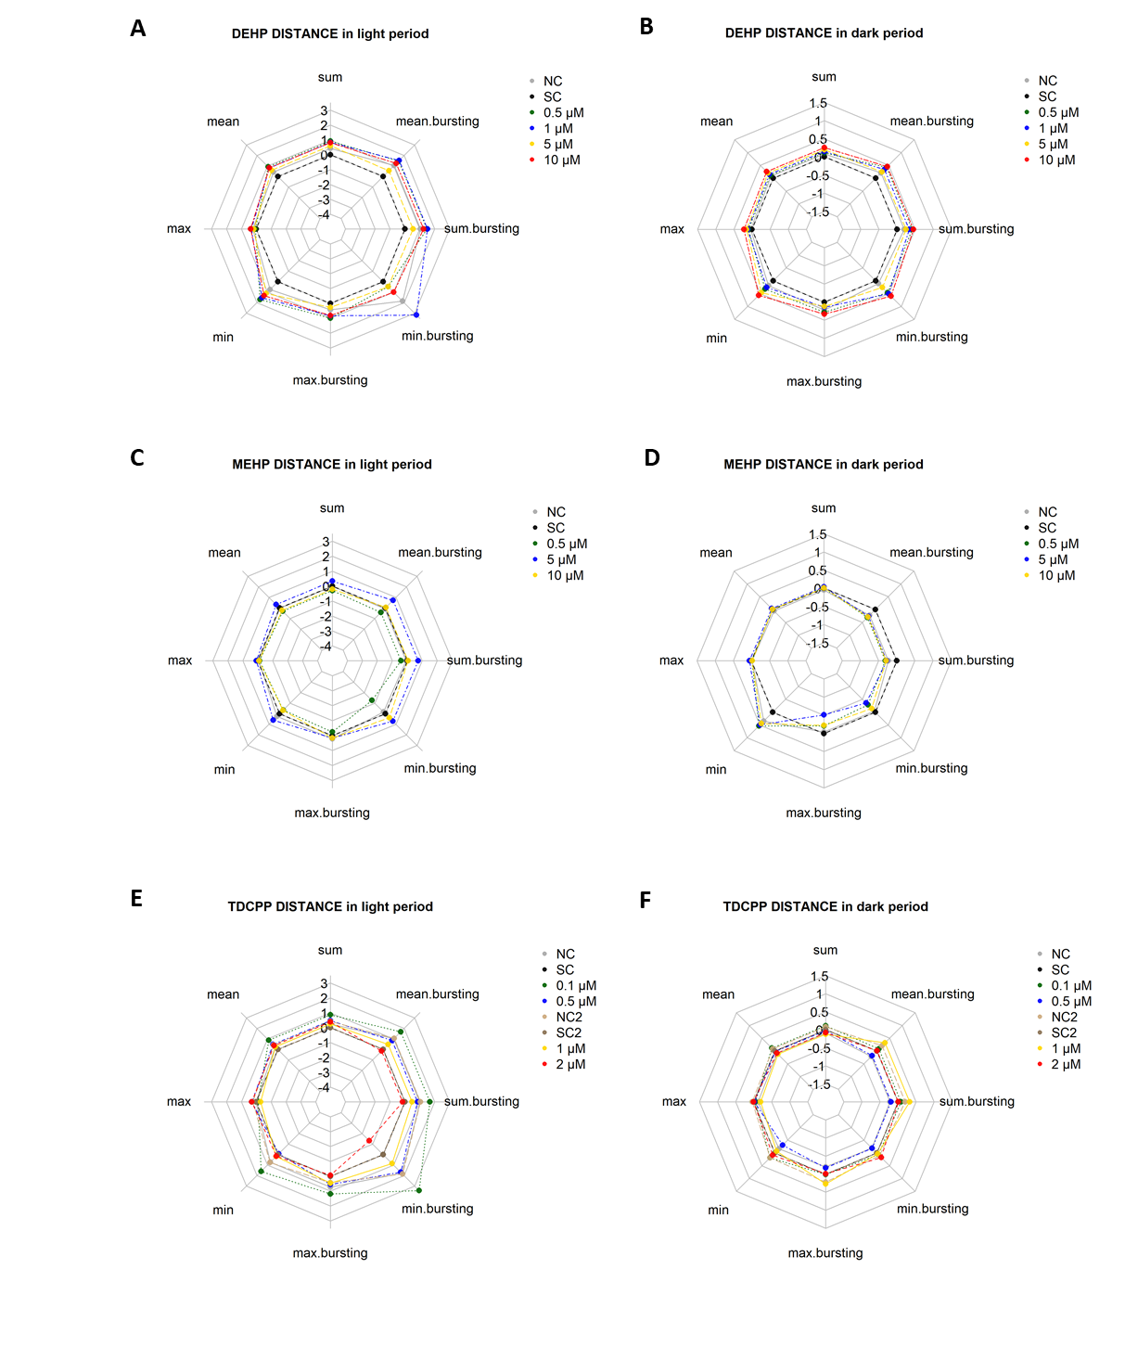

Figure S: Results from the LDT test using 5 dpf eleutheroembryos exposed for five days

to A) and B) DEHP, C) and D) MEHP, E) and F) TDCPP. Radar charts depict behavioural parameters regarding the distance moved by embryos in light (A), C), E)) and darkness (B), D), F)). Sum/ mean total = sum/ mean total distance moved by embryos, max./min. total= mean of maximum/minimum total distance moved by embryos, max./min. bursting= mean of maximal/minimal distance moved by embryos during burst, sum/mean bursting= sum/mean total distance moved by embryos during burst. Maximum/minimum refers to the farthest/shortest distance measured for embryonic movement. SC =0.01% DMSO. n= 3 (MEHP), n= 4 (DEHP and TDCPP).

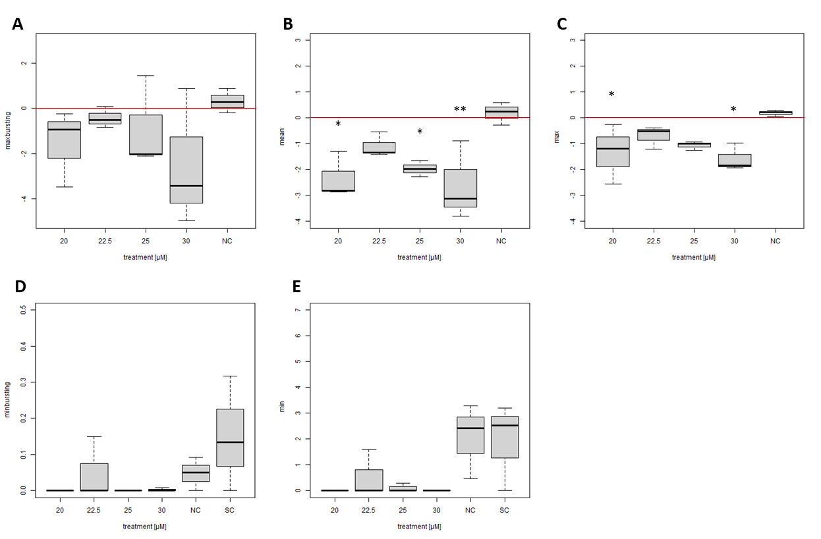

Figure S8: Statistical analysis of dichlorvos exposed embryos in the light period

for the parameter distance moved. A) *max.bursting*, B) *mean*, C) *max*., D) *min.bursting*, E) *min.*. Figures A)-C) depict log2 fold change and figures D) and E) absolute values. The red line indicates the SC. Error bars indicate the standard deviation Asterisks mark results significantly different from the NC (A)-C) or the SC (D) and E). *= p ≤ 0.05, **= p ≤ 0.01.

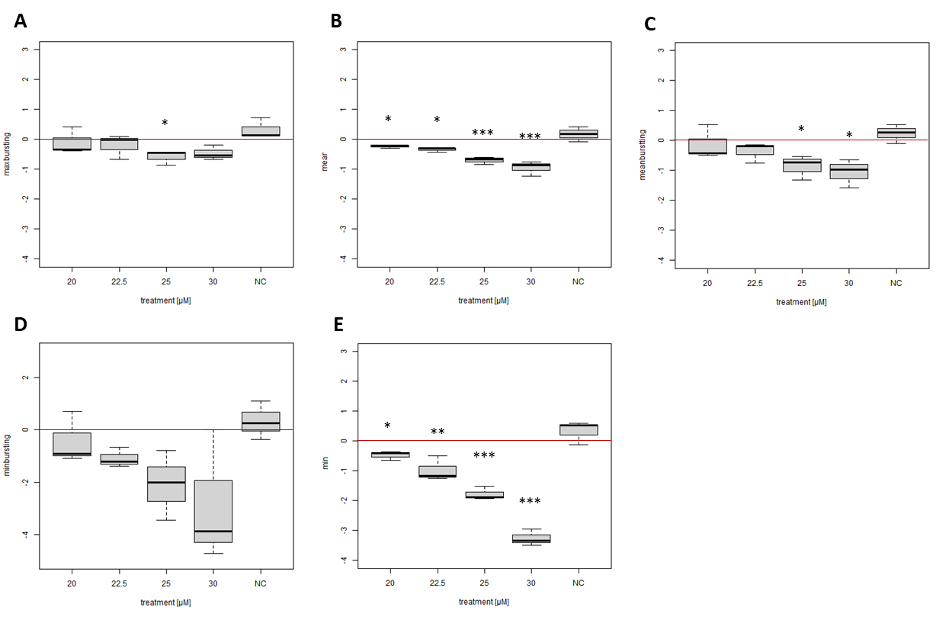

Figure S9: Statistical analysis of dichlorvos exposed embryos in the dark period

for the parameter distance moved. A) *max.bursting,* B) *mean*, C) *mean.bursting*, D) *min.bursting*, E) *min*. Figures depict log2 fold change values. The red line indicates the SC. Error bars indicate the standard deviation Asterisks mark results significantly different from the NC. *= p ≤ 0.05, **= p ≤ 0.01. n = 3.

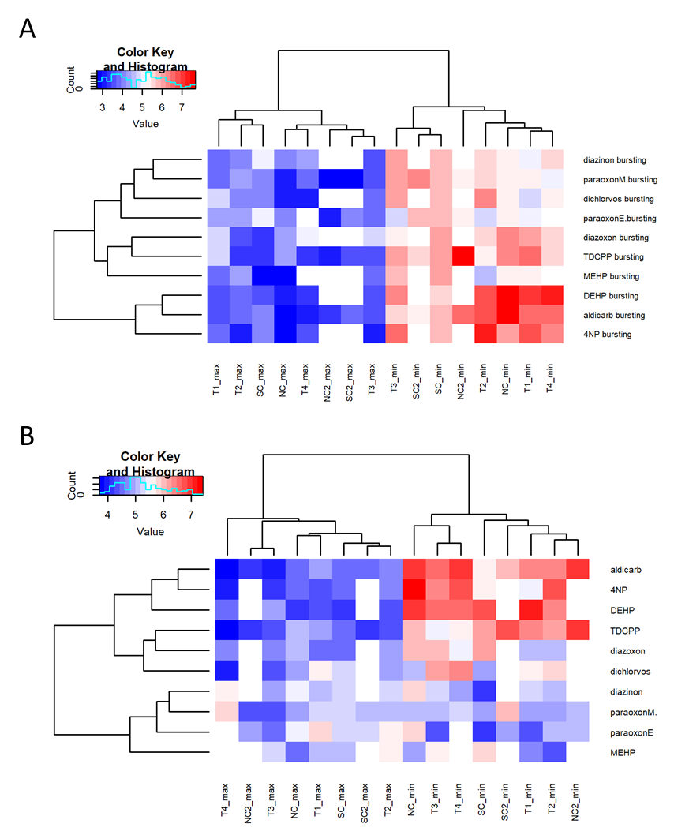

Figure S10: Timely occurrence of minimal and maximal distance moved in the dark period.

Heatmap A) depicts minima and maxima data on the distance moved during bursting and B) on the overall distance. The colour key indicates the time in minutes (blue early, red late during 10 minutes tracking period). White sqares imply missing data, e.g. for NC2 or SC2 as these were needed for a limited set of test substance, only. NC = negative control, SC =  solvent control, max =  maximum, min = minimum. Heatmaps and hierarchical clustering were done using R version 4.0.2 with the heatmap.2 function of the gplots package (R Core Team, 2020; Warnes et al., 2016).

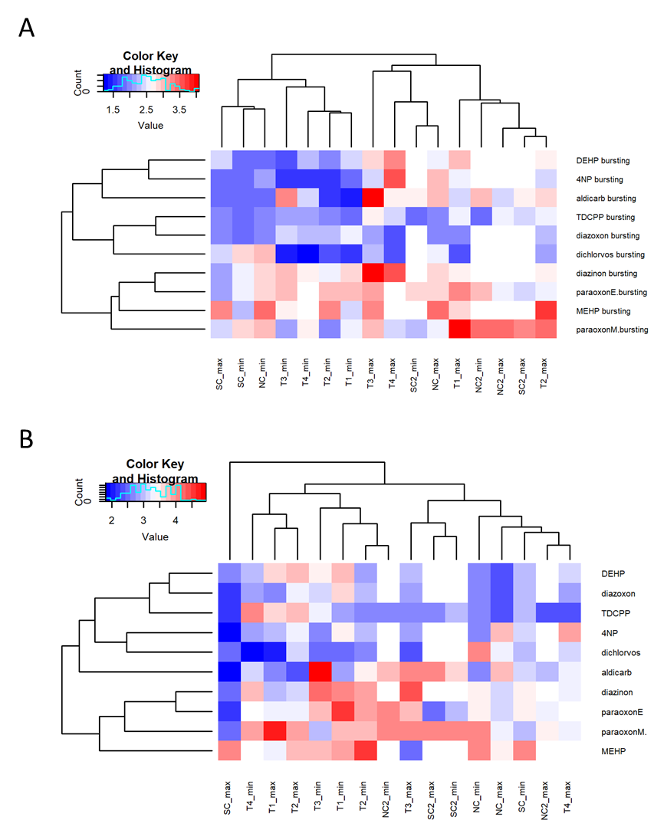

Figure S11: Timely occurrence of minimal and maximal distance moved in the light period.

Heatmap A) depicts minima and maxima data on the distance moved during bursting and B) on the overall distance. Data do not show a monotonic occurrence of minima and maxima as compared to data of the dark period (Figure S10). The colour key indicates the time in minutes (blue early, red late during 10 minutes tracking period). White sqares imply missing data, e.g. for NC2 or SC2 as these were needed for a limited set of test substance, only. NC = negative control, SC =  solvent control, max =  maximum, min = minimum. Heatmaps and hierarchical clustering were done using R version 4.0.2 with the heatmap.2 function of the gplots package (R Core Team, 2020; Warnes et al., 2016).



Figure S : Results representing the transition from light to darkness.

The differences due to the transition are expressed as mean distance moved [cm] (A, C) or mean time moved [s] (B, D) calculated from the last minute during light and the first minute of the dark period. Error bars indicate the standard deviation. Data were derived from three replicates with 12 organisms each. *= p< 0.05.

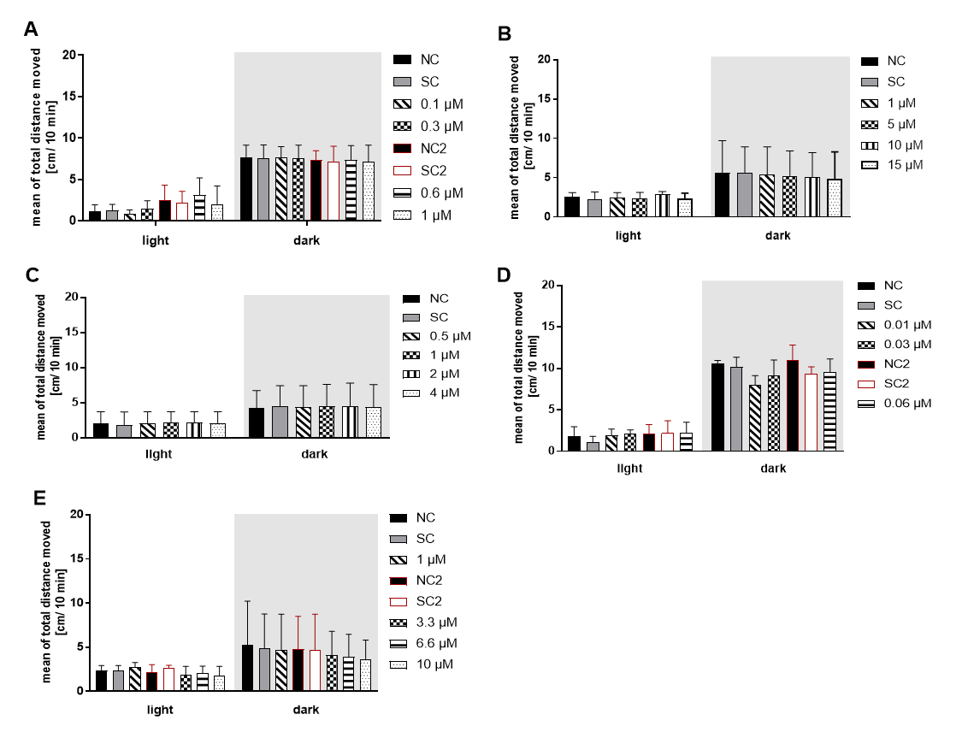

Figure S: Bar graphs from the LDT test using 5 dpf eleutheroembryos and exposed for five days

to A) aldicarb, B) diazinon, C) diazoxon, D) paraoxon-ethyl, E) paraoxon-methyl. Data are displayed as mean of the total distance moved/ 10 min. time interval. Error bars indicate the standard deviation. For Graphs A), D) and E) additional controls are depicted since the respective exposures could not be investigated on one plate. SC =0.01% DMSO. n= 3 for B), D), E), and n= 4 for A), C)



Figure S14: Bar graphs from the LDT test using 5 dpf eleutheroembryos and exposed for five days

to A) TDCPP, B) NP, C) DEHP, D) MEHP, E) TDCPP, F) 4-NP, G) DEHP, H) MEHP. Data are displayed as mean of the total distance moved/ 10 min. time interval. Error bars indicate the standard deviation. For Graph A) additional controls are depicted since the respective exposures could not be investigated on one plate. SC =0.01% DMSO. n= 3 for B), D) and n= 4 for A), C).