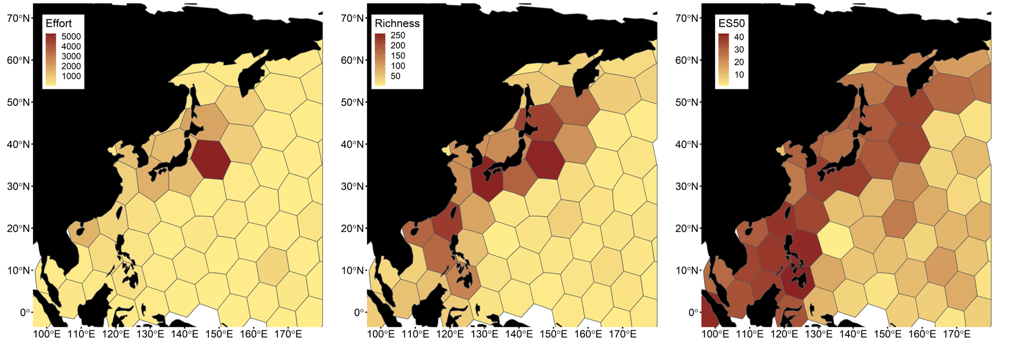
Figure A1. Biodiversity patterns of selected crustacean taxa in the NWP. Sampling effort (abundance, left), species richness (middle) and expected species richness (ES50, right) of Thecostraca, Ostracoda, Copepoda and Malacostraca excl. Syncarida per hexagonal cells (ca. 700,000 km² per cell).
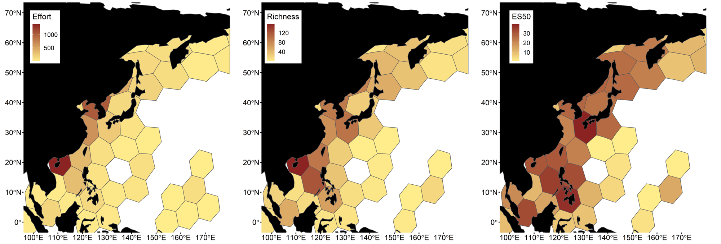
Figure A2. Biodiversity patterns of shallow (< 500 m) benthic crustaceans in the NWP. Sampling effort (abundance, left), species richness (middle) and expected species richness (ES50, right) of shallow water benthic crustaceans per hexagonal cells (ca. 700,000 km² per cell). Lower counts of coloured grid cells in species richness and expected species richness than in sampling effort are caused by distribution records that lack taxonomic identification to species level.

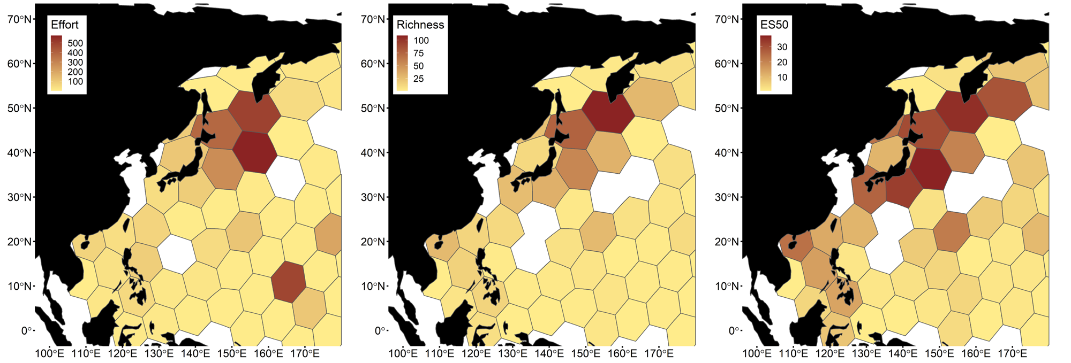
Figure A3. Biodiversity patterns of deep-sea (> 500 m) benthic crustaceans in the NWP. Sampling effort (abundance, left), species richness (middle) and expected species richness (ES50, right) of deep-sea benthic crustaceans per hexagonal cells (ca. 700,000 km² per cell). Lower counts of coloured grid cells in species richness and expected species richness than in sampling effort are caused by distribution records that lack taxonomic identification to species level.

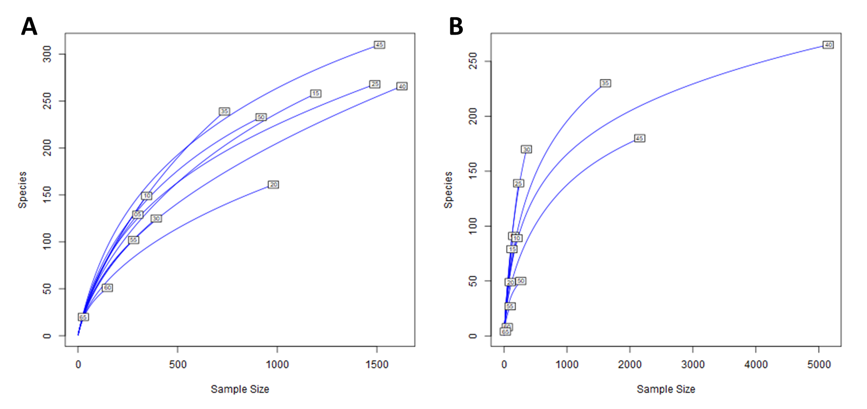
Figure A4. Rarefaction curves of benthic and pelagic crustacean taxa across a latitudinal gradient. Rarefaction curves were calculated for benthic (A) and pelagic crustacean taxa (B) across a latitudinal gradient (5° latitudinal bands).
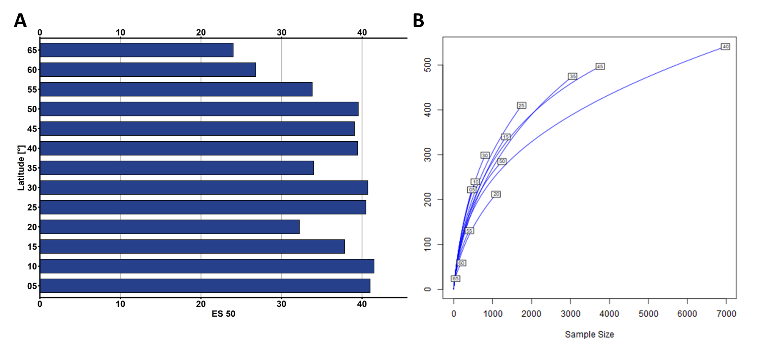
Figure A5. Distribution of expected species richness (ES50, A) and rarefaction curve (B) for selected crustacean taxa across a latitudinal gradient. ES 15 and rarefaction curves were calculated for Thecostraca, Ostracoda, Copepoda and Malacostraca excl. Syncarida across a latitudinal gradient (5° latitudinal bands).
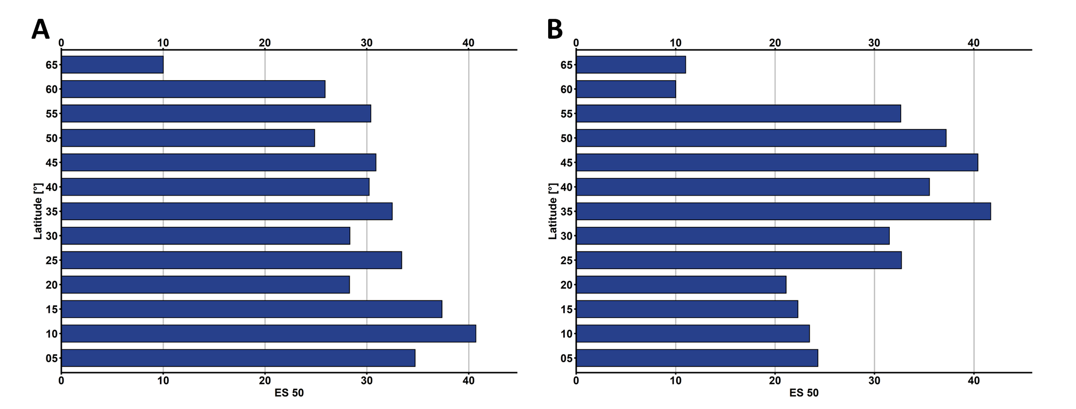
Figure A6. Distribution of expected species richness (ES50) for benthic shallow water (A) and deep-sea (B) crustaceans across a latitudinal gradient (5° latitudinal bands).
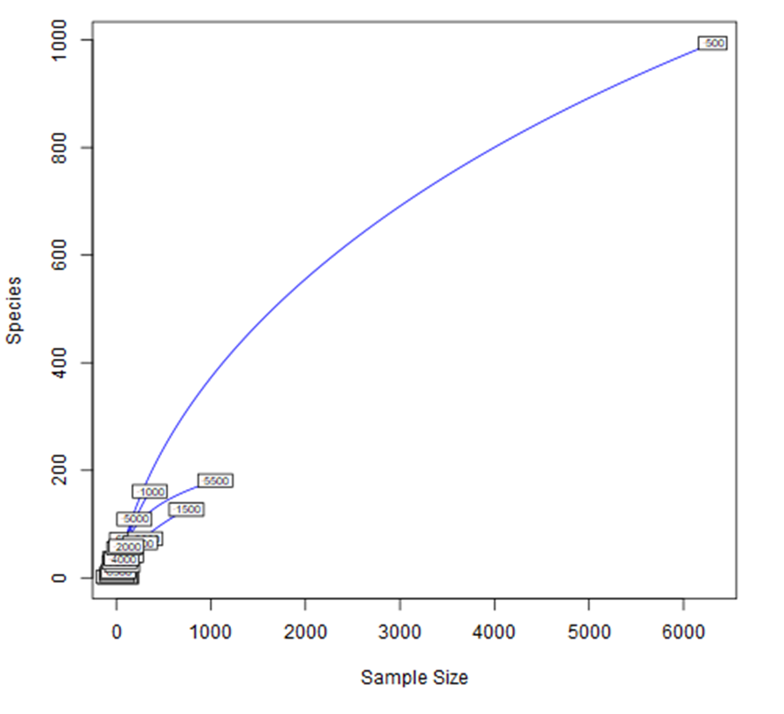
Figure A7. Rarefaction curves of benthic crustacean taxa across a bathymetric gradient. Rarefaction curves were calculated for benthic crustacean taxa across a bathymetric gradient (500 m depth intervals).

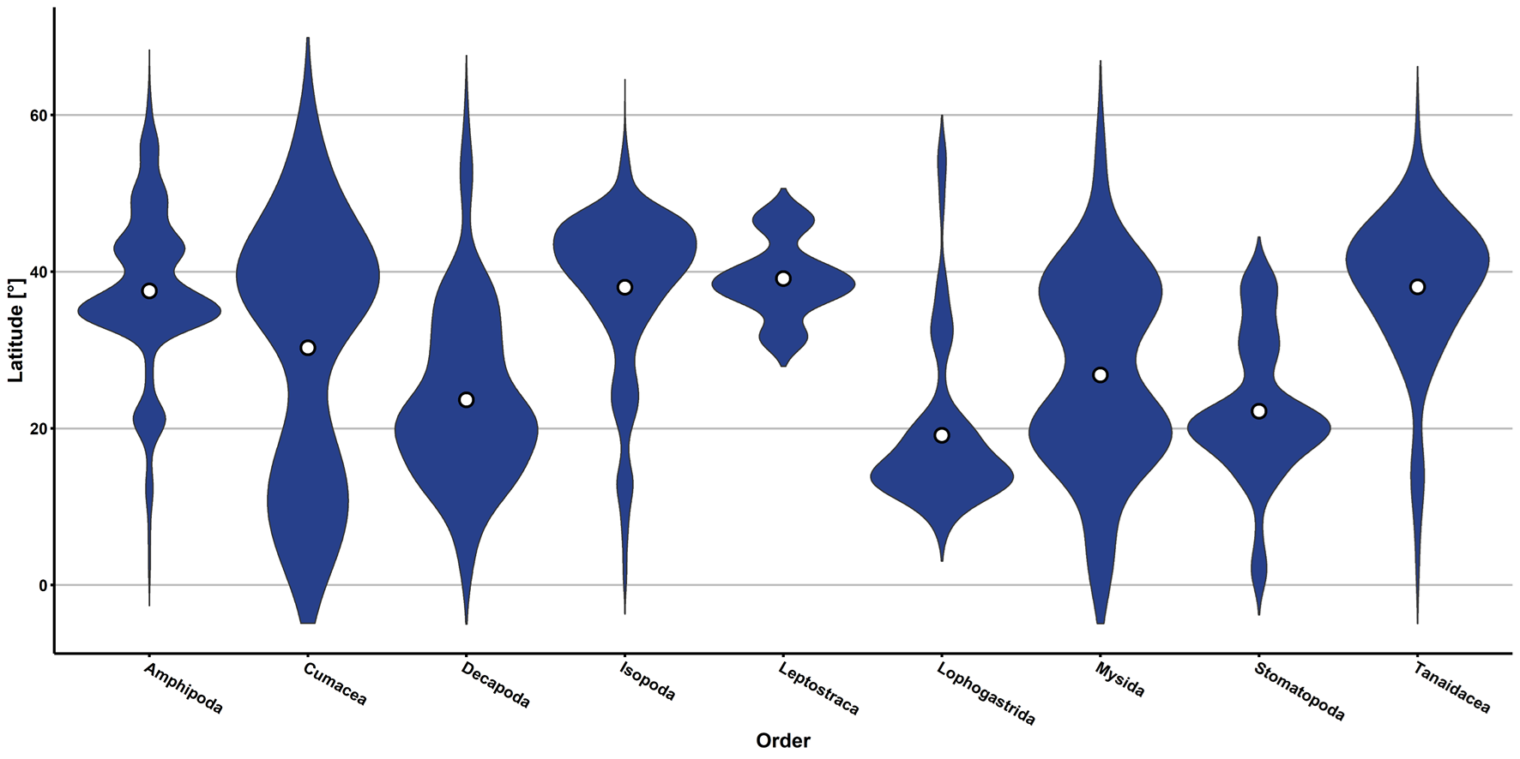
Figure A8. Abundance of malacostracan orders in the NWP across a latitudinal gradient. For readability each of these violin plots possesses the same maximum width, which in turn means no informative conclusions regarding comparisons of abundance across (sub-)classes is possible. The median of each plot is highlighted by a white dot.
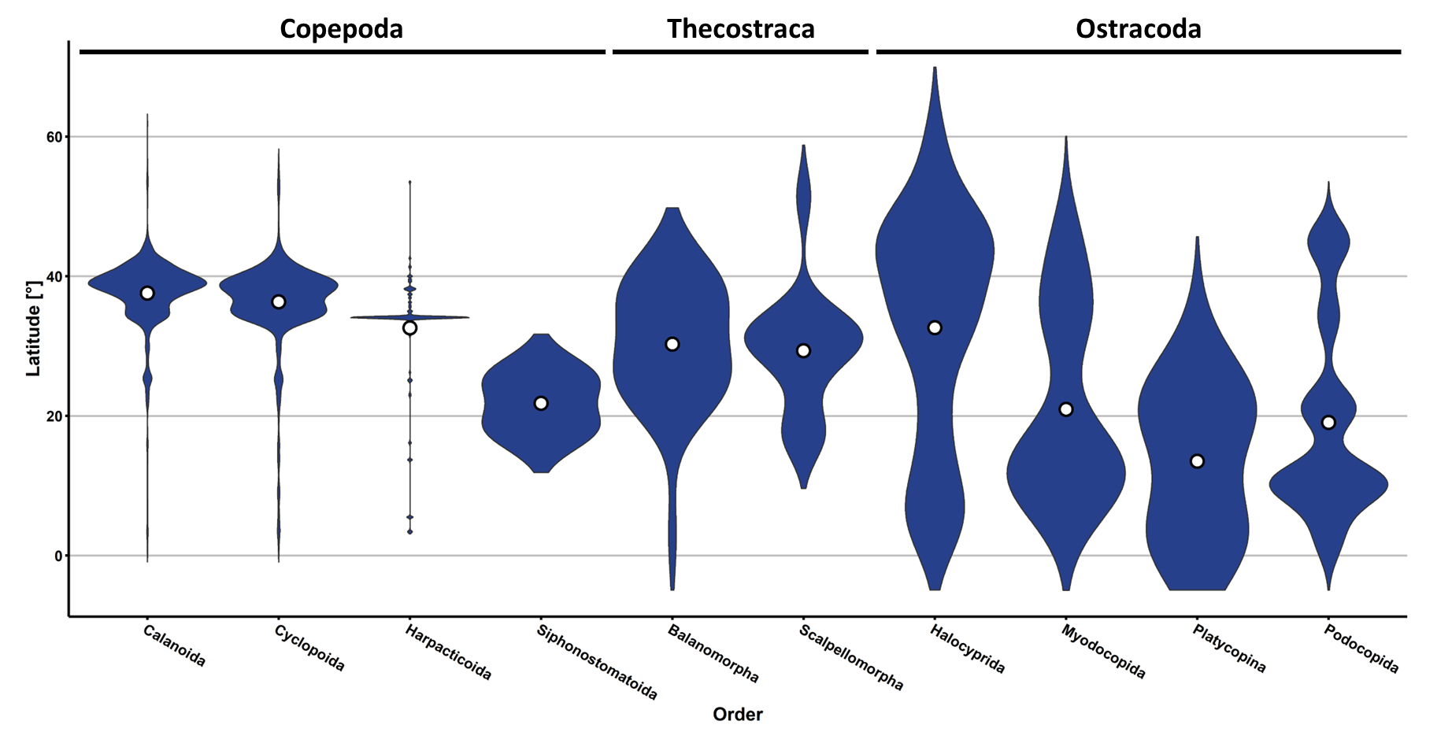
Figure A9. Abundance of non-malacostracan orders in the NWP across a latitudinal gradient. For readability each of these violin plots possesses the same maximum width, which in turn means no informative conclusions regarding comparisons of abundance across (sub-)classes is possible. The median of each plot is highlighted by a white dot.
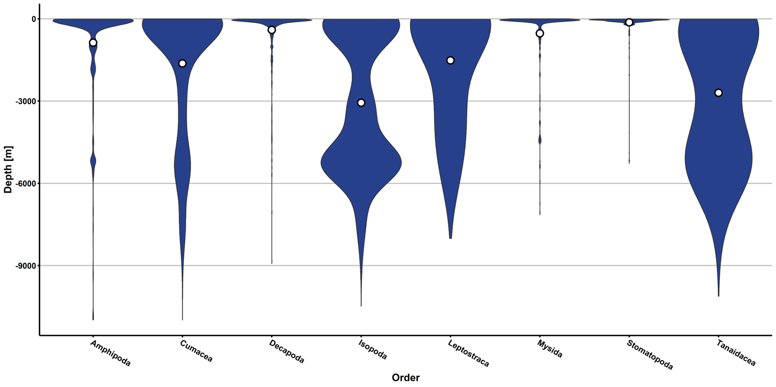
Figure A10. Abundance of benthic malacostracan orders in the NWP across a bathymetric gradient. Depth information was inferred from GEBCO’s maximum depth at each record’s geographical location, due to low coverage of depth information in the OBIS and GBIF database entries. For readability each of these violin plots possesses the same maximum width, which in turn means no informative conclusions regarding comparisons of abundance across (sub-)classes is possible. The median of each plot is highlighted by a white dot.
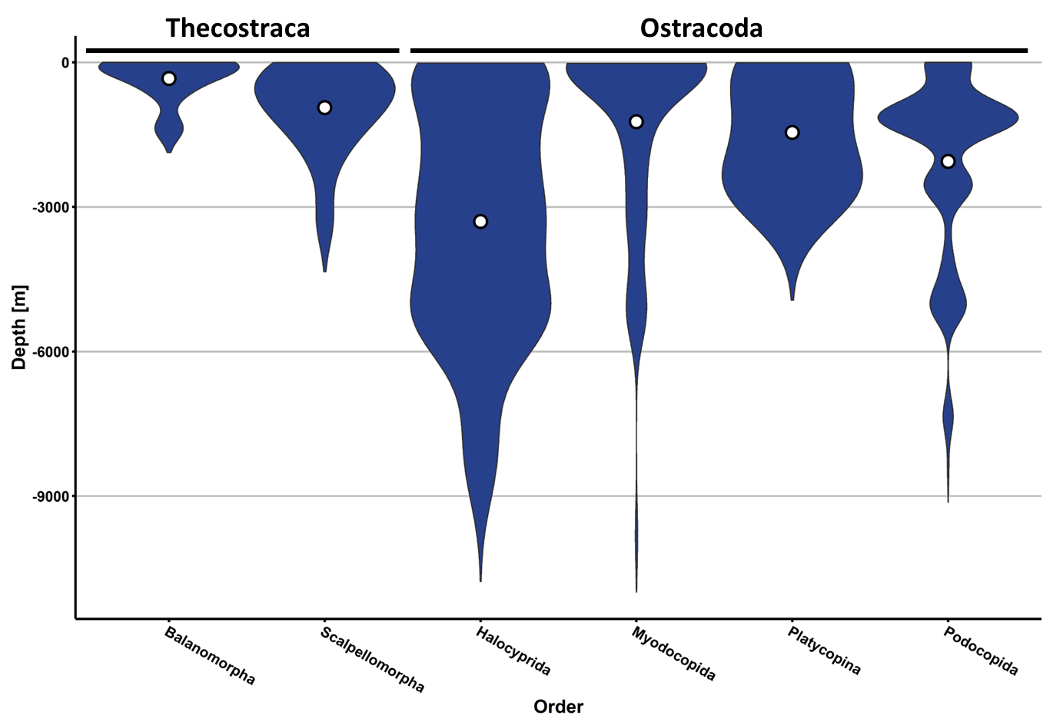
Figure A11. Abundance of benthic non-malacostracan orders in the NWP across a bathymetric gradient. Depth information was inferred from GEBCO’s maximum depth at each record’s geographical location, due to low coverage of depth information in the OBIS and GBIF database entries. For readability each of these violin plots possesses the same maximum width, which in turn means no informative conclusions regarding comparisons of abundance across (sub-)classes is possible. The median of each plot is highlighted by a white dot.
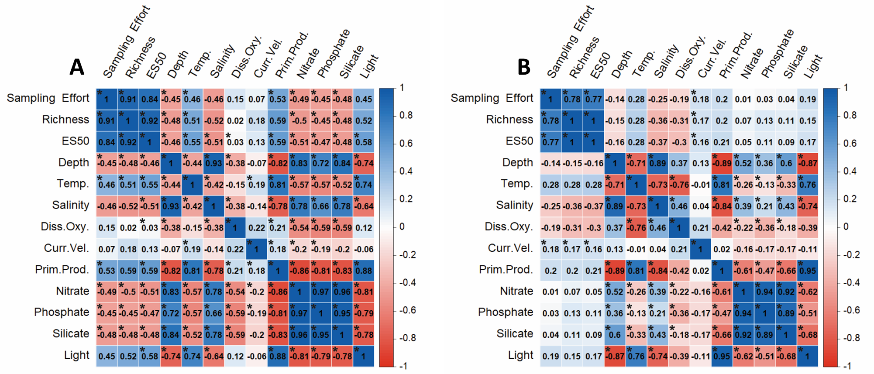
Figure A12. Correlation matrices of environmental factors in the NWP and biodiversity measurements of benthic shallow water (A) and deep-sea (B) crustaceans. Shallow-water and deep-sea benthic crustaceans were tested against the same set of environmental variables from Bio-ORACLE (bottom) using Spearman correlation. Correlation scores marked with an asterisk were significant on a 5% confidence level. Biodiversity measurements of crustaceans from shallow waters correlated positively with light, productivity, and temperature and negatively with depth, nitrate, phosphate, salinity, and silicate. Deep-sea crustacean biodiversity measurements exclusively exhibited weak positive correlations to current velocity.

