Online Appendix

Overwhelming Targeting Options:
Selecting Audience Segments for Online Advertising

Online Appendix A: Interviews with Industry Experts
Table A1: Summary of our Interviews with Industry Experts in Setting up Targeted Campaigns
(1)  Role  (years of experience) | (2)  Market side  (country) | (3)  How do you currently make  targeting decisions? | (4)  Do you conduct a break-even analysis beforehand?
Director of Data Science & Marketing Analytics  (15 yrs.) | Marketing Analytics Consulting  (DE) | Combination of broad and narrow segments | YES  (Benchmark: 0 profits)
Partner Manager  (6 yrs.) | Platform  (DE) | Mostly behavioral segments (e.g., interest or in-market segments) | SOMETIMES if the advertiser provides the required metrics  (Benchmark: 0 profits)
Digital Communications Specialist  (4 yrs.) | Agency  (AT) | Segments that provide a medium reach (e.g., as indicated by the Facebook campaign manager) | NO
CEO  (8 yrs.) | Agency  (AT) | Always broad and asks Facebook to find the right target group within that broadly specified audience | YES  (Benchmark: 0 Profits)
Trader Programmatic & Social Advertising  (2 yrs.) | Agency  (AT) | Mix of broad and narrow, behavioral segments (e.g., interest or in-market segments) | NO
Notes: DE: Germany; AT: Austria.

Online Appendix B: Field Experiment on Facebook

Online Appendix B.1: Ad Creatives and Descriptives
Figure B1: Ad Creatives
Notes: Each user saw all five creatives.

Table B1: Descriptive Statistics by Targeting Strategy
Targeting  Strategy |  | Budget  (in €) | Reach | Number of Impressions | CPM  (in €) | CTR  (in %) | Profit  (in €)
No-targeting | Avg. | 30.65 | 4,817.48 | 6,373.00 | 5.00 | 0.46 | 333.95
 | SD | 16.51 | 2,692.34 | 3,646.62 | 0.86 | 0.35 | 185.76
 | Min. | 0.16 | 39.00 | 42.00 | 3.41 | 0.00 | −5.19
 | Max. | 49.63 | 9,098.00 | 11,575.00 | 8.17 | 2.38 | 720.51
Broad- targeting | Avg. | 30.65 | 4,156.77 | 5,280.98 | 5.87 | 0.47 | 278.87
 | SD | 16.50 | 2,134.43 | 2,839.83 | 0.70 | 0.36 | 148.39
 | Min. | 0.33 | 48.00 | 50.00 | 4.33 | 0.00 | −0.33
 | Max. | 49.54 | 7,274.00 | 9,353.00 | 7.94 | 1.90 | 720.58
Narrow- targeting | Avg. | 30.65 | 3,680.55 | 4,784.86 | 6.62 | 0.54 | 323.60
 | SD | 16.60 | 1,914.04 | 2,587.43 | 1.30 | 0.33 | 186.80
 | Min. | 0.25 | 33.00 | 34.00 | 4.08 | 0.00 | −0.25
 | Max. | 50.48 | 6,112.00 | 8,304.00 | 10.63 | 2.31 | 833.15
Notes: Avg.: Average; SD: Standard deviation; Min.: Minimum; Max.: Maximum; CPM: Cost per mille; CTR: Click-through rate; data on the daily level; each targeting strategy received a total budget of €1,900 for 62 days.

As intended, all targeting strategies spent approximately the same budget per day; narrow-targeting generated fewer impressions, was more expensive, and created higher CTR than broad- and no-targeting (compare impressions, costs per mille (CPMs), and CTRs across targeting strategies).

Online Appendix B.2: Break-Even Performance
In this Online Appendix, we use Equation (8) in the main paper to calculate the break-even performance so that targeting is as profitable as no-targeting. Specifically, we find a break-even performance of 1.21 for broad-targeting (= (1/0.83) – (€4.81 – 0.83×€5.80)/
(1,000×0.83×0.36%×1.60%×€1,000)) and 1.33 for narrow-targeting (= (1/0.75) – (€4.81 – 0.75×€6.40)/(1,000×0.75×0.36%×1.60%×€1,000)). Those levels are higher than the realized performance increase of 1.02 (1.29) for broad- (narrow-) targeting, explaining why these selected strategies were less profitable than no-targeting.

Online Appendix C: Model Insights

Online Appendix C.1: Advertiser’s Profit under No-Targeting
We formalize the advertiser’s profit under no-targeting (${}_{0}$) by multiplying the number of conversions ($Q_{0}$) by the profit per conversion. The profit per conversion is the difference between the (absolute) margin per conversion ($m_{0}$) and the amount of money that the advertiser spends to acquire one conversion, called the acquisition cost (${acq}_{0}$):
 | $π_{0}=Q_{0}(m_{0}-{acq}_{0})$. | (C.1.1)
The number of conversions ($Q_{0}$) is equal to the number of ad impressions ($N_{0}$) multiplied by the click-through rate (${CTR}_{0}$) and the conversion rate (${CR}_{0}$). Therefore, $Q_{0}=N_{0}{CTR}_{0}{CR}_{0}$. Publishers usually charge advertisers per CPM. Thus, we calculate the cost of acquiring one conversion (acquisition cost) as follows:
 | $${acq}_{0}=\frac{{CPM}_{0}}{1,000{CTR}_{0}{CR}_{0}},$$ | (C.1.2)
where ${CPM}_{0}$ is the advertising cost in CPM (i.e., the cost an advertiser pays for 1,000 non-targeted ad impressions). Depending on whether the CPM is determined in an RTB auction or not, the advertiser inserts either the fixed price into Equation (C.1.1) or an expectation of the price that is the outcome of an advertising auction (platforms often provide advertisers with price estimates, even in case of RTB auctions). Next, we insert the number of conversions ($Q_{0}$) and the acquisition cost from Equation (C.1.2) into the advertiser’s profit under no-targeting in Equation (C.1.1) to yield the following advertiser’s profit function:
 | $$π_{0}=N_{0}{CTR}_{0}{CR}_{0}\left(m_{0}-\frac{{CPM}_{0}}{1,000{CTR}_{0}{CR}_{0}}\right).$$ | (C.1.3)

Online Appendix C.2: Effect of Changes in Click-Through Rate (α_{i}), Conversion Rate (β_{i}), and Reach (γ_{i}) on Advertiser’s Targeted Profit (π_{i})
Subsequently, we show how changes in the click-through rate, conversion rate, and margin per conversion (i.e., $α_{i}$, $β_{i}$, and $γ_{i}$, respectively) affect the advertiser’s profit ($π_{i}$) when targeting an audience segment $i$ ∈ I. We take the first derivate of the advertiser’s profit under targeting ($π_{i}$) with respect to $α_{i}$, $β_{i}$, and $γ_{i}$:
 | $$\frac{∂π_{i}}{∂α_{i}}=β_{i}γ_{i}δ_{i}{{N_{0}CTR}_{0}CR}_{0}m_{0},$$ | (C.2.1)

 | $$\frac{∂π_{i}}{∂β_{i}}=α_{i}γ_{i}δ_{i}{{N_{0}CTR}_{0}CR}_{0}m_{0},$$ | (C.2.2)

 | $$\frac{∂π_{i}}{∂γ_{i}}=α_{i}β_{i}δ_{i}{{N_{0}CTR}_{0}CR}_{0}m_{0}.$$ | (C.2.3)
Comparing equations (C.2.1), (C.2.2), and (C.2.3), we see that all of the derivatives are a function of $C=δ_{i}N_{0}{CTR}_{0}{CR}_{0}m_{0}$ and one of the three multipliers (i.e., $β_{i}γ_{i}$, $α_{i}γ_{i}$ and ${α_{i}β}_{i}$). More specifically, ${∂π_{i}}/{∂α_{i}}=f\left(C, β_{i},γ_{i}\right)$, ${∂π_{i}}/{∂β_{i}}=f\left(C, α_{i},γ_{i}\right)$, and ${∂π_{i}}/{∂γ_{i}}=f\left(C, α_{i}, β_{i}\right).$ Put differently, a given change in $α_{i}$, $β_{i}$, or $γ_{i}$ (say Δx), changes the profit by the same amount (holding other parameters fixed). Therefore, for simplicity, we denote $α_{i}β_{i}γ_{i}$ as the performance multiplier and investigate its combined effect on the advertiser’s profit under targeting.

Online Appendix C.3: Relationship Between the Decrease in Reach and Data Cost
Figure C1, Panel A, displays the relationship between the decrease in reach and the data cost in our Facebook field experiment. Setting (observed) CPM_{0t} = CPM_{it} (where 0 represents no-targeting, and i represents targeting audience segment $i$ ∈ I and on day t ∈ {1, 2, …, 62}), we estimate $\hat{λ}$ = 2.10 (i.e., the parameter that leads to the lowest sum of squared errors when predicting extra cost due to targeting audience segments). $\hat{λ}$ = 2.10, for example, indicates that the estimated cost of targeting an audience segment i with a reach of $δ_{i}$ = 0.7 is approximately €2.11 (i.e., $P_{i}=1/{δ_{i}^{\hat{λ}}}=1/{{0.7}^{2.10}=€2.11}$; see the dashed vertical and horizontal lines in Panel A).
Similar estimations based on data from Spotify lead to $\hat{λ}$ = 0.29 (see Panel B).
Figure C1: Relationship Between Decrease in Reach (δ_{i}) and Data Cost (P_{i}/DC_{i})

Panel A: Facebook

Panel B: Spotify
Notes: The dashed line represents the estimated values.

Online Appendix C.4: Effect of Reach on Break-Even Performance when ${}_{0}≤0$
If the untargeted campaign is not profitable (i.e., ${}_{0}≤0$), it would be sufficient for advertisers to calculate the break-even performance that leads to (at least) zero profits. In this section, we derive the corresponding break-even performance that leads to (at least) zero profits. Thus, we set Equation (4) to zero:
 | $$π_{i}=δ_{i}N_{0}{CTR}_{0}{CR}_{0}\left(α_{i}β_{i}γ_{i}m_{0}-\frac{{CPM}_{i}+1/{δ_{i}^{\hat{λ}}}}{1,000{CTR}_{0}{CR}_{0}}\right)=0.$$ | (C.4.1)

We then solve for the performance multiplier (i.e., $α_{i}β_{i}γ_{i}$) of audience segment $i$ with a given reach ($δ_{i}$):
 | $${\left(α_{i}β_{i}γ_{i}\right)}^{*}=\frac{{CPM}_{i}+1/{δ_{i}^{\hat{λ}}}}{1,000{CTR}_{0}{{CR}_{0}m}_{0}}.$$ | (C.4.2)
Equation (C.4.2) describes the minimum break-even performance of audience segment $i$, making targeting not unprofitable. This break-even performance has a negative and non-linear effect on the break-even performance because ${∂{(α_{i}β_{i}γ_{i})}^{*}}/{∂δ_{i}}<0$ and ${∂^{2}{(α_{i}β_{i}γ_{i})}^{*}}/{{∂δ_{i}}^{2}>0}$:
 | $$\frac{∂{\left(α_{i}β_{i}γ_{i}\right)}^{*}}{∂δ_{i}}=-\frac{\hat{λ}δ_{i}^{-\hat{λ}-1}}{1,000{CTR}_{0}{{CR}_{0}m}_{0}}<0$$ | (C.4.3)
and
 | $$\frac{∂^{2}{(α_{i}β_{i}γ_{i})}^{*}}{{∂δ_{i}}^{2}}=\frac{\hat{λ}\left(\hat{λ}+1\right)δ_{i}^{-\hat{λ}-2}}{1,000{CTR}_{0}{CR}_{0}m_{0}}>0.$$ | (C.4.4)

Online Appendix C.5: Effect of Reach on Break-Even Performance with Unknown Data Cost
The reach of an audience has a negative and non-linear effect on the break-even performance because:
 | $$\frac{∂{\left(α_{i}β_{i}γ_{i}\right)}^{*}}{∂δ_{i}}=-\frac{1,000{{}_{0}}/{N_{0}}+\hat{λ}δ_{i}^{1-\hat{λ}}}{1,000{δ_{i}^{2}CTR}_{0}{{CR}_{0}m}_{0}}<0$$ | (C.5.1)
and
 | $$\frac{∂^{2}{(α_{i}β_{i}γ_{i})}^{*}}{{∂δ_{i}}^{2}}=\frac{(\hat{λ}\left(\hat{λ}+1\right)δ_{i}+2δ_{i}^{\hat{λ}}1,000{{}_{0}}/{N_{0}})}{1,000{δ_{i}^{\hat{λ}+3}CTR}_{0}{CR}_{0}m_{0}}>0.$$ | (C.5.2)

Online Appendix C.6: Effect of Reach on Break-Even Performance with Known Data Cost
In this Online Appendix, we show that the first (second) derivatives of the break-even performance of audience segment $i$ with respect to its reach are negative (positive).
The first derivative of the break-even performance with respect to its reach is negative because:
 | $$\frac{∂{\left(α_{i}β_{i}γ_{i}\right)}^{*}}{∂δ_{i}}=-\frac{{}_{0}}{{δ_{i}}^{2}{N_{0}CTR}_{0}{CR}_{0}m_{0}}<0.$$ | (C.6.1)
The second derivative of the break-even performance with respect to its reach is positive because:
 | $$\frac{∂^{2}{(α_{i}β_{i}γ_{i})}^{*}}{{∂δ_{i}}^{2}}=\frac{2{}_{0}}{{δ_{i}}^{3}{N_{0}CTR}_{0}{CR}_{0}m_{0}}>0.$$ | (C.6.2)

Online Appendix D: Empirical Study on Spotify
Figure D1: Screenshot of Spotify Ad Studio for Building Audiences
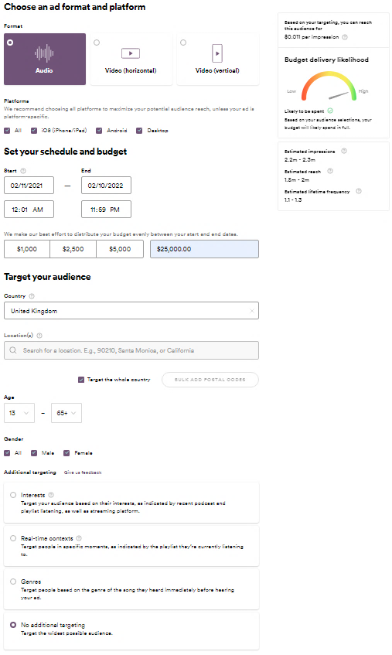
Figure D2: Minimum Lift in Performance Across Different Audience Segments
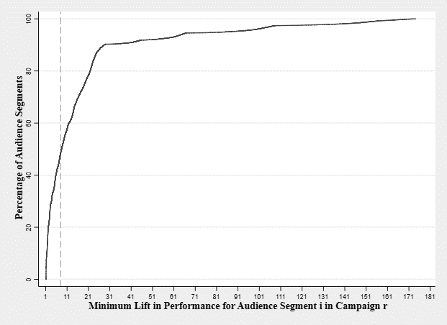
Notes: Results are based on a total of 45,440 (= 71×640) audience segments (i.e., audience segment i ∈ {1, 2, …, 71} in campaign r ∈ {1, 2, …, 640}); we assume $α_{i}{=β}_{i}=γ_{i}$.

Reading example: The dashed vertical line represents that around 50% of audience segments require a minimum increase in performance of more than 100% to be at least as profitable as no-targeting.
Figure D3. Hypothetical Advertiser on Spotify: Distribution of Minimum Lift in Performance (i.e., ${(α_{i}β_{i}γ_{i})}^{*}$) and Reach Across Different Audience Segments

Notes: Values of the bar charts are on the left-hand side; values of the dashed lines are on the right-hand side. Avg.: Average; SD: Standard deviation; Min.: Minimum.
We use the following values to derive the results: Number of impressions (N₀) = 1,800,000; click-through rate (CTR₀) = 1.00%; conversion rate (CR₀) = 2.00%; margin per conversion (m₀) = $200.00; CPM under no-targeting (CPM₀) = $11.00; CPM under targeting an audience segment $i$ (CPM_{i} + DC_{i}) varies from $11.00 to $15.00; subscript 0 refers to no-targeting, and subscript i refers to targeting audience segment i ∈ I.

Table D1: Summary of Audience Segments for Targeting Based on Interests, Real-Time Contexts, and Genre
Audience i | Reach in 000s  (% of all free users) |  | Cost of no-targeting (i.e., CPM₀) | Total Cost of targeting  (i.e., CMP_{i} + DC_{i})
Interests
Books | 170 | (9.44%) | $ 11.00 | $ 14.00
Business | 280 | (15.56%) | $ 11.00 | $ 14.00
Comedy | 550 | (30.56%) | $ 11.00 | $ 14.00
Commuting | 220 | (12.22%) | $ 11.00 | $ 14.00
Cooking | 26 | (1.44%) | $ 11.00 | $ 14.00
Culture & Society | 600 | (33.33%) | $ 11.00 | $ 14.00
DIY Hobbies & Crafts | 60 | (3.33%) | $ 11.00 | $ 14.00
Education | 270 | (15.00%) | $ 11.00 | $ 14.00
Fitness | 26 | (1.44%) | $ 11.00 | $ 14.00
Gaming | 550 | (30.56%) | $ 11.00 | $ 14.00
Health & Lifestyle | 430 | (23.89%) | $ 11.00 | $ 14.00
History | 65 | (3.61%) | $ 11.00 | $ 14.00
In-Car Listening | 800 | (44.44%) | $ 11.00 | $ 14.00
Love & Dating | 190 | (10.56%) | $ 11.00 | $ 14.00
News | 230 | (12.78%) | $ 11.00 | $ 14.00
Parenting | 600 | (33.33%) | $ 11.00 | $ 14.00
Partying | 300 | (16.67%) | $ 11.00 | $ 14.00
Podcasts | 900 | (50.00%) | $ 11.00 | $ 14.00
Running | 150 | (8.33%) | $ 11.00 | $ 14.00
Science & Medicine | 70 | (3.89%) | $ 11.00 | $ 14.00
Sport & Recreation | 170 | (9.44%) | $ 11.00 | $ 14.00
Studying or Focusing | 210 | (11.67%) | $ 11.00 | $ 14.00
TV & Film | 90 | (5.00%) | $ 11.00 | $ 14.00
Tech | 850 | (47.22%) | $ 11.00 | $ 14.00
Theater | 65 | (3.61%) | $ 11.00 | $ 14.00
Travel | 70 | (3.89%) | $ 11.00 | $ 14.00
Real-Time Context
Chill | 85 | (4.72%) | $ 11.00 | $ 15.00
Cooking | 85 | (4.72%) | $ 11.00 | $ 15.00
Dinner | 38 | (2.11%) | $ 11.00 | $ 15.00
Focus | 150 | (8.33%) | $ 11.00 | $ 15.00
Gaming | 100 | (5.56%) | $ 11.00 | $ 15.00
Holidays | 11 | (0.61%) | $ 11.00 | $ 15.00
Party | 75 | (4.17%) | $ 11.00 | $ 15.00
Study | 75 | (4.17%) | $ 11.00 | $ 15.00
Travel | 120 | (6.67%) | $ 11.00 | $ 15.00
Workout | 110 | (6.11%) | $ 11.00 | $ 15.00
Genre
Alternative | 440 | (24.44%) | $ 11.00 | $ 13.00
Blues | 16 | (0.89%) | $ 11.00 | $ 13.00
Christian | 70 | (3.89%) | $ 11.00 | $ 13.00
Classical | 70 | (3.89%) | $ 11.00 | $ 13.00
Country | 120 | (6.67%) | $ 11.00 | $ 13.00
Easy Listening | 120 | (6.67%) | $ 11.00 | $ 13.00

Table D1: Data from Spotify Ad Studio: Summary of Audience Segments for Targeting Based on Interests, Real-Time Contexts, and Genre—Continued
Audience i | Reach in 000s  (% of all free users) |  | Cost of no-targeting (i.e., CPM₀) | Total Cost of targeting  (i.e., CMP_{i} + DC_{i})
EDM | 320 | (17.78%) | $ 11.00 | $ 13.00
Electronica | 410 | (22.78%) | $ 11.00 | $ 13.00
Folk | 230 | (12.78%) | $ 11.00 | $ 13.00
Funk | 60 | (3.33%) | $ 11.00 | $ 13.00
Hip Hop | 900 | (50.00%) | $ 11.00 | $ 13.00
Holiday | 16 | (0.89%) | $ 11.00 | $ 13.00
House | 310 | (17.22%) | $ 11.00 | $ 13.00
Indie Rock | 550 | (30.56%) | $ 11.00 | $ 13.00
Jazz | 75 | (4.17%) | $ 11.00 | $ 13.00
Latin | 100 | (5.56%) | $ 11.00 | $ 13.00
Metal | 150 | (8.33%) | $ 11.00 | $ 13.00
New Age | 75 | (4.17%) | $ 11.00 | $ 13.00
Pop | 1,200 | (66.67%) | $ 11.00 | $ 13.00
Punk | 200 | (11.11%) | $ 11.00 | $ 13.00
Reggae | 110 | (6.11%) | $ 11.00 | $ 13.00
RnB | 330 | (18.33%) | $ 11.00 | $ 13.00
Rock | 700 | (38.89%) | $ 11.00 | $ 13.00
Soundtrack | 180 | (10.00%) | $ 11.00 | $ 13.00
Spoken & Audio | 10 | (0.56%) | $ 11.00 | $ 13.00
Traditional | 120 | (6.67%) | $ 11.00 | $ 13.00
Notes: Data from Spotify Ad Studio (https://adstudio.spotify.com/).

Table D2: Hypothetical Advertiser on Spotify: Minimum Lift in CTR₀ When Topping-Up Targeted Audience Segments
Audience(s) i | Reach in 000s  (% of all users) |  | Cost of no-targeting  (i.e., CPM₀) | Total Cost of targeting  (i.e., CMP_{i} + DC_{i}) | Min. lift in CTR₀ ($α_{i}^{*}$)
Interests
Fitness | 26 | (1.44%) | $ 11.00 | $ 14.00 | 3.70
Fitness/Health & Lifestyle | 450 | (25.00%) | $ 11.00 | $ 14.00 | 1.48
Fitness/Health & Lifestyle/Running | 550 | (30.00%) | $ 11.00 | $ 14.00 | 1.40
Theatre | 65 | (3.61%) | $ 11.00 | $ 14.00 | 2.73
Theatre/TV & Film | 150 | (8.33%) | $ 11.00 | $ 14.00 | 2.08
Theatre/TV & Film/Comedy | 650 | (36.11%) | $ 11.00 | $ 14.00 | 1.33
In-Car Listening | 800 | 44.44% | $ 11.00 | $ 14.00 | 1.26
In-Car Listening/Commuting | 850 | 47.22% | $ 11.00 | $ 14.00 | 1.24
In-Car Listening/Commuting/Travel | 900 | 50.00% | $ 11.00 | $ 14.00 | 1.22
Education | 270 | (15.00%) | $ 11.00 | $ 14.00 | 1.73
Education/Studying or Focusing | 440 | (24.44%) | $ 11.00 | $ 14.00 | 1.49
Real-Time Contexts
Chill | 85 | (4.72%) | $ 11.00 | $ 15.00 | 2.51
Chill/Cooking | 170 | (9.44%) | $ 11.00 | $ 15.00 | 2.00
Chill/Cooking/Dinner | 200 | (11.11%) | $ 11.00 | $ 15.00 | 1.90
Holidays | 12 | 0.67% | $ 11.00 | $ 15.00 | 4.78
Holidays/Chill | 95 | 5.28% | $ 11.00 | $ 15.00 | 2.42
Holidays/Chill/Travel | 200 | 11.11% | $ 11.00 | $ 15.00 | 1.90
Notes: Results are based on 1.8 million available users in the UK (i.e., N₀ = 1.8 million); for $α_{i}^{*}$, we assume α_{i} = β_{i} = γ_{i}; subscript 0 refers to no-targeting, and subscript i refers to targeting audience segment $i$ ∈ I.

Online Appendix E: Empirical Study on ATT Introduction
Figure E1: Common Trend Assumption
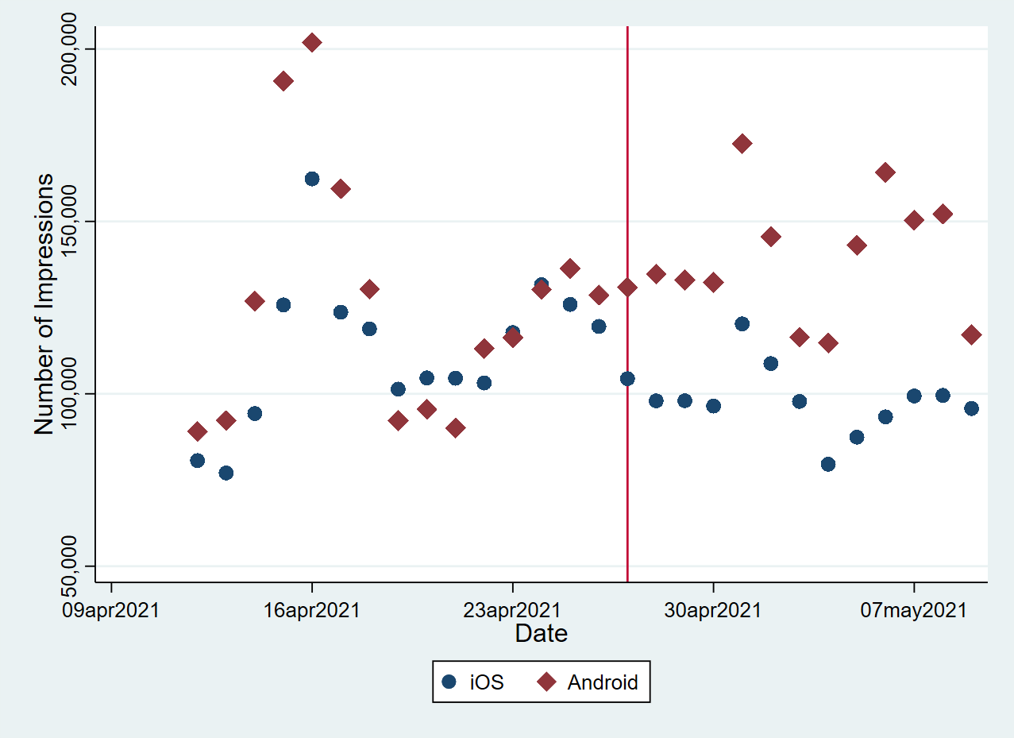
Notes: The solid vertical line represents the introduction of Apple’s ATT framework on April 26, 2021; the similar trend of the number of impressions on iOS and Android devices prior to the launch of ATT (i.e., the left-hand side of the vertical line) indicates that the common trend assumption is reasonable in this context; the increase in the number of impressions before the ATT launch is because more campaigns were launched during that period, which does not contradict the common trend assumption.
Table E1: Descriptive Statistics by Targeting Strategy
Targeting  Strategy |  | Number of Impressions | CPM  (in €) | CTR  (in %)
Broad-targeting | Avg. | 1,829.90 | 10.98 | 1.50
 | SD | 5,624.50 | 6.71 | 5.08
 | Min. | 1.00 | 0.83 | 0.04
 | Max. | 71,089.00 | 25.10 | 100.00
Narrow- targeting | Avg. | 627.86 | 14.37 | 2.03
 | SD | 2,384.54 | 6.11 | 6.82
 | Min. | 1.00 | 0.65 | 0.06
 | Max. | 26,415.00 | 25.13 | 100.00
Notes: Avg.: Average; SD: Standard deviation; Min.: Minimum; Max.: Maximum; CPM: Cost per mille; CTR: Click-through rate; data on the daily campaign level.

