Supplement

Na⁺ homeostasis in Acinetobacter baumannii is facilitated

via the activity of the Mrp antiporter

Josephine Joy Hubloher, Lisa van der Sande, Volker Müller*

Department of Molecular Microbiology & Bioenergetics, Institute of Molecular Biosciences, Goethe-University Frankfurt am Main, Germany;

Running title: Na⁺ cycling in A. baumannii ATCC 19606

*Correspondence to: Volker Müller, Department of Molecular Microbiology & Bioenergetics, Institute of Molecular Biosciences, Goethe-University Frankfurt am Main, Max-von-Laue-Str. 9, 60438 Frankfurt, Germany. Tel.: + 49 69 79829507. E-mail address: vmueller@bio.uni-frankfurt.de

Tab. S1 Genes encoding Mrp antiporter subunits in A. baumannii ATCC 19606 & their properties
Locus tag | Encoded protein | Gene length (bp) | Molecular mass [kDa] | Predicted transmembrane helices*
F911_03564 | MrpA’ | 2835 | 102.5 | 25
F911_03565 | MrpC | 366 | 13.1 | 3
F911_03566 | MrpD | 1809 | 66.8 | 14
F911_03567 | MrpE | 525 | 20.0 | 4
F911_03568 | MrpF | 273 | 9.9 | 3
F911_03569 | MrpG | 402 | 14.9 | 3
* Prediction of transmembrane helices was done by the program Expasy

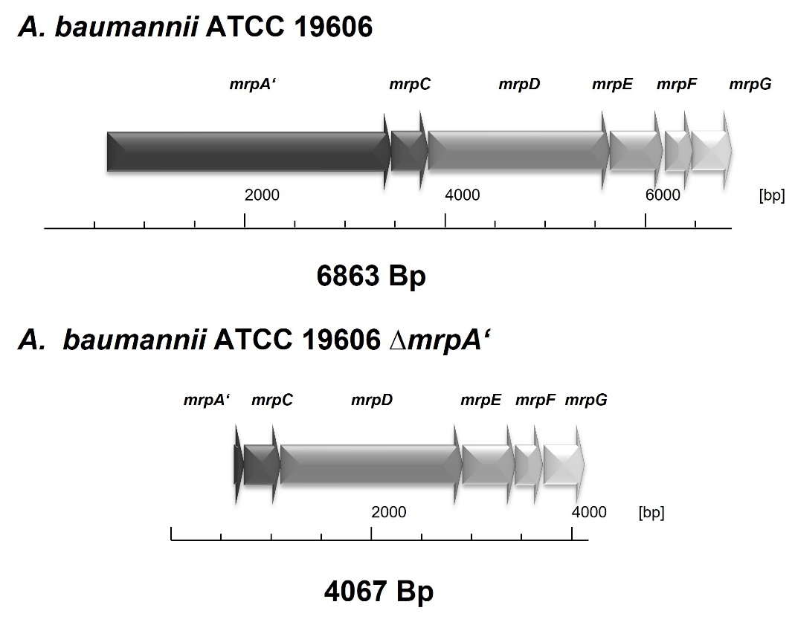
Fig. S1 Genetic organization of the mrp gene cluster of A. baumannii ATCC 19606 and the A. baumannii ATCC 19606 ∆mrpA’ mutant.

Fig. S2 Genetic complementation of A. baumannii ATCC 19606 ∆mrpA. Growth of A. baumannii ATCC 19606_F911_00233::kan^{R} (A), ∆mrpA’_F911_00233::kan^{R} (B) ∆mrpA’_F911_00233:: mrpA’_kan^{R} (C) was monitored in L0-medium (○) with 5 mM LiCl (□), 300 mM NaCl (△) or an initial pH of 10 (▽) in the presence of 20µg/ ml kanamycin. Precultures were grown in L0-medium (pH 7) overnight in the presence of 20 µg/ ml kanamycin and were used to inoculate prewarmed medium to an initial OD_{600nm} of 0.1 Error bars denote the standard deviation from at least three biological replicates.
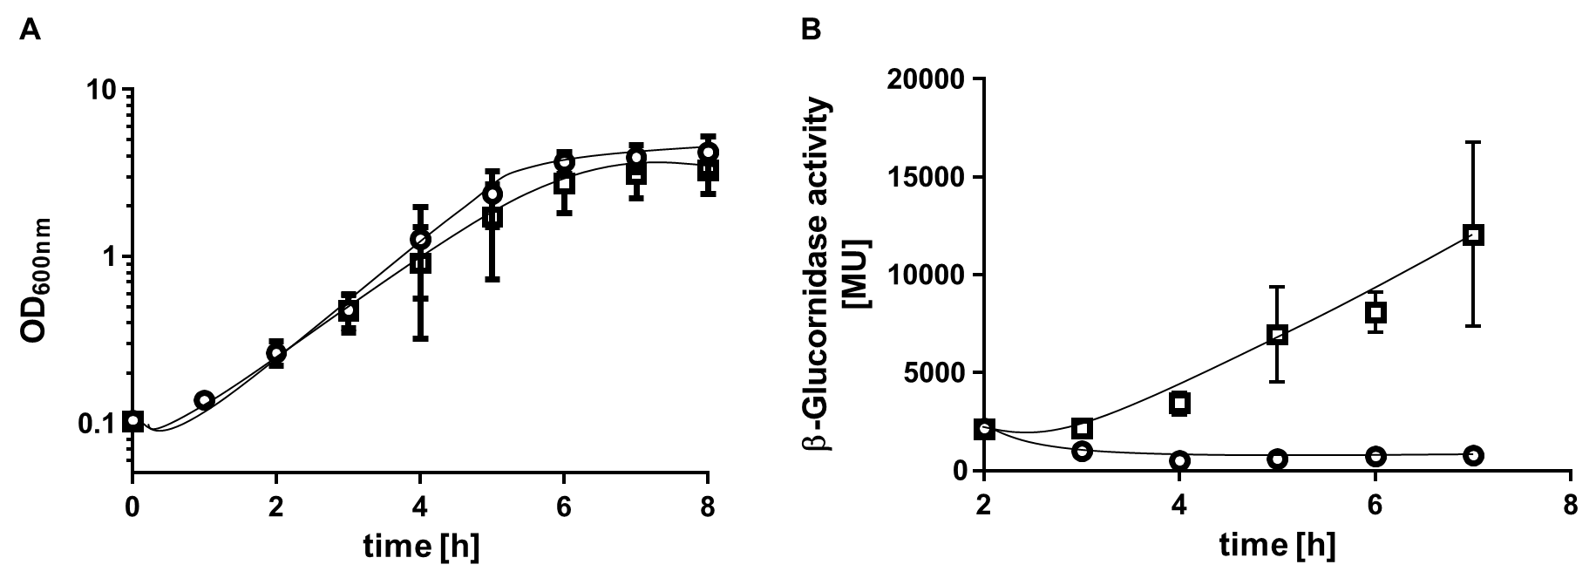
Fig. S3 Activity of the mtlD promoter determined by reporter gene assays. (A) Growth and (B) corresponding β-glucoronidase activity of the reporter gene strain ATCC 19606 + pVRL2_up_mtlD_gusA grown in mineral medium (○) with 200 mM NaCl (□). Error bars denote standard deviation calculated from at least three biological replicates.
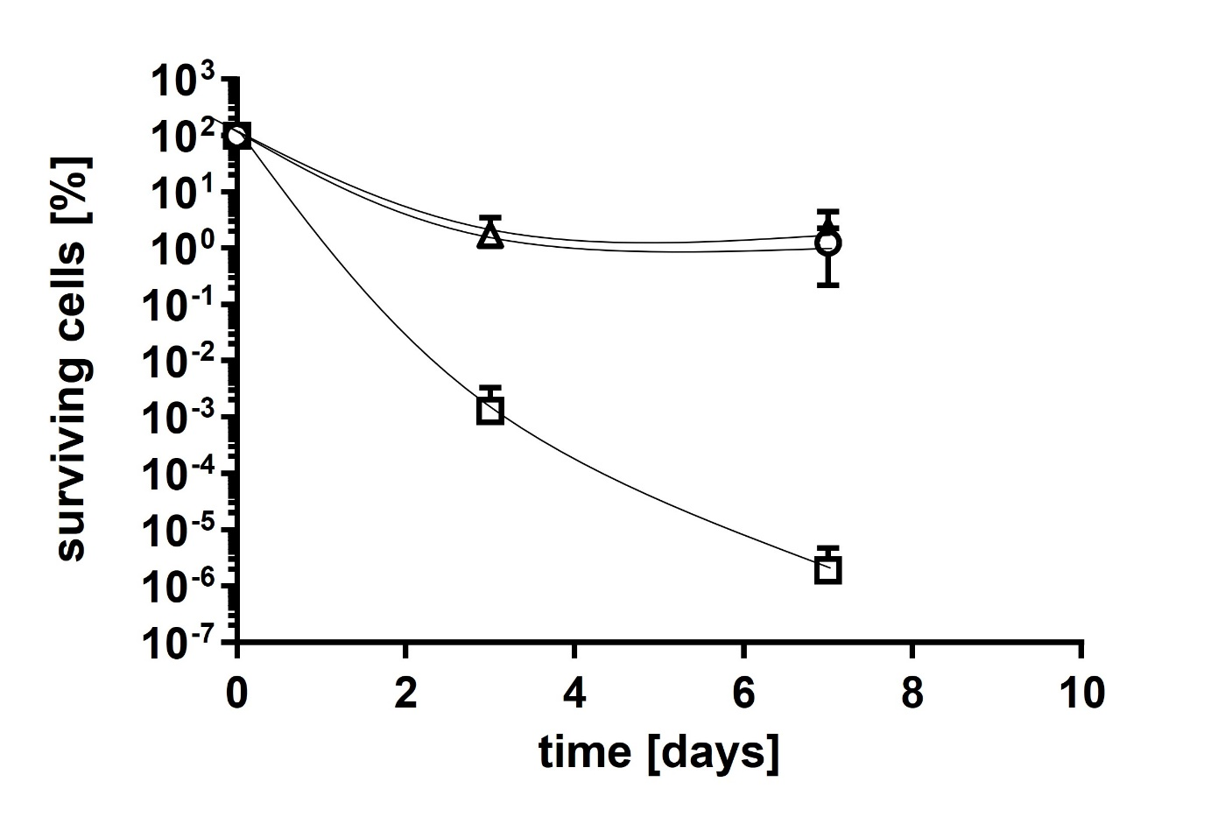
Fig. S4 Desiccation resistance of A. baumannii ATCC 19606_F911_00233::kan^{R} (△), ∆mrpA’_F911_00233::kan^{R} (□) ∆mrpA’_F911_00233::mrpA’_kan^{R} (○). A. baumannii strains were spotted on culture plates and incubated in a climate chamber at 22°C and 31% relative humidity (RH). Bacteria were removed from the plates by resuspending with 360 µl K⁺-phosphate buffer (10 mM, pH 6.8). Appropriate dilutions were prepared and cell forming units were determined on solid L0-medium. Error bars denote the standard deviation calculated from at least three biological replicates.

Fig. S5 Growth of A. baumannii wild type and ∆mrpA’ in inactivated human urine. A. baumannii ATCC 19606, ∆mrpA’, ATCC 19606_F911_00233::kan^{R}, ∆mrpA’_F911_00233::kan^{R} and ∆mrpA’_F911_00233::mrpA’_kan^{R} were grown in L0-medium overnight in the presence of 20 µg/ml kanamycin. Precultures were used to inoculate prewarmed inactivated human serum to an initial OD₆₀₀ of 0.1. Cells were incubated for 24 at 37 °C and the optical density was measured.

Tab S2 Primers used in this study.
pBIISK_sacB_kan^{R}_fwd | GGCTGCAGGAATTCGATG | Construction of pBIISK_sacB_kanR_∆mrpA
pBIISK_sacB_kan^{R}_rev | CGGGGGATCCACTAGTTCTAGAGCGG | Construction of pBIISK_sacB_kanR_∆mrpA
mrpA_up_fw | AGCATCGAATTCCTGCAGCCTTCCACCGGAATTTGGAC | Construction of pBIISK_sacB_kanR_∆mrpA
mrpA_up_rev | TCGAGTGGCGACAAGGGTGGTGCCTAATATTAAC | Construction of pBIISK_sacB_kanR_∆mrpA
mrpA_down_fwd | CCACCCTTGTCGCCACTCGAGTATGTCTG | Construction of pBIISK_sacB_kanR_∆mrpA
mrpA_down_rev | TAGAACTAGTGGATCCCCCGAACAGGTAAAATGCTGCAC | Construction of pBIISK_sacB_kanR_∆mrpA
Mrp fw | GGAAGCCGTGAAGAATTG | Control primer
Mrp rev | TTTATTCTTGAGGAGGTTCC | Control primer
pBIISK_fwd | AGTGGATCCCCCGGGCTG | Construction of pBIISK_∆mrpA’::kan^{R}
pBIISK_rev | AGTTCTAGAGCGGCCGCC | Construction of pBIISK_∆mrpA’::kan^{R}
Up_mrpA_fwd | GTGGCGGCCGCTCTAGAACTGCTCAATTTTTATAATAAAACCG | Construction of pBIISK_∆mrpA’::kan^{R}
Up_mrpA_rev | CACAATCGCTCATATATAATTTAGACCGAAGCC | Construction of pBIISK_∆mrpA’::kan^{R}
kan^{R}_mrpA_fwd | ATTATATATGAGCGATTGTGTAGGCTGG | Construction of pBIISK_∆mrpA’::kan^{R}
kan^{R}_mrpA_rev | AAACTGATCAATATGAATATCCTCCTTAGTTCCTATTC | Construction of pBIISK_∆mrpA’::kan^{R}
Down_mrpA_fwd | ATATTCATATTGATCAGTTTAGAATTCTTACTG | Construction of pBIISK_∆mrpA’::kan^{R}
Down_mrpA_rev | TGCAGCCCGGGGGATCCACTCGGATTCATAACGGCTAC | Construction of pBIISK_∆mrpA’::kan^{R}
LPP_fw | GTTGCGCAATACAACTTG | Amplification PCR product
LPP_rev | AGTTAACCGCATAGCCCAGC | Amplification PCR product
pBIISK_fw | ATCGAATTCCTGCAGCCC | Construction of pBIISK_mrpA’& pBIISK_kan^{R}
pBIISK_rev | ATCAAGCTTATCGATACCGTC | Construction of pBIISK_mrpA’ & pBIISK_kan^{R}
Up_fw | ACGGTATCGATAAGCTTGATGAAGCCTACCTCAAGATAAG | Construction of pBIISK_mrpA’& pBIISK_kan^{R}
Up_rev | CACAATCGCTGCTAAGAGGTTTCACTTC | Construction of pBIISK_mrpA’& pBIISK_kan^{R}
Kan^{R}_fw | ACCTCTTAGCAGCGATTGTGTAGGCTGG | Construction of pBIISK_mrpA’
Kan^{R}_rev | GGAGCTGTCCATATGAATATCCTCCTTAGTTCCTATTC | Construction of pBIISK_mrpA’
Kan^{R}_rev | TACCATCAGCATATGAATATCCTCCTTAGTTCCTATTC | Construction of pBIISK_kan^{R}
mrpA_fw | ATATTCATATGGACAGCTCCCTGAAACC | Construction of pBIISK_mrpA’
mrpA_rev | TACCATCAGCTCATGATGATTTCTCCCCATG | Construction of pBIISK_mrpA’
down_fw | ATCATCATGAGCTGATGGTAGTGTGGGATTAC | Construction of pBIISK_mrpA’
down_fw | ATATTCATATGCTGATGGTAGTGTGGGATTAC | Construction of pBIISK_kan^{R}
down_rev | CCGGGCTGCAGGAATTCGATAAGGATCTGCAGGAATCAATTC | Construction of pBIISK_kan^{R} & pBIISK_mrpA’
LPP_fw | TAAGATTCAATCAGCCCAGTC | amplification PCR-product
LPP_rev | ATAGGTACTTACCCCCTTATTC | amplification PCR-product
Check-fw | ATCGCCGGGTAGCTATGTTC | Control primer
Check-rev | TCTTTCTGGCGGTAATCC | Control primer
pVRL2_up fw | GAGCTCCAATTCGCCCTATAG | Construction of pVRL2_upmrpA’_gusA
pVRL2_up rev | TCTTTCCAGTCGGGAAAC | Construction of pVRL2_upmrpA’_gusA
gusA_fw | GGATACGAGTATGGGCAGCAGCCATCAC | Construction of pVRL2_upmrpA’_gusA
gusA_rev | TATAGGGCGAATTGGAGCTCCTACCGGCCGCATAGGCC | Construction of pVRL2_upmrpA’_gusA
mrp up_fwd gus | AGGTTTCCCGACTGGAAAGAGTTAATTGACCAGATCGATTC | Construction of pVRL2_upmrpA’_gusA
mrp up_rev gus | TGCTGCCCATACTCGTATCCATATATAATTTAGAC | Construction of pVRL2_upmrpA’_gusA
pVRL2_gusA fw | ATGGGCAGCAGCCATCAC | Construction of pVRL2_upmtlD_gusA
pVRL2_gusA rev | TCTTTCCAGTCGGGAAACC | Construction of pVRL2_upmtlD_gusA
upstream_mtlD fw | AGGTTTCCCGACTGGAAAGATGCCGAAATTTATGAAGG | Construction of pVRL2_upmtlD_gusA
upstream_mtlD rev | TGGTGATGGCTGCTGCCCATTTTTTACCTCTTTTTTGATCATG | Construction of pVRL2_upmtlD_gusA

