Supplementary Materials

Supplement Figure 1: Multivariate analysis

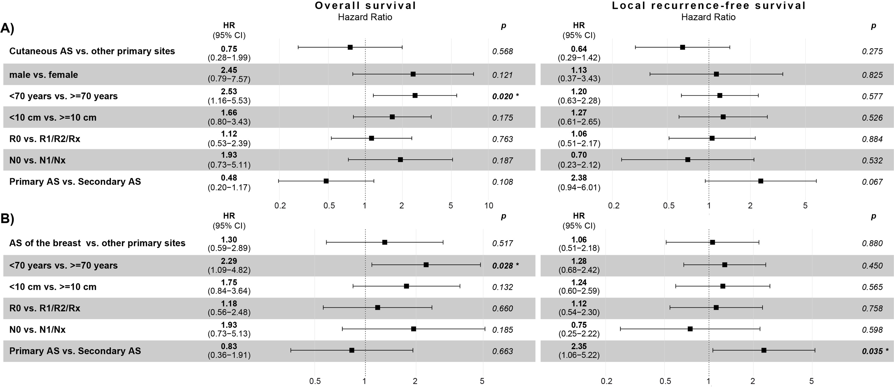

Supplement Figure 2: Multivariate analysis metastasis-free survival

