Functional brain connectomes reflect acute and chronic cannabis use.

Supplementary information

Ramaekers JG ¹, Mason NL¹, Toennes SW², Theunissen EL¹, Amico E^{3,4}

¹Faculty of Psychology and Neuroscience, Maastricht University, The Netherlands
²Institute of Legal Medicine, University of Frankfurt, Germany
³Institute of Bioengineering, Center for Neuroprosthetics, EPFL, Geneva, Switzerland
⁴Department of Radiology and Medical Informatics, University of Geneva, Switzerland

Correspondence: j.ramaekers@maastrichtuniversity.nl and enrico.amico@epfl.ch

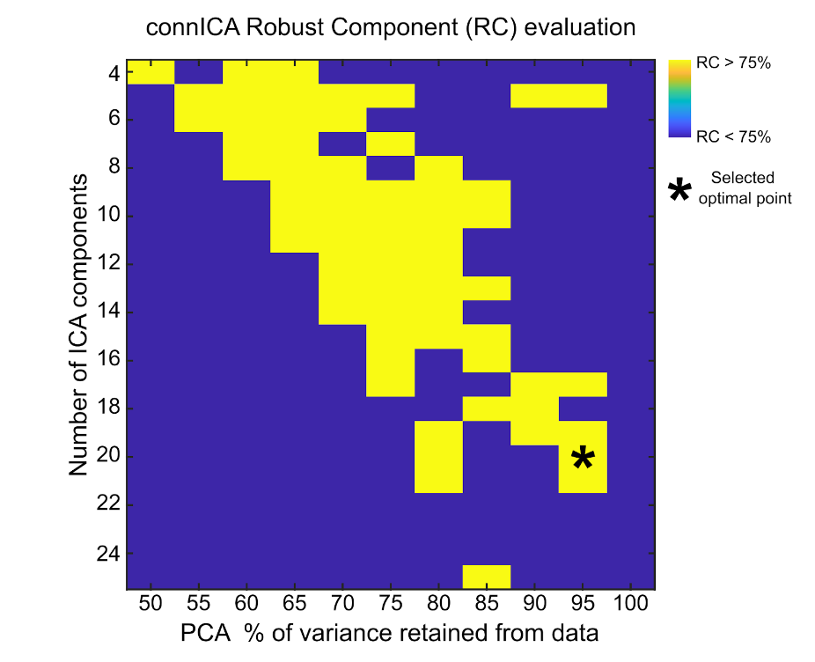

Fig. S1. Exploration of optimal connICA parameters. The two free parameters of the connICA methodology ¹, i.e. the number of ICA components and the percentage of variance retained, were explored to maximize: 1) the number of robust components and, 2) the percentage of variance retained from the data. The optimal point at 95% retained variance in PCA and 20 independent components is indicated by an asterisk.

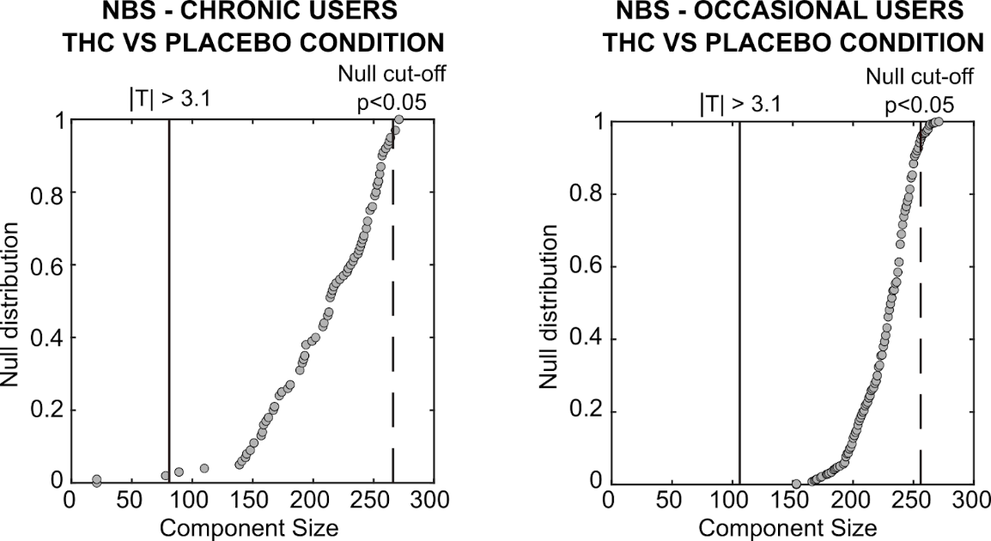

Fig. S2. NBS analysis of THC vs placebo effects in each cannabis user group. Giant component size extracted from the T-statistic matrix obtained when comparing THC vs placebo conditions within the cannabis user groups. Note how the effect does not survive the cut-off threshold obtained by random shuffling the drug labels, in both groups

Table S1. Mean subject characteristics (SD) and history of drug use for occasional and chronic cannabis users who completed the study (N=26).
Variable | Occasional Users | Chronic Users | Value | df | P value
Gender (male/female), n, total | 7/7, 14 | 9/3, 12 | χ2 = 1.71‡ | 1 | 0.19
Age, years | 22.14 (2.51) | 21.83 (2.25) | t=0.33† | 24 | 0.74
History of cannabis use, years | 5.21 (2.61) | 5.33 (1.78) | t=.-0.13† | 24 | 0.89
Frequency of cannabis use, per week | 1.12 (0.78) | 6.63 (1.40) | t=-12.64† | 24 | 0.00*
Alcohol consumption, glasses per week | 6.68 (6.68) | 3.17 (2.32) | t=1.73† | 24 | 0.10
Caffeine consumption (per week) | 8.07 (7.11) | 8.88 (6.05) | t=-0.31† | 24 | 0.76
Nicotine consumption, per week | 14.00 (21.15) | 19.29 (28.23) | t=-1.58† | 24 | 0.13
Occasional use of other drugs, n | 9 | 9 | χ2 = 0.00‡ | 1 | 1.00
*Significant P values
†Independent t test
‡χ2 test for frequency data

Table S2 Mean (SE) subjective high, lapses of attention averaged over two time points in each treatment condition. OU=occasional users; CU=chronic users.
 | Subjective High (cm) |  |  | Lapses of attention (#)
 | Post-resting state 1  (20 min) | Post-resting state 2  (42 min) | average | Pre-resting state 1  (1 min) | Pre-resting state 2  (22 min) | Average
OU
Placebo | 1.21 (.38) | 0.92 (.37) | 1.07 (.31) | 3.50 (.81) | 5.35 (1.51) | 4.42 (1.08)
THC | 5.36 (.70) | 3.92 (.61) | 4.73 (.61) | 5.0 (1.26) | 8.07 (1.78) | 6.15 (1.38)
CU
Placebo | 2.50 (.62) | 2.08 (.62) | 2.29 (.57) | 1.25 (.30) | 1.08 (.31) | 1.16 (.23)
THC | 4.83 (.75) | 4.08 (.73) | 4.45 (.71) | 1.83 (.34) | 1.91 (.62) | 1.87 (.35)

Table S3 Mean (SE) THC, THC-COOH and 11-OH-COOH concentrations at baseline and two time points prior to resting state fMRI in THC condition. OU=occasional users; CU=chronic users.
 | THC  (ng/ml) | THC-COOH  (ng/ml) | 11-OH-THC  (ng/ml)
OU
Baseline | 0 | 1.54 (.61) | 0
6 min (pre-resting state 1) | 8.61 (1.46) | 8.31 (1.78) | 1.61 (.31)
28 min (pre-resting state 2) | 2.88 ((0.50) | 7.78 (1.58) | .93 (.19)
CU
Baseline | 3.48 (.89) | 47.44 (14.33) | 1.55 (.38)
6 min (pre-resting state 1) | 15.86 (3.48) | 48.81 (14.19) | 3.84 (1.13)
28 min (pre-resting state 2) | 6.66 (1.55) | 45.53 (15.43) | 2.10 (.62)

