Appendix A
Supplementary material to “Seedling recruitment of small-seeded and large-seeded species in forests and pastures in Southern Ecuador" by Barczyk et al. 2024

Table A1. Description of the five species used in the seed sowing experiment in the tropical mountains of South Ecuador. Extra information and photos can be found in the field guide published by Acosta Rojas et al. (2021).
Species and  family | Seed mass [g] |  | Seeds sown | Starting date and time span | Species characteristics incl. information about seed collection
Ocotea sp. [Lauraceae] | 0.5272 |  | 528 | December 2018 – 18 months | Mid-successional, tall tree, dispersed by birds and the spectacled bear, seeds collected from trees in Bombuscaro (1000m)
Clusia ducuoides [Clusiaceae] | 0.0054 |  | 2980 | March 2019 – 15 months | Late-successional, tall tree, dispersed by birds, seeds collected from trees in San Francisco (2000m)
Hieronyma fendleri [Phyllantaceae] | 0.0079 |  | 3600 | March 2019 – 15 months | Mid-successional, small tree, dispersed by birds, seeds collected from trees San Francisco (2000m)
Tapirira guianensis subsp. subandina [Anacardiaceae] |  | 0.4063 | 720 | September 2019 – 10 months | Mid-successional, tall tree, dispersed by birds and mammals, seeds collected from trees in San Francisco (2000m)
Hedyosmum purpurascens [Chloranthaceae] | 0.0135 |  | 634 | June 2019 – 12 months | Early-successional, small tree, dispersed by birds, seeds collected from trees in Cajanuma (3000 m)

Table A2. Variation of selected abiotic and biotic factors across habitats and elevations in the tropical mountains of South Ecuador. (A) Mean daily maximum surface temperature of the three driest months; (B) mean daily surface temperature of the three driest months; (C) average soil moisture during the dry (i.e., less rainy) season; (D) mean herbivory incidence on established seedlings; (E) mean fungal pathogen incidence on established seedlings. Mean and standard deviation are shown in columns (n = 9 subplots).

 | 1000 m  Mean ± SD | 2000 m  Mean ±SD | 3000 m  Mean ±SD
A) Mean daily max temperature [°C]
FOREST | 21.1 ± 0.7 | 15 ± 1.1 | 12 ± 0.6
PASTURE | 25.2 ± 2.4 | 18.8 ± 1.8 | 25.6 ± 2.7
B) Mean daily mean temperature [°C]
FOREST | 19.3 ± 0.3 | 12.9 ± 1.1 | 10.3 ± 0.3
PASTURE | 21.1 ± 0.5 | 14.1 ± 0.5 | 15.9 ± 0.6
C) Average soil moisture [%]
FOREST | 36 ± 10.2 | 50.7 ± 5.5 | 72.7 ± 18.5
PASTURE | 59.4 ± 9.7 | 56.7 ± 12.8 | 51.2 ± 20.5
D) Mean herbivory incidence [0-1]
FOREST | 0.5 ± 0.3 | 0.5 ± 0.5 | 0 ± 0
PASTURE | 0.7 ± 0.4 | 0.4 ± 0.5 | 0.04 ± 0.06
E) Mean fungal pathogen incidence [0-1]
FOREST | 0.6 ± 0.3 | 0.5 ± 0.5 | 0.01 ± 0.02
PASTURE | 0.8 ± 0.3 | 0.4 ± 0.4 | 0.2 ± 0.2

Table A3. Species-specific variation in seedling establishment and recruitment success in the tropical mountains of South Ecuador. Seedling establishment is defined as the proportion of all established seedlings over the experimental period to the total number of seeds sown at the sowing units [0-1] and recruitment success is defined as a proportion of survived seedlings after the entire experimental period to the total number of seeds sown at the sowing units [0-1].

 | Species  Mean ± SD | Forest  Mean ±SD | Pastures  Mean ±SD
Clusia ducuoides (2000 m)
Seedling establishment | 0.09 ± 0.14 | 0.02 ± 0.03 | 0.15 ± 0.15
Recruitment success | 0.03 ± 0.09 | 0.004 ± 0.01 | 0.06 ± 0.11
Hedyosmum purpurascens (3000 m)
Seedling establishment | 0.08 ± 0.08 | 0.07 ± 0.05 | 0.07 ± 0.05
Recruitment success | 0.08 ± 0.08 | 0.09 ± 0.14 | 0.09 ± 0.14
Hieronyma fendleri (2000 m)
Seedling establishment | 0.06 ± 0.07 | 0.04 ± 0.04 | 0.03 ± 0.04
Recruitment success | 0.02 ± 0.04 | 0.07 ± 0.09 | 0.02 ± 0.04
Ocotea sp. (1000 m)
Seedling establishment | 0.50 ± 0.24 | 0.44 ± 0.25 | 0.30 ± 0.18
Recruitment success | 0.31 ± 0.18 | 0.56 ± 0.23 | 0.31 ± 0.19
Tapirira guianensis ssp. subandina (2000 m)
Seedling establishment | 0.14 ± 0.13 | 0.18 ± 0.14 | 0.12 ± 0.11
Recruitment success | 0.07 ± 0.10 | 0.09 ± 0.11 | 0.03 ± 0.07

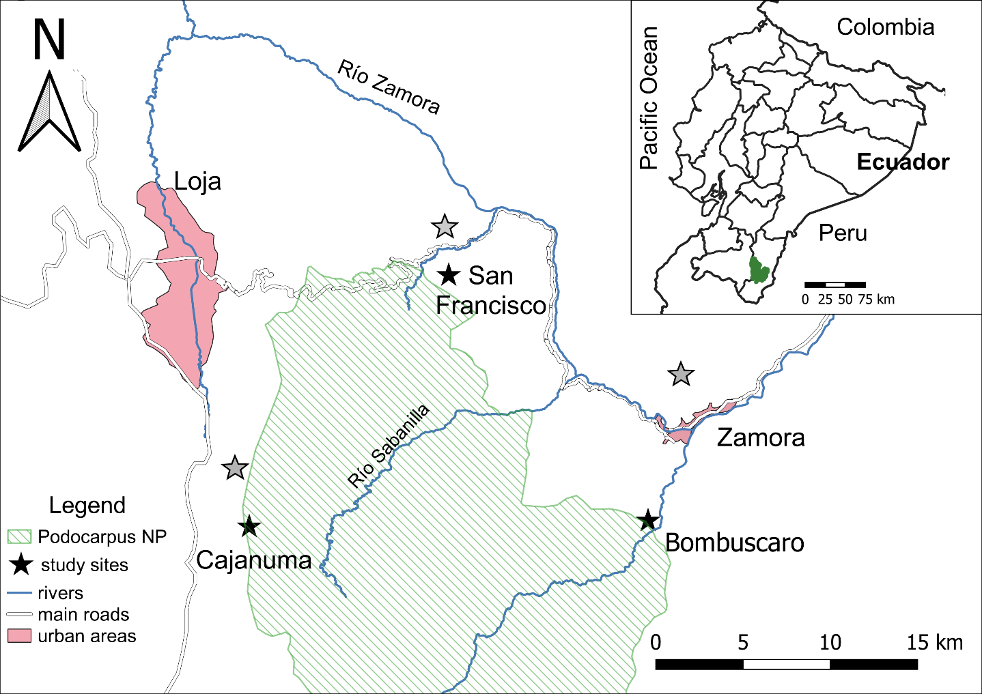
Fig. A1. Map of Podocarpus National Park and surroundings. Map at the top right shows Ecuador with the Podocarpus NP marked with green colour. Black stars symbolize the study sites in forest and grey stars symbolize the study sites in pastures.

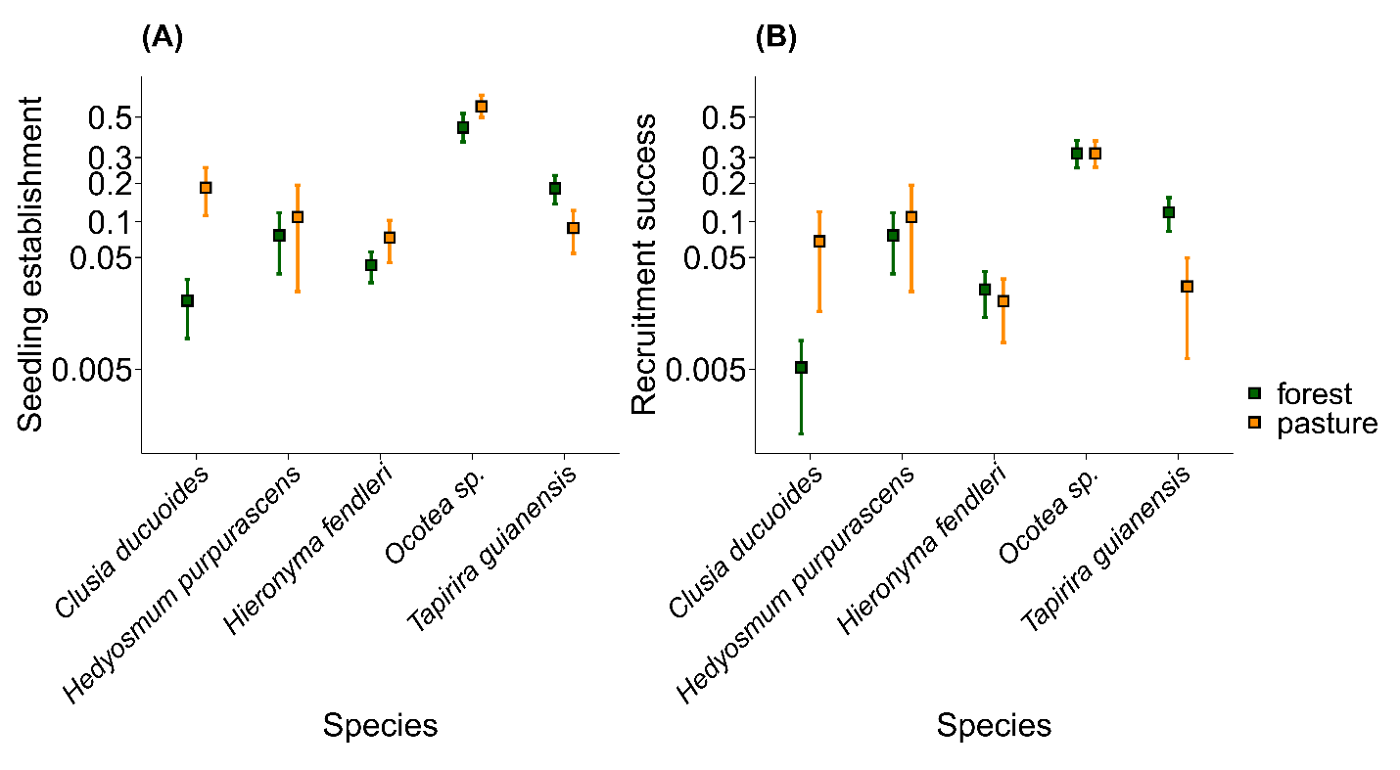Fig. A2. Species-specific seedling establishment and recruitment success in two habitat types (green: forest, yellow: pasture) in the sowing experiment in the tropical mountains in South Ecuador. (A) Seedling establishment, defined as the number of all seedlings emerging during the first year after sowing, divided by the total number of seeds sown (10 months in case of T. guianensis ssp. subandina); (B) recruitment success, as the number of alive seedlings encountered at the last visit, divided by the total number of seeds sown (10 months in case of T. guianensis ssp. subandina) to the total number of seeds sown. Species are ordered according to their seed size; from small (three small-seeded species on the left) to large (two large-seeded species on the right). Each species was sown at the elevation of its origin, i.e. Ocotea sp. at 1000 m a.s.l.; Clusia ducuoides, Hieronyma fendleri and Tapirira guianensis ssp. subandina at 2000 m a.s.l. and Hedyosmum purpurascens at 3000 m a.s.l. Recruitment variables (A and B) are presented on a logit scale. Squares indicate mean proportions of seedling establishment and recruitment success and error bars correspond to 95% confidence intervals around the mean.

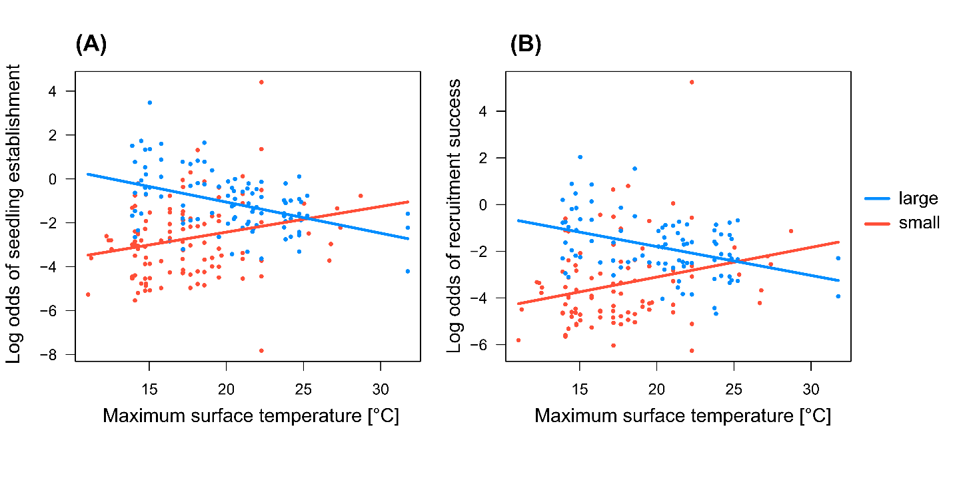 Fig. A3. Seedling establishment and recruitment success of large-seeded (blue) and small-seeded species (red) as a function of the maximum surface temperature. (A) Seedling establishment, defined as the number of all seedlings emerging during the first year after sowing, divided by the total number of seeds sown; (B) recruitment success, defined as the number of alive seedlings encountered at the last visit, divided by the total number of seeds sown. Plots show partial residuals of the mean log odds of both recruitment variables of two large-seeded species and three small-seeded species at the sowing units. Lines indicate the interacting effects of surface temperature and seed size as shown in Table 3.

Resumen (abstract in spanish)
El reclutamiento de plántulas es un proceso crucial para la regeneración de las plantas y la restauración de los bosques. Sin embargo, se sabe poco sobre cómo los factores abióticos y bióticos limitan el reclutamiento de plántulas de diferentes tamaños a lo largo de gradientes ambientales en las montañas tropicales. Aquí, llevamos a cabo un experimento de siembra con cinco especies de árboles en bosques y pastos a lo largo de un gradiente de elevación en el sur de Ecuador. Para cuantificar el reclutamiento de plántulas en relación con la temperatura, la humedad del suelo y el estrés biótico, sembramos semillas de cinco especies arbóreas de diferente tamaño en tres elevaciones (1000, 2000 y 3000 m s.n.m.) en bosques primarios y pastos. Nosotros probamos (1) cómo el tipo de hábitat influye en el reclutamiento de plántulas de semillas pequeñas y grandes, y (2) cómo los factores abióticos y bióticos limitan el reclutamiento de plántulas de semillas de diferentes tamaños. Nosotros encontramos que las plantas de semillas grandes reclutaron mejor que las de semillas pequeñas, pero sólo en el bosque. El reclutamiento de dos especies con semillas grandes se vio limitado principalmente por la alta temperatura de la superficie, lo que explica el menor reclutamiento de especies con semillas grandes en los pastos en comparación con el bosque. Nuestro estudio muestra que el tamaño de las semillas es un rasgo funcional clave que interviene en la variabilidad del reclutamiento de plántulas en los hábitats de los ecosistemas tropicales. Concluimos que las medidas de restauración deberían tener como objetivo mitigar las temperaturas extremas en los pastos tropicales para ayudar a la regeneración natural de las especies arbóreas con semillas de gran tamaño.

