Supplementary materials

Estimation of the Incidence of Urachal Cancer: A Systematic Review and Meta-Analysis of Registry-Based Studies

Csilla Olah¹, András Kubik^{2,3}, Péter Mátrai⁴, Marie Anne Engh³, Viktória Barna³, Péter Hegyi^{3,4,5}, Henning Reis⁶, Péter Nyirády², Tibor Szarvas^{1,2}

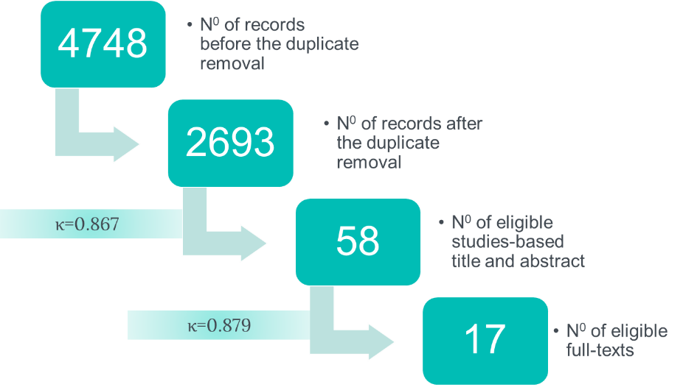
Supplementary Figure 1. Flow chart of the process of paper selection.

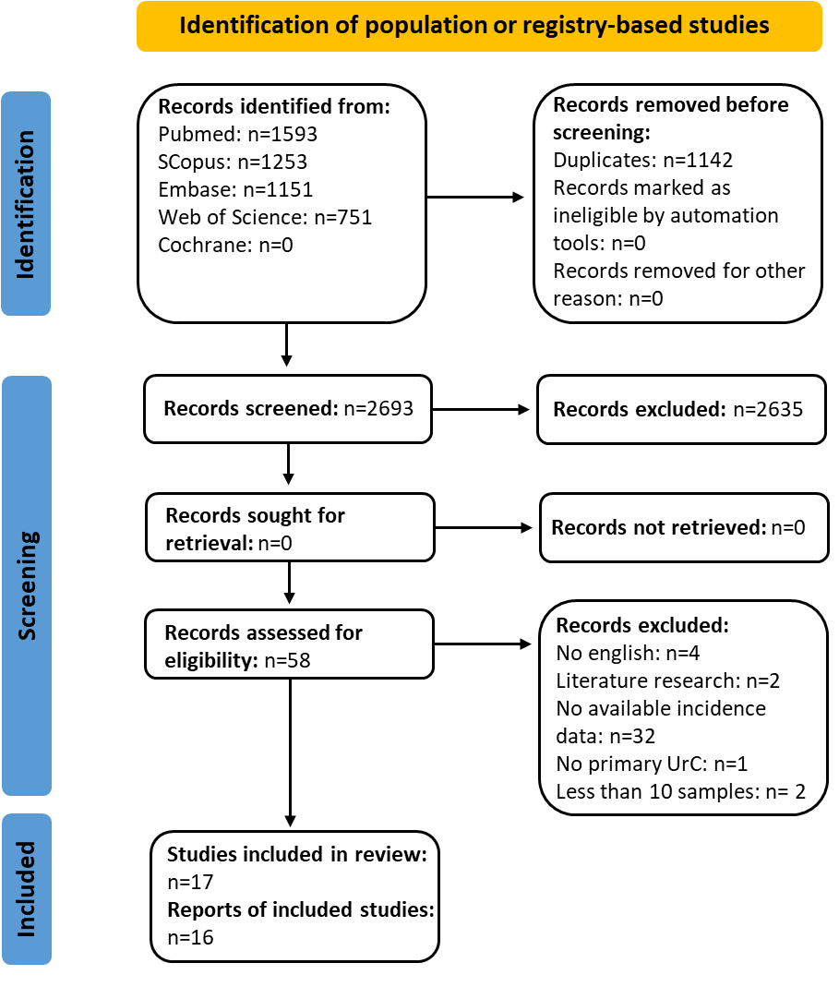
Supplementary Figure 2. PRISMA flow chart with studies used for the present systematic review.

Supplementary Table 1. Studies included the present systemic review. BC: bladder caner, UrC: urachal carcinoma.
 | Study | UrC patients | Authors | Published | Occurrence | Incidence | Database | Period | Period | Habitants | Risk of Bias | Analysis
 | Country | number of UrC patients |  | PMID | UrC/BC ratio | estimated for 100.000 year-persons | Registry- or population-based studies | range | years | estimated during the study period | Joanna Briggs Institute checklist | Included for incidence analysis | Descriptive (based on clinical data)
1. | Ireland | 26 | Collins et al. | 27746878 | 0.3% | 0.033 | National Cancer Registry in Ireland | 1994-2011 | 18 | 4.4M | Included | yes | yes
2. | Netherlands | 152 | Bruins et al. | 22901574 | 0.2% | 0.046 | Netherlands Cancer Registry | 1989-2009 | 21 | 15.7M | Included | yes | yes
3. | Germany | 154 | Hager et al. | 32784300 | 0.2% | 0.038 | Robert Koch Institute | 2011-2015 | 5 | 81.3M | Included | yes | yes
4. | Canada | 62 | Pinthus et al. | 16697798 | < 0.1% | 0.022 | Ontario Cancer Registry | 1976-2002 | 27 | 10.3M | Included | yes | no
5. | Japan | 456 | Nagumo et al. | 31793080 | 0.4% | 0.060 | Hospital-based cancer registry (University of Tsukuba) | 2008-09 / 2012-2015 | 2 / 4 | 127.5M | Included | yes | yes
6. | USA | 841 | Dursun et al. | 35509235 | no data | 0.030 | The National Cancer Database | 2004-2016 | 13 | 216.1M | Included | yes | yes
7. | Germany | 121 | Darr et al. | https://doi.org/10.1200/JCO.2023.41.6_suppl.480 | no data | 0.056 | NRW Cancer Registry | 2008-2019 | 12 | 18M | Included | no | no
8. | USA | 315 | Benjamin et al. | https://doi.org/10.1016/j.annonc.2022.07.1844 | no data | 0.029 | California Cancer Registry | 1988-2019 | 32 | 33.97M | Included | no | no
9. | USA | 841 | Limonnik et al. | 36069175 | 0.15% | 0.030 | The National Cancer Database | 2004-2016 | 13 | 216.1M | Included | no | yes
10. | USA | 501 | Ding et al. | 35719613 | no data | 0.014 | SEER | 1975-2018 | 44 | 79.8M | Included | no | no
11. | USA | 618 | Yu et al. | 34595114 | no data | 0.016 | SEER | 1975-2018 | 44 | 85.5M | Included | no | no
12. | USA | 420 | Mylonas et al. | 27592530 | no data | 0.021 | SEER | 1988-2012 | 25 | 81.1M | Included | no | no
13. | USA | 392 | Flammia et al. | https://doi.org/10.1097/JU.0000000000002603.07 | no data | 0.033 | SEER | 2004-2016 | 13 | 92.6M | Included | no | no
14. | USA | 226 | Luzzago et al. | 31960108 | no data | 0.019 | SEER | 2004-2016 | 13 | 92.6M | Included | no | no
15. | USA | 507 | Yu et al. | 32676391 | no data | 0.015 | SEER | 1973-2015 | 43 | 77.5M | Included | no | no
16. | USA | 151 | Wright et al. | 16826584 | no data | 0.008 | SEER | 1973-2002 | 30 | 66.4M | Included | no | no
17. | USA | 314 | Zhou et al. | 34278741 | no data | 0.009 | SEER | 1975-2016 | 42 | 85.5M | Included | no | no

References

- Collins DC, Velázquez-Kennedy K, Deady S, Brady AP, Sweeney P, Power DG. National Incidence, Management and Survival of Urachal Carcinoma. Rare Tumors. 2016;8(3):6257.
- Bruins HM, Visser O, Ploeg M, Hulsbergen-van de Kaa CA, Kiemeney LA, Witjes JA. The clinical epidemiology of urachal carcinoma: results of a large, population based study. J Urol. 2012;188(4):1102-7.
- Hager T, Kraywinkel K, Szarvas T, Hadaschik B, Schmid KW, Reis H. Urachal Cancer in Germany and the USA: An RKI/SEER Population-Based Comparison Study. Urol Int. 2020;104(9-10):803-809.
- Pinthus JH, Haddad R, Trachtenberg J, Holowaty E, et al. Population based survival data on urachal tumors. J Urol. 2006;175(6):2042-7.
- Nagumo Y, Kojima T, Shiga M, et al. Clinicopathological features of malignant urachal tumor: A hospital-based cancer registry data in Japan. Int J Urol. 2020;27(2):157-162.
- Dursun F, Lim K, Svatek RS, et al. Clinical outcomes and patterns of population-based management of urachal carcinoma of the bladder: An analysis of the National Cancer Database. Cancer Med. 2022;11(22):4273-4282.
- Darr C, Möller L, Schürger N, et al. Journal of Clinical Oncology 41, no. 6_suppl (February 20, 2023) 480-480.
- Benjamin DJ, Shrestha A, Fellman A, Cress R, Rezazadeh Kalebasty A. Urachal cancer: A population-based study of 315 cases in California from 1988-2019. Ann of Oncology;2022;33: S1346.
- Limonnik V, Samiei A, Abel S, Wegner RE, Vemana G, Mao SS. Urachal carcinoma: A novel staging system utilizing the National Cancer Database. Cancer Med. 2023;12(3):2752-2760.
- Ding L, Xia B, Zhang Y, Liu Z, Wang J. Web-Based Prediction Models for Overall Survival and Cancer-Specific Survival of Patients With Primary Urachal Carcinoma: A Study Based on SEER Database. Front Public Health. 2022;10:870920.
- Yu X, Ma C, Wang M, et al. Construction and Validation of Novel Prediction Tools Based on Large Population-Based Database to Predict the Prognosis of Urachal Cancer After Surgery. Front Oncol. 2021;11:718691.
- Mylonas KS, O Malley P, Ziogas IA, El-Kabab L, Nasioudis D. Malignant urachal neoplasms: A population-based study and systematic review of literature. Urol Oncol. 2017;35(1):33.e11-33.e19.
- Flammia RS, Chierigo F, Hoeh B, et al. Radical vs partial cystectomy for urachal carcinoma: a population-based analysis. Journal of Urology. https://doi.org/10.1097/JU.0000000000002603.07
- Luzzago S, Palumbo C, Rosiello G, et al. Survival of contemporary patients with non-metastatic urachal vs. non-urachal adenocarcinoma of the urinary bladder. World J Urol. 2020;38(11):2819-2826.
- Yu DD, Dong H, Wu ZG, et al. U-shaped relationship of age at diagnosis and cancer-specific mortality in primary urachal adenocarcinoma: a cohort study. Transl Androl Urol. 2020;9(3):1073-1081.
- Wright JL, Porter MP, Li CI, Lange PH, Lin DW. Differences in survival among patients with urachal and nonurachal adenocarcinomas of the bladder. Cancer. 2006;107(4):721-728.
- Zhou YW, Long YX, Song K, et al. Anterior wall adenocarcinoma of bladder with similar clinicopathological and prognostic characteristics as common bladder carcinomas should not be treated as or classified into urachal adenocarcinomas. Cancer Med. 2021;10(16):5415-5428.

